District 5030 Community Grants Application.
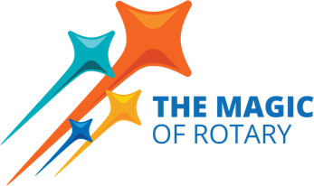
- The district has approximately $20,000 in District Designated Funds (DDF) available for clubs to access to use on projects in their local communities.
- The district will match the club 2 to 1, with a maximum match of $750
- Application will be simple and available on the district and foundation grants website (https://5030grants.com) on April 1, 2024.
- The club describes their community project and the area of focus and routes for approval to their Assistant Governor. Payments will be made to the club or its foundation only.
- Projects must comply with all Rotary Foundation terms and conditions and must be completed by June 30, 2023.
- Clubs must have their Annual Fund Goal Amount loaded on Rotary.org to participate.
- First come first served until the funds are gone!
- Please consider donating to Polio Plus!

District Designated Funds are made possible by your donations to The Rotary Foundation’s Annual Fund. Each year, our district receives DDF to fund district and global grant projects. Your contributions to The Rotary Foundation are critical for our continuing support of club service projects locally and internationally.

