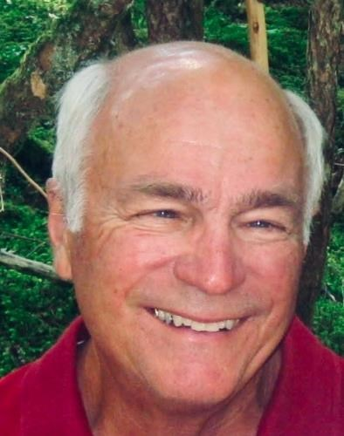**Bert BELLES**

September 17, 1940 - December 22, 2024  
  
Spokane, WA – Bert "Bud" Belles, a beloved husband, father, grandfather, and friend, passed away peacefully at home on December 22nd at the age of 84, with his wife, Marcia, by his side. Bud's life was one of quiet strength, unwavering love, and deep devotion to his family and community.  
  
Born in Spokane and raised in Oakesdale, WA, Bud was the son of Bert and Dorothy Belles and the older brother to his sister, Janet. His upbringing in a farming community shaped his values of hard work, humility, and the ability to fix just about anything.  
  
Bud graduated from Washington State University in 1963 with a degree in Mechanical Engineering. From 1963 to 1966, he worked at Hanford in the Tri-Cities as an engineer. He married the love of his life, Marcia, in 1964, beginning a partnership of over 60 years filled with love, family, and adventure.  
  
In 1966, Bud began an esteemed career at IBM, where he worked for 25 years. Bud then started his own consulting practice until 2009 when he retired. Although his talents and work ethic brought offers from other places, Bud and Marcia chose to stay rooted in Spokane and Priest Lake -places they deeply loved.  
  
Together, they raised three boys – David (wife, Kris), Paul (wife, Lisa), and Mike (wife, Katie). Bud took immense pride in his family, and his greatest joy was being "Papa" to Matt, Jake, Dylan, Kyle, Katy, Harper, Charlee, and Cohen. He loved watching their games, talking with them, and sharing simple moments of laughter and connection.  
  
Bud lived by a quiet but powerful creed – be humble, treat others with respect, help people without expecting anything in return, and lead by example. He believed in honesty, hard work, and family, values that he instilled in his children not by preaching, but by living them every day.  
  
He was community driven. During his service at Rotary, he was President, a Paul Harris Fellow, and served on the International Youth Exchange Committee. He served on the board of Spokane Youth Sports Association (SYSA), when in 1979 he developed a computerized soccer scheduling program for the youth teams. He was President of the Priest Lake Lessees Association as well as served on multiple other Priest Lake boards dedicated to preserving the pristine beauty and protecting the quality of life that made the lake so special to him.  
  
Bud was a talented woodworker, loved to travel, sail, and golf. The twinkle in his eye and his gentle, steady presence will not be forgotten – but it will be deeply missed.  
  
Bud's life was a testament to love, kindness, and quiet dedication. His legacy lives on in the family he adored and the countless lives he touched.  
  
A celebration of Bud's life will be held at The Hangar Events Center, on January 25th, at 2:00. The address is 6095 E. Rutter Ave., Spokane, WA 99212.  
  
In lieu of flowers, the family asks that donations be made to Rotary District 5080 Charitable Fund. Checks can be mailed to 3833 E. Eloika Rd., Deer Park, WA 99006-9127.

To plant trees in memory, please visit the [Sympathy Store](https://sympathy.legacy.com/en-us/funeral-flowers/productdetails/?type=obituary&p=208278333&pn=bert-belles&affiliateId=2568&sku=tre-tim&pm=240).