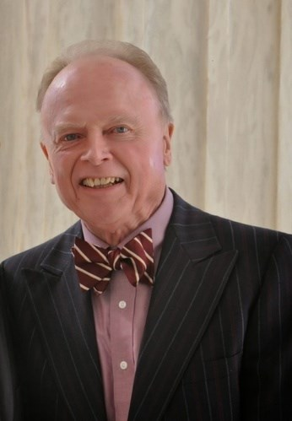Kennewick, Washington - Floyd Edwin Ivey, Jr. was called to Heaven on Friday, August 9, 2024. Floyd was born in Raton, New Mexico on August 17, 1940. He met his wife, Margaret (Peggy) McFarland Ivey, at the University of New Mexico and they were married in 1966. While living in Las Vegas, Nevada he was an electrical engineer at EG&G. They moved to Spokane and he started law school at Gonzaga in 1973. In 1977 they moved to Kennewick where he was a registered patent attorney in private practice, retiring in 2021.  
  
Floyd is survived by his sons Ian (Karen) and Lyle (Angie), and brother Allen (Phyllis), and preceded in death by his wife, Peggy. He was an active member of Bethlehem Lutheran Church in Kennewick, where he served as an elder. He was an active member and a past president of the Pasco-Kennewick Rotary Club. The memorial service will be held at Bethlehem Lutheran Church on Saturday, August 17, 2024, at 10:00 a.m., with fellowship to follow. In lieu of flowers, donations may be made to Bethlehem Lutheran Church at 2505 W. 27th Ave., Kennewick, Washington 99337.