

The Daybreak for the week of Tuesday March 26, 2024
Meet at the Hume at 6:50 to order breakfast.
Role Schedule
Greeter: Peter Chipman Inspirational Message: Lorne Westnedge Toast: Allison Alder

Our speaker on March 26 will be Membership Chair Allison Alder

As the first Rotary Club of Nelson Daybreak member to be appointed as D5080 District Governor, Lorne is involved in a very special journey. He will share some of his experiences at International Assembly 2024 and as a leader at Pacific Northwest President-Elect’s Training (PNWPETS). The International Assembly brought together District Governors Elect from 518 Districts around the world and an amazing cast of speakers.

Volunteers Needed for the Easter Egg Hunt on Saturday March 30
Sheila Hart is so thankful for the 55 club members, Friends of Rotary and Trafalgar Interactors and LVR Interactors who have confirmed that they will help with this major community event.
Put on your Easter Bonnet with all the frills upon it and be at the park by 10:15 to enjoy a raucous Easter Bonnet Parade led by a small contingent from the Nelson Moving Mosaic Samba Band. This joyful group may be enticed to continue their tunes after the parade is over. The Ukuladies will also entertain from 11 am on.
.

International Dinner Proceeds Distributed

Rotary Nelson Daybreak was buoyed by the success of their 2024 International Dinner. In keeping with their goals of supporting Food Security Programs in Nelson, donations are being made to Our Daily Bread, Nelson Community Food Centre, the Salvation Army Food Cupboard and the St. Saviours Anglican Church Food Pantry. Pictured below, Jim Reimer of Our Daily Bread was so appreciative of receiving a cheque from Treasurer John Stegman.
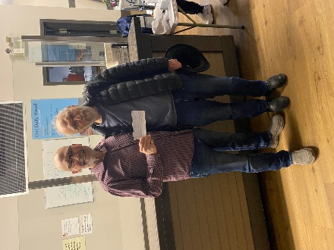
In keeping with the club’s commitment to International Service, Haiti Arise was provided with funds for the salary for a teacher for a year. The club continues to support Rotary’s Polio Plus initiative to eradicate polio worldwide. Few of us knew that a man, who recently died in Texas had lived for 70+ years in an iron lung after contracting polio at age 6.

Club Donates to Kangaroo Mother Care Project
Last September, the club was introduced to the Kangaroo Mother Care Project by Dr. Doug MacMillan.
"Kangaroo mother care involves skin-to-skin care with the mother or with another family member: The father, grandmother, aunts and uncles, and brothers and sisters have all done it," says Doug McMillan, a member of the Rotary Club of Calgary, Alberta, and a neonatologist experienced in global child health. Mothers get support to breastfeed exclusively, and if someone else is helping with the kangaroo care, the baby is fed stored breastmilk.
Since then, multiple studies have shown kangaroo mother care saves newborn lives: It maintains better temperature, improves nutrition and growth, decreases infection, and enhances the bonding between the mother and the baby, explains McMillan, a member of The Rotary Foundation Cadre of Technical Advisers. It has benefits for mothers too, reducing postpartum depression and enhancing their perceived ability to care for their newborns.
Women tailors made 500 kangaroo mother care wraps as part of the project in Mbarara, generating income in the area. The wraps are easier to use and better accepted than the kangas, or pieces of cloth, mothers may have used earlier to carry around their babies, says McMillan, who has been volunteering in Mbarara for over 20 years. Meanwhile, Rotarians were able to secure meals for mothers who needed food, which has improved breastfeeding and reduced the rate of women leaving hospital care early.

Meg Milner, the champion of this project for this club will be exploring opportunities for “hands-on” volunteering in the future.


The last day to register is March 17 and all payments are to be made on-line.
The Spring Assembly is the primary district training event for club and district leaders, and those who want to be in this group. It’s combined with the District Membership Seminar and a Business Meeting where club Presidents-Elect will vote on the district budget for the 2024-2025 Rotary year. A top-notch guest speaker will be coming with a topic that is vital to us all at this time.
The cost for the District Assembly is $35 (USD), which covers lunch cost, and a little more for supplies. It will be an action-packed day.


Coeur d'Alene, Idaho, Thursday, May 2 to Sunday, May 4, 2024.
On May 2, the District Celebration 2024 will be held in beautiful Coeur d’Alene, Idaho and we want you to attend. Why? Because we all could benefit from spending time with fellow Rotarians to network and celebrate all the good we’re doing in our district and beyond. Register before March 14 and be entered to win a free night in the luxurious Hagadone penthouse suite at the Coeur d’Alene Resort https://registrations.dacdb.com/Register/index.cfm?EventID=77708734&NoCaptcha

Our Speaker on March 12 was Bren Beckwith PhD
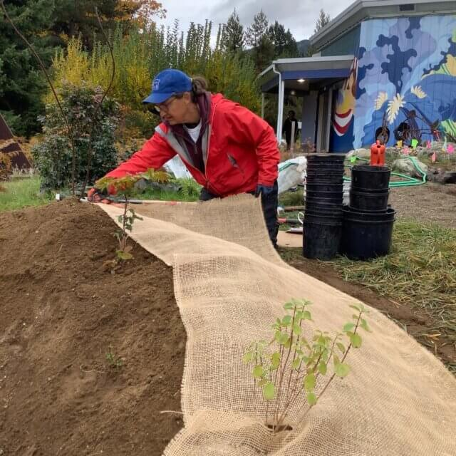

Bren Beckwith PhD pictured above is a Plant Ecologist and Ethnoecologist. Her business is KinSeed Ecologies, a Nelson-based native seed, plant and consulting company. Bren opened our eyes and minds to the value of using native plants in our home garden spaces as well as in several public gardens currently under development. Of note was information about the 16 different species of Bumble Bees that live in the interior of BC. There is at least a dozen rare and climate vulnerable Butterfly species in the West Kootenays. The Kootenay Native Plant Society connects people, plants and place. This is the only Native Plant Society in BC. Their signature program, Pollination Pathway Climate Adaptation Initiative (2021-2025) is working to enhance habitat for native plants and their pollinators in the West Kootenay region. A Butterfly Habitat Interpretive Garden is being developed at Syringa Provincial Park. It is home to over 50 species of native plants that are beneficial to butterflies and other native pollinators.
Native plants are more than just a good idea; adopting them into your life and home spaces can meet sustainability targets, boost local biodiversity, build community, and enhance well-being - for you and many other beings too!
Committees for Rotary year 2024-25 Confirmed to Date at February 9, 2024
President: Sheila Hart
President-Elect for 2025-26: Allison Alder
Past President: Andy Leathwood
Secretary: Sandra England
Treasurer: Ian Comishin
Programs: Chair Sandra England
Club Administration Committee: Chair Dave Simpson
Membership Committee: Chair Allison Alder
PR Committee including Facebook: Sheila Hart, Pat Dooley
Youth Services including Trafalgar School Interact: Chair Marilyn Miller, Ezra Foy, Dave Douglas
Foundation Committee: Chair Peter Chipman
Community Services Committee:
International Services Committee: Chair John Stegman
WaCanId Reps – Dave Simpson and Alan Inkster

Conference Committee for 2025 District Conference. Note: More will be added in the next weeks and months
Co-Chairs: Andy Leathwood and Ainslie Mackie.
Treasurer: Jeanette McCarvell
Program Chair: Allison Alder
Home Hospitality and Home Stay: Sheila Hart and June Nuyens
Co-Masters of Ceremony: Pat Dooley and John Dooley

Future District 5080 Conferences
May 2-5, 2024, at the Coeur d’Alene Resort
May 2-4, 2025, at Selkirk College in Nelson

Future RI Conventions
2024 Singapore – May 25-29
2025- Calgary – June 21-25 Lorne’s DG Year (Calgary conventions are always late in June as earlier dates might be impacted by Stanley Cup play-offs)
2026 – Taipei, Taiwan -June 13-17
2027 – Hawaii – June 5-9

Special Notes for 2024
Saturday March 23 – District Assembly – Spokane Valley Tech.
Saturday March 30 – Easter Egg Hunt
Thursday May 2 – Sunday May 5 – District Conference at the Coeur d’Alene Resort
May 25-29 – Rotary International Convention, Singapore
Friday September 6 & Saturday September 7 – Road Kings Queen City Cruise
Monday September 9 – Cops for Kids Dinner
Sept 11-15 – Rotary Institute in Spokane. This involves 30 Districts.
Sunday September 15-Wednesday September 18 – RFE visit of Australian Team from Adelaide
Saturday September 21 – District Council, Rossland.
Saturday October 5 – Fall Assembly in Spokane; Sunday October 6 – Fall Assembly in Creston
Week of November 5 – World Interact Week

2025 – this is going to be a very busy year
February 20-22, 2025 - PNWPETS
Monday March 17-March 28 – Spring Break 2025
Saturday April 20, 2025 – Easter Egg Hunt
Friday May 2 – Sunday May 4 – District Conference in Nelson
June 21-25 – Rotary International Convention in Calgary



