**The Daybreak for the week of Tuesday April 9, 2024**

**We are meeting at the Hume. Come a few minutes early to order breakfast**

**Role Schedule**

Greeter: Pat Dooley Inspirational Message: Sandra England Toast: Ezra Foy

**Easter Egg Hunt 2024 was a huge success.**

We were blessed….gorgeous weather, at least 790 participants which was a bit more than last year, an exhilarating performance by the Nelson Moving Mosaic Samba Band as they lead the kids to the egg hunt, the captivating Ukaladies who enchanted the busy face painting volunteers and the crafters, the delicious hot dogs and Smokies embellished with braised onions. The biggest pay off was the joy displayed on faces of the participants of all ages. A special word of thanks to co-sponsors, the RDCK and Save-On Foods and many, many friends of Rotary. Let’s plan for next year – Saturday April 19, 2025.

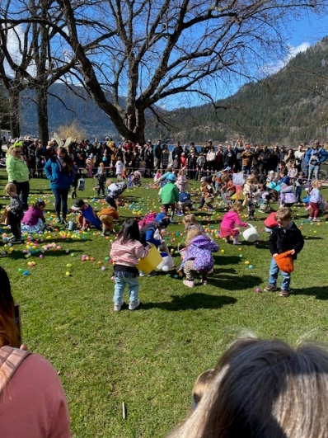 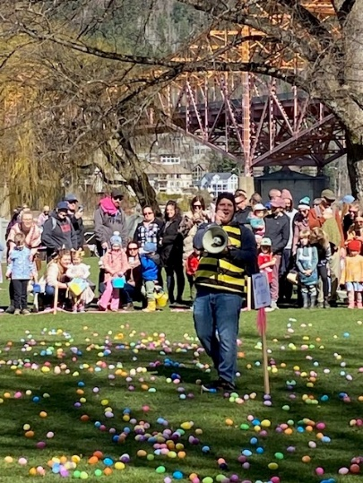 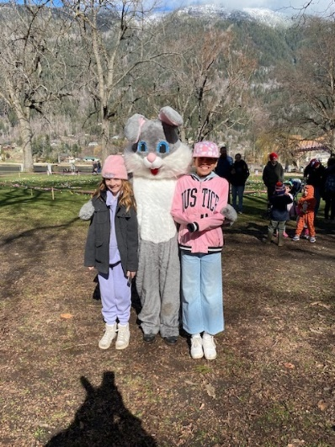

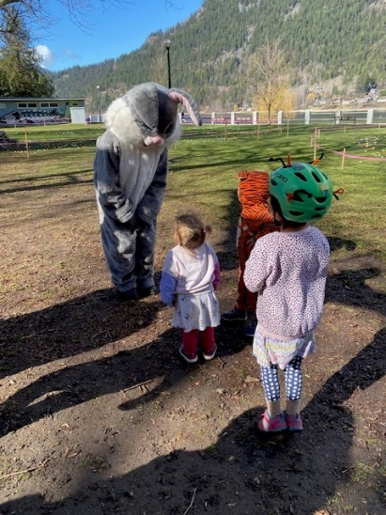 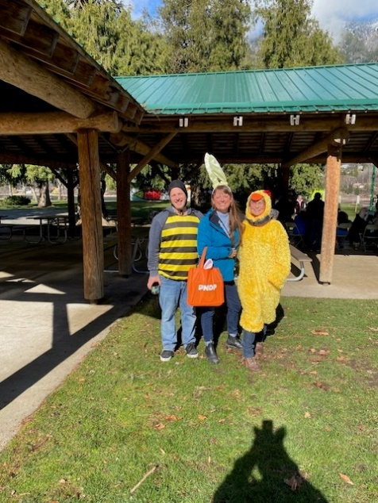 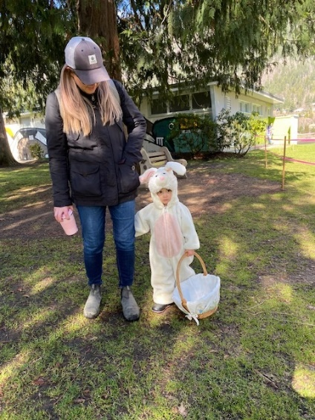

**Food Security Donations**

The Club is so pleased that we can support Food Security Programs in Nelson. On March 28, Alex Hawes (pictured right), the recently appointed Executive Director for the Nelson Food Centre and Norah Nitz from St. Saviours Food Bank (pictured centre) attended our meeting to update us about current food related issues in Nelson. Cheques were presented by President Andy Leathwood.

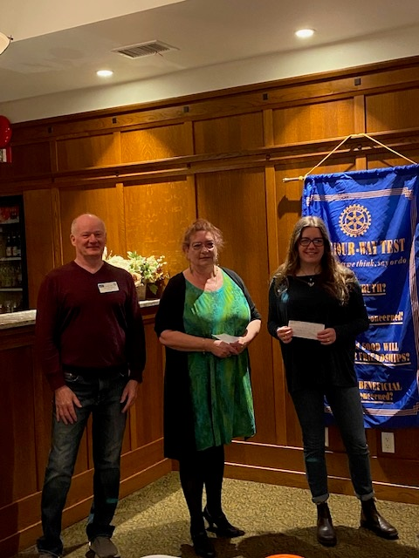

Alex reported that **Nelson Community Food Centre** serves about 500 people by operating Monday-Thursday 9-4. The Good Food Bank Program that operates on Wednesdays from 1-4 has clients that come from all walks of life: seniors, families with young children, people with disabilities, and under-employed who work but are making less than a living wage. There are 50 active volunteers associated with the program. The Centre is proud of their garden program and is searching for additional garden space to use. The Centre offers a Food Skills Program. They have provided opportunities for participants at Selkirk College’s SOAR Program. The Nelson Community Food Centre is a proud partner of Community Food Centers Canada (CFCC), a national non-profit that builds health, belonging, and social justice in communities across Canada through the power of food.

**Norah Nitz of St. Savior’s Food Pantry**, reported that there has been a 20% increase in utilization of the program which has been in existence for 24 years. It is 100% volunteer operated. Clients include people on Old Age Pension, people with disabilities, part time workers. On Fridays a breakfast program is operates from 9-11, which is supported by Save-On Foods, Oso-Negro Coffee, Kootenay Coop and Silver King Tofu.

**Allison Alder was a Membership Workshop Leader on March 26**

Allison is leading members through a process whereby we can better understand the issues that impact membership retention and growth. Members feel significant satisfaction with their experience in Rotary Club of Nelson Daybreak, placing highest values on opportunities for service, global and local impact, fellowship, learning and leadership development. Members perceive barriers for new members include the cost of membership and meals, the commitment of time for club meetings and projects, as well as the perception of Rotary as outdated, poor awareness of Rotary's service focus, and consequential low appeal for a diverse or younger population. The club considered bold ideas for change that would help mitigate these barriers.

The conversation on membership and change will continue at next Tuesday's meeting on Zoom. Come out and help shape Rotary Club of Nelson Daybreak next phase!

In advance, please contribute your thoughts. (thoughts from the meeting will be added)

Follow this link to identify what makes the NDR experience unique: <https://www.menti.com/algh9pkvjtu6>

Follow this link to contribute your BIG ideas: <https://www.menti.com/alxo56zviokf>

**District Assembly Was an Enjoyable Experience for Attendees**

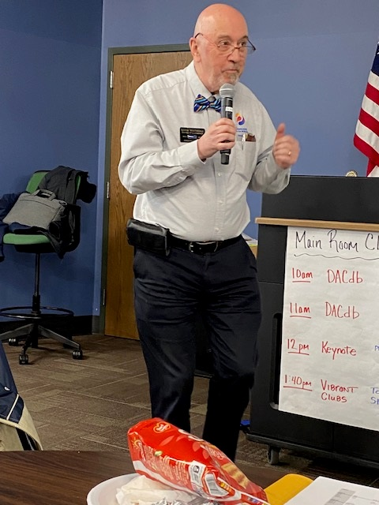

DGE Lorne Westnedge and his team provided an enriching enjoyable experience for over 100 Rotarians who attended District Assembly in Spokane Valley on March 23, 2024. Assistant Governors received training about their roles and responsibilities. Club Secretaries and Treasurers received training in addition to what is available through the Rotary Learning Centre. The sessions about RYLA, Mini-RYLA, Youth Protection were well attended. Sessions on DACdb enticed participants to learn more. Of note is the document entitled District 5080 Social Media Toolkit for Rotary Clubs Seeking to Grow Membership. PE and District Secretary Sheila has copies available. Wendy Lacroix and Marilyn Miller lead the Interact Session. Leadership was inspired by sessions on Building Vibrant and Successful Clubs and Succession Planning. The session about The Rotary Foundation will be followed up by additional sessions in the fall in Spokane and Creston. Keynote Speaker, PDG Michael Caruso from District 5100 inspired the audience to do more Peacebuilding by following the example set by D5100 that has a plethora of Peacebuilder Activities including:

* Identifying and sponsoring Peace Fellow Applicants,
* Sponsoring or hosting Peace Village Camps,
* Participating in “creating friendships for peace” program,
* Planting and dedicating peace poles,
* Supporting peace District and Global Grants,
* Partnering with other clubs in peace projects,
* Offering to serve on a District Peace Subcommittee,
* Supporting a project for the UN Day of Peace.

**Planning is underway for D5080 Conference in Nelson in 2025**.

The next planning meeting is scheduled for April 23 at 3 pm.

**Coeur d'Alene, Idaho, Thursday, May 2 to Sunday, May 4, 2024.**

LAST CALL FOR EARLY REGISTRATION DISCOUNT - Early bird discount for District Conference & Celebration registration ends March 31st.  Room discounts are also locked in

through that date, so  [REGISTER NOW](https://district5080.org/district-5080-conference.php?fbclid=IwAR2NYel7D1gOU-XhhW-9_nOSwDT_VxZhTzcsalHQcyB1cQ4PrSrXq7LX8yE_aem_AWpm1_txn03wezTCfqWmXbEgfi-KHPZSEQtE2NtBcgSc8o6k4B7bS8gXa-dsZM8MqfEua3OAxOgOOTfUNbqwbavW)  
Over 200 have already registered(and of course it's only going to be better if you are there too.)

On May 2, the District Celebration 2024 will be held in beautiful Coeur d’Alene, Idaho and we want ***you***to attend. Why? Because we all could benefit from spending time with fellow Rotarians to network and celebrate all the good we’re doing in our district and beyond. Register before March 14 and be entered to win a free night in the **luxurious Hagadone penthouse suite**at the Coeur d’Alene Resort [**https://registrations.dacdb.com/Register/index.cfm?EventID=77708734&NoCaptcha**](https://registrations.dacdb.com/Register/index.cfm?EventID=77708734&NoCaptcha)  
Check out the short video podcast interview where we discussed some of what to expect at the conference: [Vibe Up Podcast](https://youtu.be/Y3bYmvd9BPk)

**The Conference Committee has shared information about the wonderful array of musicians who will be entertaining at this event.**

GABOR GASZTONYI--POLIO SURVIVOR •  HOMELESSNESS PANEL  •  CHIEF ALLAN--HISTORY & CULTURE OF THE COEUR D’ALENE TRIBE  •  DEEPA WILLINGHAM--FOUNDER OF PACE UNIVERSAL (https://www.paceuniversal.org/)

**FUN EVENTS**:

CHAMBER PARTY • MARGARITAVILLE • CRUISE ON LAKE COEUR D’ALENE  •  GOLFING ON THE COEUR D’ALENE RESORT COURSE  •  MUDGY & MILLIE & CAROUSEL WALKING TOUR  •  WINE & CHEESE TASTING AT COEUR D’ALENE CELLARS  •  ONLINE AUCTION (ALL PROCEEDS TO FUND POLIOPLUS)

**AMAZING ENTERTAINMENT**

YOUTH EXCHANGE TALENT SHOW • COURTNEY & COMPANY • ERIC E.

*SCAN THE QR CODE OR ENTER THE REGISTRATION LINK AND REGISTER FOR THE DISTRICT 5080 CELEBRATION TODAY! (in the read more section)

## ***What time is it?  It's RYLA TIME!***

**RYLA - June 29 - July 6, 2024**  
**Location**:  University of Idaho Campus, Moscow, Idaho.  
**Cost:**  $700 per student, payable at time of application.  
**Who:**  Open to young adults in the age range of 18-25.  
**Who can send:**  Each Rotary Club can send two attendees.  Additional attendees can be placed on a waiting list. (We only accept application through the clubs)  
**Transportation:** Currently, transport is scheduled by the sponsoring Rotary Club.  If you are part of the "Ryla Bus Route", there is a $75 charge to pay for the bus and gas. (Route to be established)  
**Must Haves:**  Canadians must have a passport or documents to enter the US and return to Canada.

**Refer to the email sent by Debi Dockins** on March 28, 2024, for more information and application forms.

**Committees for Rotary year 2024-25 Confirmed to Date at February 9, 2024**

**President:** Sheila Hart

**President-Elect for 2025-26:** Allison Alder

**Past President:**  Andy Leathwood

**Secretary:** Sandra England

**Treasurer:** Ian Comishin

**Programs:** Chair Sandra England

**Club Administration Committee:** Chair Dave Simpson

**Membership Committee:** Chair Allison Alder

**PR Committee including Facebook**: Sheila Hart, Pat Dooley

**Youth Services including Trafalgar School Interact:** ChairMarilyn Miller, Ezra Foy, Dave Douglas

**Foundation Committee**: Chair Peter Chipman

**Community Services Committee:**

**International Services Committee:** Chair John Stegman

**WaCanId Reps** – Dave Simpson and Alan Inkster

**Conference Committee for 2025 District Conference. Note: More will be added in the next weeks and months**

**Co-Chairs:** Andy Leathwood and Ainslie Mackie.

**Treasurer**: Jeanette McCarvell

**Program Chair:** Allison Alder

**Home Hospitality and Home Stay:** Sheila Hart and June Nuyens

**Co-Masters of Ceremony:**  Pat Dooley and John Dooley

**Future District 5080 Conferences**

**May 2-5, 2024, at the Coeur d’Alene Resort**

**May 2-4, 2025, at Selkirk College in Nelson**

**Future RI Conventions  
2024 Singapore – May 25-29  
2025- Calgary – June 21-25 Lorne’s DG Year (Calgary conventions are always late in June as earlier dates might be impacted by Stanley Cup play-offs)**

**2026 – Taipei, Taiwan -June 13-17**

**2027 – Hawaii – June 5-9**

**Special Notes for 2024**

Thursday May 2 – Sunday May 5 – District Conference at the Coeur d’Alene Resort

May 25-29 – Rotary International Convention, Singapore

Friday September 6 & Saturday September 7 – Road Kings Queen City Cruise

Monday September 9 – Cops for Kids Dinner

Sept 11-15 – Rotary Institute in Spokane. This involves 30 Districts.

Sunday September 15-Wednesday September 18 – RFE visit of Australian Team from Adelaide

Saturday September 21 – District Council, Rossland.

Saturday October 5 – Fall Assembly in Spokane; Sunday October 6 – Fall Assembly in Creston

Week of November 5 – World Interact Week

**2025 – this is going to be a very busy year**

February 20-22, 2025 - PNWPETS

Monday March 17-March 28 – Spring Break 2025

Saturday April 20, 2025 – Easter Egg Hunt

Friday May 2 – Sunday May 4 – District Conference in Nelson

June 21-25 – Rotary International Convention in Calgary