**The Daybreak for the week of Tuesday April 16, 2024**

**We are meeting at the Hume.**

**Come a few minutes early to order breakfast.**

**Role Schedule**

Greeter: Pat Dooley Inspirational Message: Margaret Milner Toast: Allison Alder

**Our Speaker this week will be Anjie daSilva of the Salvation Army who will brief us about services and involvement with Disaster Planning.**

**Allison Alder, Calls Upon You to Complete the Membership Survey**

Allison is leading members through a process whereby we can better understand the issues that impact membership retention and growth. Members feel significant satisfaction with their experience in Rotary Club of Nelson Daybreak. A survey document has been forwarded to all club members and Allison requests that you complete it as soon as possible in order that our Membership Recruitment Strategy can be formalized.

**DGE Lorne’s Update…Might You Be Interested in Serving on a District Committee?**

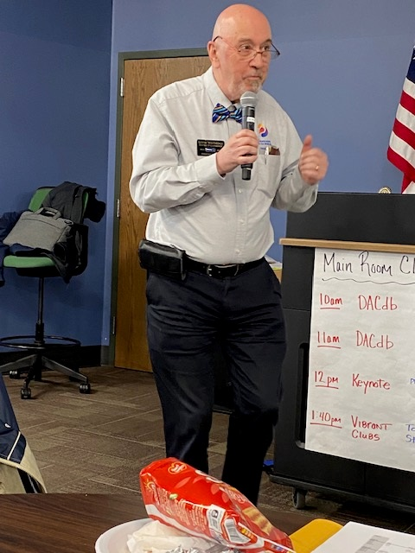

**Planning is underway for D5080 Conference in Nelson in 2025**.

The next planning meeting is scheduled for April 23 at 3 pm at Ian Comishin’s Board Room.

**Coeur d'Alene, Idaho, Thursday, May 2 to Sunday, May 4, 2024.**

Over 200 have already registered(and of course it's only going to be better if you are there too.)

On May 2, the District Celebration 2024 will be held in beautiful Coeur d’Alene, Idaho and we want ***you***to attend. Why? Because we all could benefit from spending time with fellow Rotarians to network and celebrate all the good we’re doing in our district and beyond. [**https://registrations.dacdb.com/Register/index.cfm?EventID=77708734&NoCaptcha**](https://registrations.dacdb.com/Register/index.cfm?EventID=77708734&NoCaptcha)  
Check out the short video podcast interview where we discussed some of what to expect at the conference: [Vibe Up Podcast](https://youtu.be/Y3bYmvd9BPk)

**The Conference Committee has shared information about the wonderful array of musicians who will be entertaining at this event.**

GABOR GASZTONYI--POLIO SURVIVOR • HOMELESSNESS PANEL • CHIEF ALLAN--HISTORY & CULTURE OF THE COEUR D’ALENE TRIBE  •  DEEPA WILLINGHAM--FOUNDER OF PACE UNIVERSAL (https://www.paceuniversal.org/)

**FUN EVENTS**:

CHAMBER PARTY • MARGARITAVILLE • CRUISE ON LAKE COEUR D’ALENE • GOLFING ON THE COEUR D’ALENE RESORT COURSE •  MUDGY & MILLIE & CAROUSEL WALKING TOUR  •  WINE & CHEESE TASTING AT COEUR D’ALENE CELLARS  •  ONLINE AUCTION (ALL PROCEEDS TO FUND POLIOPLUS)

**AMAZING ENTERTAINMENT**

YOUTH EXCHANGE TALENT SHOW • COURTNEY & COMPANY • ERIC E.

*SCAN THE QR CODE OR ENTER THE REGISTRATION LINK AND REGISTER FOR THE DISTRICT 5080 CELEBRATION TODAY! (in the read more section)

## ***What time is it?  It's RYLA TIME!***

**RYLA - June 29 - July 6, 2024**  
**Location**:  University of Idaho Campus, Moscow, Idaho.  
**Cost:**  $700 per student, payable at time of application.  
**Who:**  Open to young adults in the age range of 18-25.  
**Who can send:**  Each Rotary Club can send two attendees.  Additional attendees can be placed on a waiting list. (We only accept application through the clubs)  
**Transportation:** Currently, transport is scheduled by the sponsoring Rotary Club.  If you are part of the "Ryla Bus Route", there is a $75 charge to pay for the bus and gas. (Route to be established)  
**Must Haves:**  Canadians must have a passport or documents to enter the US and return to Canada.

**Refer to the email sent by Debi Dockins** on March 28, 2024, for more information and application forms.

**Rotary Club of Nelson Daybreak Contact: Marilyn Miller**

**Committees for Rotary year 2024-25 Confirmed to Date at February 9, 2024**

**President:** Sheila Hart

**President-Elect for 2025-26:** Allison Alder

**Past President:**  Andy Leathwood

**Secretary:** Sandra England

**Treasurer:** Ian Comishin

**Programs:** Chair Sandra England

**Club Administration Committee:** Chair Dave Simpson

**Membership Committee:** Chair Allison Alder

**PR Committee including Facebook**: Sheila Hart, Pat Dooley

**Youth Services including Trafalgar School Interact:** ChairMarilyn Miller, Ezra Foy, Dave Douglas

**Youth Protection Officer:**  Marilyn Miller

**Foundation Committee**: Chair Peter Chipman

**Community Services Committee:**

**International Services Committee:** Chair John Stegman

**WaCanId Reps** – Dave Simpson and Alan Inkster

**Conference Committee for 2025 District Conference. Note: More will be added in the next weeks and months**

**Co-Chairs:** Andy Leathwood and Ainslie Mackie.

**Treasurer**: Jeanette McCarvell

**Program Chair:** Allison Alder

**Home Hospitality and Home Stay:** Sheila Hart and June Nuyens

**Co-Masters of Ceremony:**  Pat Dooley and John Dooley

**Future District 5080 Conferences**

**May 2-5, 2024, at the Coeur d’Alene Resort**

**May 2-4, 2025, at Selkirk College in Nelson**

**Future RI Conventions  
2024 Singapore – May 25-29  
2025- Calgary – June 21-25 Lorne’s DG Year (Calgary conventions are always late in June as earlier dates might be impacted by Stanley Cup play-offs)**

**2026 – Taipei, Taiwan -June 13-17**

**2027 – Hawaii – June 5-9**

**Special Notes for 2024**

Thursday May 2 – Sunday May 5 – District Conference at the Coeur d’Alene Resort

May 25-29 – Rotary International Convention, Singapore

Friday September 6 & Saturday September 7 – Road Kings Queen City Cruise

Monday September 9 – Cops for Kids Dinner

Monday September 9 – Saturday September 14 – Wacanid Ride

Sept 11-15 – Rotary Institute in Spokane. This involves 30 Districts.

Sunday September 15-Wednesday September 18 – Rotary Friendship Exchange visit of Australian Team from Adelaide

Sept. 19-22 – Waterton-Glacier Peace Park Session at Glacier Park Lodge, East Glacier, Montana

Saturday September 21 – District Council, Rossland.

Saturday October 5 – Fall Assembly in Spokane; Sunday October 6 – Fall Assembly in Creston

Week of November 5 – World Interact Week

**2025 – this is going to be a very busy year**

February 20-22, 2025 - PNWPETS

Monday March 17-March 28 – Spring Break 2025

Saturday April 20, 2025 – Easter Egg Hunt

Friday May 2 – Sunday May 4 – District Conference in Nelson

June 21-25 – Rotary International Convention in Calgary