**The Daybreak for the week of Tuesday May 14, 2024**

**We will meet at the Hume. Please come a few minutes before 7 to order breakfast.**

**Our speaker on May 14 will be Paige Thurston of Living Lakes Canada speaking about Monitoring Water in the Kootenays.**

## ***What time is it?  It's RYLA TIME!***

**RYLA - June 29 - July 6, 2024**

**Location**:  University of Idaho Campus, Moscow, Idaho.  
**Cost:**  $700 per student, payable at time of application.  
**Who:**  Open to young adults in the age range of 18-25.  
**Who can send:**  Each Rotary Club can send two attendees.  Additional attendees can be placed on a waiting list. (We only accept application through the clubs)  
**Transportation:** Currently, transport is scheduled by the sponsoring Rotary Club.  If you are part of the "Ryla Bus Route", there is a $75 charge to pay for the bus and gas. (Route to be established)  
**Must Haves:**  Canadians must have a passport or documents to enter the US and return to Canada.

**Refer to the email sent by Debi Dockins** on March 28, 2024, for more information and application forms.

**Rotary Club of Nelson Daybreak Contact: Marilyn Miller**

**D5080 Conference 2024 Enjoyed by Attendees**

The beautiful Coeur d’Alene Resort was a drawing card for 260 Rotarians and spouses who attended the 2024 D5080 Conference from May 2-5, 2024. Golf at the Coeur d’Alene Golf Course, a luncheon cruise on the lake, Margaritaville at the nearby CDA Rotary Centennial Park and a Peace Pole Dedication Ceremony at the Human Rights Education Institute exposed attendees to more than just the conference centre. RYE students from throughout the District proudly introduced themselves and their countries’ flags. Four enchanted the crowd with a variety of talent performances. The students left the conference and started a week long trip in Washington State and Idaho.

Keynote speakers included PDG Demetress Harrell, the RI Representative, who not only inspired attendees but also reached out on zoom to Rotarians unable to attend the conference. Demetress called on each of us to share the power of our personal Rotary story, develop a passion to grow Rotary, practice building peace and stay engaged in the push to eradicate polio.

PDG Deepa Willingham’s sharing of the statistics regarding the atrocities of human(mostly children) trafficing involving 2 million annually was shocking. Bringing it closer to home, human trafficing in all 50 USA states involves 30,000+ individuals and the Super Bowl is commonly known as the single largest incident in the USA. A pimp can make $150,000-$200,000 each year and the average pimp has 4-6 girls. The grim statistics of human trafficing include 50% of the victims are children of an average age of 12-14 with 80% being female. Deepa has been instrumental of the creation of PACE meaning the Promise of Assurance to Children Everywhere. This dream has become reality with the building of the first Proto-type Service Center in Piyali Junction ( India’s biggest hub for trafficing), to oversee the creation of a sustainable rehab model. From a start in simple rented shacks, the program provides an after school enrichment program, toilet project, self-contained sewage treatment plan and 40 wells.The Health Care Campus now has an Outpatient clinic, health care camps, ambulance and a cervical cancer vaccination camp. By staying in one place PACE has creaated opportunities. Each year a group of American students in International Studies Programs visit the site. The site has just completed addressing Rotary’s seventh area of focus. PACE also has the PLC Interact Club which is the first rural club.

On Saturday evening we enjoyed a delicious banquet, with entertainment.  The District Awards were given out to clubs and individuals, as well as recognition of Major Donors to The Rotary Foundation. Governor Doreen Kelsey was thanked for her leadership, commitment and accomplishments during her year as Governor, and a token gift was given to her by the Governor Line on behalf of District 5080. Doreen was requested to serve as DG when the incumbent could not serve due to family issues. D5080 was blessed by her knowledge, skills and dedication. D5080 definitely benefitted from Doreen’s previous experience as a DG in New Mexico.

At the closing ceremonies, our own Lorne Westnedge received his District Governor pin. What a journey he is on, and it will be even more enriching when he and Dorothy attend RI Convention in Singapore in a few short weeks.

**District Governor Line 2023-2024 LtoR Steve Roberge, DGD of Coeur d’Alene, David Keyes DGN of Sandpoint, Lorne Westnedge DGE of Nelson, Doreen Kelsey, DG of Christina Lake**

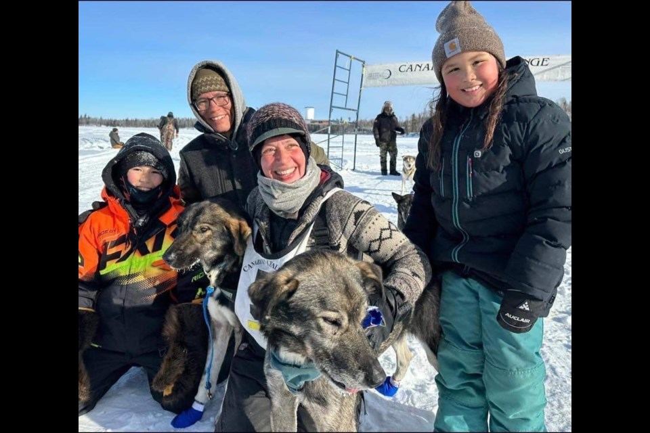

**Dog Sledding 101**

On May 7, we had a very special zoom meeting that introduced us to **On The Land Sled Dogs,** which is a small family-operated kennel located in the boreal forest near Sioux Lookout, Ontario. Their focus is on mid and distance racing, as well as tours and youth programs. The two-legged members of this kennel are the wife-husband team, **Mary England** and **Jesse Terry** and children Tevai and Miali. Jesse Terry is an Anishinabe musher.

**Special Appeal re The Rotary Foundation – as we have had several meetings with no breakfast expenses please consider making your donation to The Rotary Foundation. Here is a special report from Foundation Chair Peter Chipman.**

Our Foundation donations are on track.  For the current fiscal year that ends on June 30th, we have achieved 95% of our $3000 target and just over 70% of members have made a donation this fiscal year.  Our Club’s polio donations are 82% of annual goal of $2000.  Our club will also be contributing some of the International Dinner proceeds to Polio and will easily exceed the target.  If you have not yet donated or would like to donate more, the easiest way is to Donate on-line.  By donating while you are logged into your My.Rotary.org, your contribution will automatically be credited to your account and Nelson Daybreak.

If you would like to see your donation history, please do the following:

1. Log into your my.rotary.org
2. In the top right click on the My Account down arrow and you will see the following – Click “My Donations:

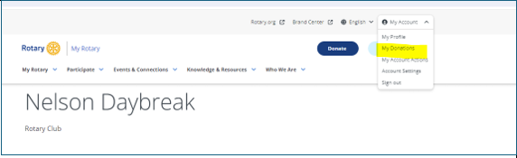

1. Click the “Donor History Report”
2. Under the Individual Report click “Donor History Report”
3. A donor history report will pop up, Look down to the bottom left of the page and you will see a tab called “Overview” that is highlighted and the tab you are currently viewing. A second tab called “Transaction Detail” is dark – click this tab.  This page shows you your contributions by date and designation converted into US$.

Please note: All amounts are reflected in US dollars.  The donations that may be showing up on your account that occur in late June for ~$35 is the club “top up” that we do to make your US dollar total equal your Canadian dollar contribution.

*Peter Chipman*

**Date has been set for our International Dinner 2025**

Mindy at Selkirk College reached out to us to set a date for our International Dinner 2025. It will be **Saturday March 1, 2025.**

**Are You Interested in Being Involved at the District Level?**

DG Doreen Kelsey is passionate about The Rotary Foundation (TRF) and will Chair the D5080 Foundation Committee after July 1. She is currently seeking volunteers for the following positions:

**District Fundraising Sub-Committee Chair and Members** – this committee partners with the Chairs of the Annual Fund, Polio Plus Fund, and Endowment Fund/Major Gifts Sub-Committees in the pursuit of fund development.  
  
**District Scholarship Sub-Committee Chair and Members**  
  
**District Vocational Training Team Sub-Committee Chair and Members -**   
The scholarship and vocational training teams listed above are funded by Rotary Foundation Global Grants.

Contact Doreen Kelsey if you are interested.

**Planning is underway for D5080 Conference in Nelson in 2025**.

The District 2025 Conference will be held at the Prestige Inn, Nelson on May 2,3 2025.

The next planning meeting is scheduled for Wednesday June 18 at 3 pm in Ian Comishin’s Board Room.

**Committees for Rotary year 2024-25 Confirmed to Date at February 9, 2024**

**President:** Sheila Hart

**President-Elect for 2025-26:** Allison Alder

**Past President:**  Andy Leathwood

**Secretary:** Sandra England

**Treasurer:** Ian Comishin

**Programs:** Chair Sandra England

**Club Administration Committee:** Chair Dave Simpson

**Membership Committee:** Chair Allison Alder

**PR Committee including Facebook**: Sheila Hart, Pat Dooley

**Youth Services including Trafalgar School Interact:** ChairMarilyn Miller, Ezra Foy, Dave Douglas

**Youth Protection Officer:**  Marilyn Miller

**Foundation Committee**: Chair Peter Chipman

**Community Services Committee:**

**International Services Committee:** Chair John Stegman

**WaCanId Reps** – Dave Simpson and Alan Inkster

**Conference Committee for 2025 District Conference. Note: More will be added in the next weeks and months**

**Co-Chairs:** Andy Leathwood and Ainslie Mackie.

**Treasurer**: Jeanette McCarvell

**Program Chair:** Allison Alder

**Home Hospitality and Home Stay:** Sheila Hart and June Nuyens

**Co-Masters of Ceremony:**  Pat Dooley and John Dooley

**Future District 5080 Conferences**

**May 2-4, 2025, in Nelson**

**Future RI Conventions  
2024 Singapore – May 25-29  
2025- Calgary – June 21-25 Lorne’s DG Year (Calgary conventions are always late in June as earlier dates might be impacted by Stanley Cup play-offs)**

**2026 – Taipei, Taiwan -June 13-17**

**2027 – Hawaii – June 5-9**

**Special Notes for 2024**

May 25-29 – Rotary International Convention, Singapore

Friday September 6 & Saturday September 7 – Road Kings Queen City Cruise

Monday September 9 – Cops for Kids Dinner

Monday September 9 – Saturday September 14 – Wacanid Ride

Sept 11-15 – Rotary Institute in Spokane. This involves 30 Districts.

Sunday September 15-Wednesday September 18 – Rotary Friendship Exchange visit of Australian Team from Adelaide

Sept. 19-22 – Waterton-Glacier Peace Park Session at Glacier Park Lodge, East Glacier, Montana

Saturday September 21 – District Council, Rossland.

Saturday October 5 – Fall Assembly in Spokane; Sunday October 6 – Fall Assembly in Creston

Week of November 5 – World Interact Week

**2025 – this is going to be a very busy year**

February 20-22, 2025 – PNWPETS

Saturday March 1, 2025 – International Dinner

Monday March 17-March 28 – Spring Break 2025

Saturday April 20, 2025 – Easter Egg Hunt

Friday May 2 – Sunday May 4 – District Conference in Nelson

June 21-25 – Rotary International Convention in Calgary