

The Daybreak for the week of Tuesday May 28, 2024
We will meet at the Hume. Please come before 7 to order breakfast.

Our speaker will be Jamie Moye, Nelson Climbing Centre
Role Schedule:
Greeter: Marilyn Miller
Inspirational Message: Margaret Milner
Toast: John Stegman
Engagement Leader: Andy Leathwood

Meals on Wheels Drivers Urgently Needed for June
As Dave Simpson is leaving town on May 21, he is trying to complete the Meals on Wheels schedule for June. Thanks to members who responded immediately to his call. If you haven’t responded or can do more to fulfill our club’s responsibility for delivering Meals on Wheels in June, please do so as soon as possible.
Remember that by volunteering in this role that you are contributing to the health and well being of seniors and keeping them in their own home.

Planning is Underway to host a Rotary Friendship Exchange Team from Australia
Dave Simpson, RFE Vice Chair is searching for volunteers to host on Sunday September 15 when the team needs to be transported from Creston and home stayed, Monday September 16 for a day trip to Kaslo, Tuesday September 17 when the team will attend our club meeting, meet the Mayor, visit Nelson & enjoy a BBQ at Simpsons. On Wednesday September 18, one couple needs transportation to Cranbrook and the others need to be transported to the airport in Spokane. Please volunteer.

What time is it? It's RYLA TIME!

RYLA - June 29 - July 6, 2024
Location: University of Idaho Campus, Moscow, Idaho.
Cost: $700 per student, payable at time of application.
Who: Open to young adults in the age range of 18-25.
Who can send: Each Rotary Club can send two attendees. Additional attendees can be placed on a waiting list. (We only accept application through the clubs)
Transportation: Currently, transport is scheduled by the sponsoring Rotary Club. If you are part of the "Ryla Bus Route", there is a $75 charge to pay for the bus and gas. (Route to be established)
Must Haves: Canadians must have a passport or documents to enter the US and return to Canada.
Refer to the email sent by Debi Dockins on March 28, 2024, for more information and application forms.
Rotary Club of Nelson Daybreak Contact: Marilyn Miller

Adopt A Highway
Lets make sure that the section of highway that we have adopted is sparkling and clean and will instill in locals and visitors alike that this is a caring community. A work party under the direction of Alan Inkster will take place on Saturday May 25 starting at 8:30 am at Railtown. Vests and pick-up sticks and garbage bags will be provided.
Planning is underway for D5080 Conference in Nelson in 2025.

The District 2025 Conference will be held at the Prestige Inn, Nelson on May 2,3 2025. The next planning meeting has been re- scheduled to Wednesday June 11 at 3 pm in Ian Comishin’s Board.

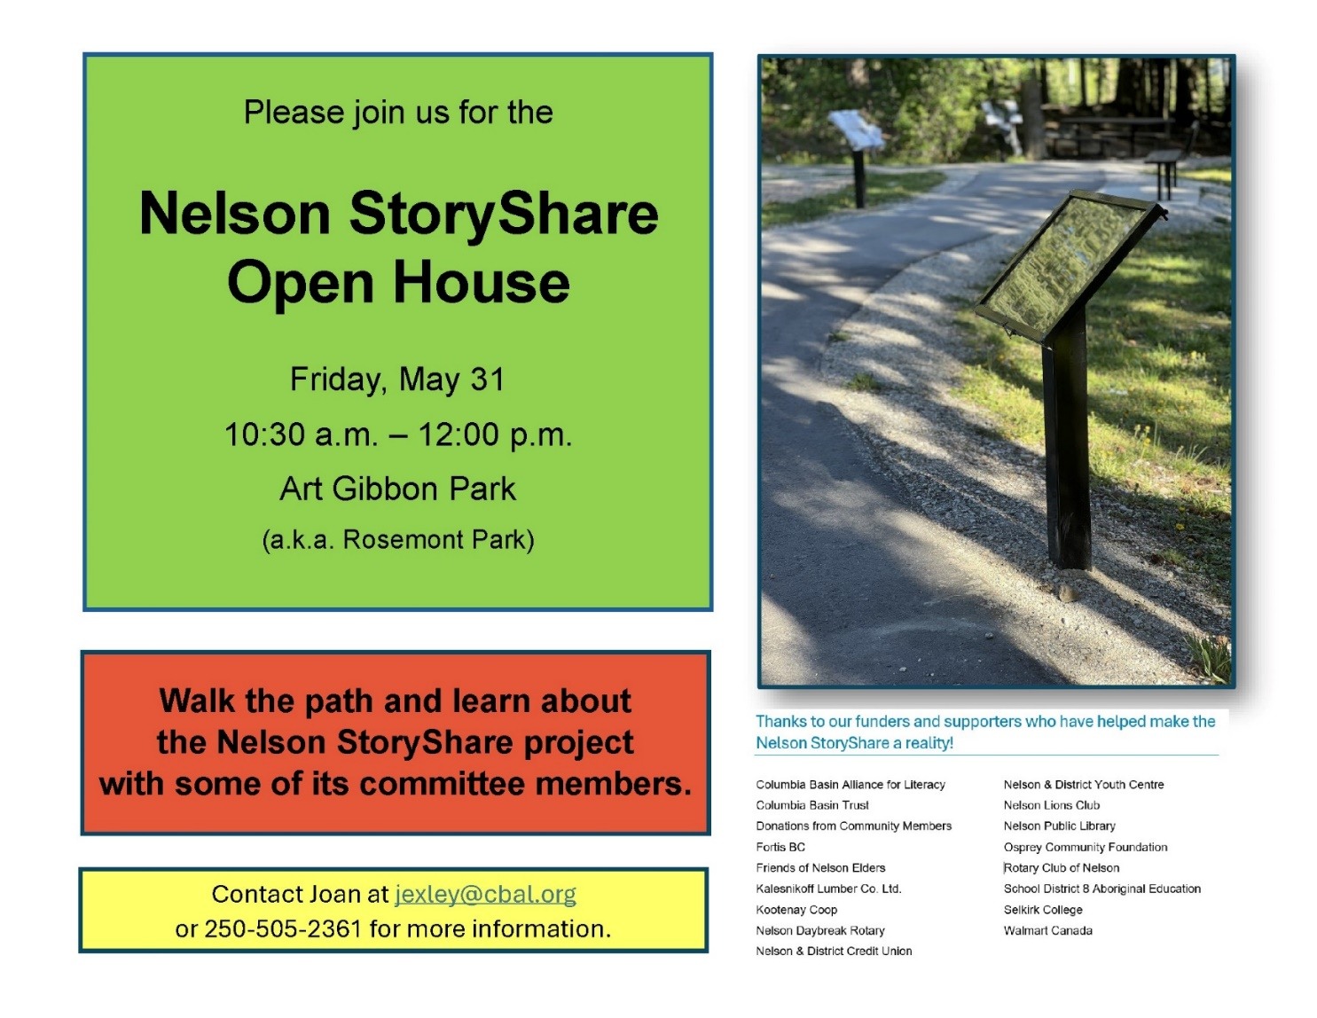
Paige Thurston of Living Lakes Canada

Living Lakes Canada, based in Nelson, is a charitable water stewardship NGO with more than 20 years of experience working with Indigenous and non-Indigenous communities to protect freshwater.
Their science-based programs are aligned with Provincial and Federal monitoring protocols and range from: groundwater, lake, stream and wetland monitoring, to foreshore health assessments, biomonitoring for aquatic assessment and restoration, and water database development and management.
Water monitoring training courses support community-based stewardship efforts across the Canadian Columbia Basin, BC and Canada. Over the decades, Living Lakes has delivered numerous educational programs targeting both youth and adults to promote water literacy and encourage a water conservation ethic. There is strong support for a volunteer program that includes providing volunteers with a free Lake Blitz Monitoring Kit as well as providing virtual training sessions and ongoing support and networking opportunities.
Cottonwood Creek Water Quality Monitoring Program includes sampling throughout the year and include studying of various factors such as conductivity, dissolved oxygen, PH factor, temperature, turbidity, bacteriological and metals and contaminants. Climate impact on lakes is significant including algal blooms, spread of invasive species and rising water temperatures.

A Tribute to John and Nancy Mackay

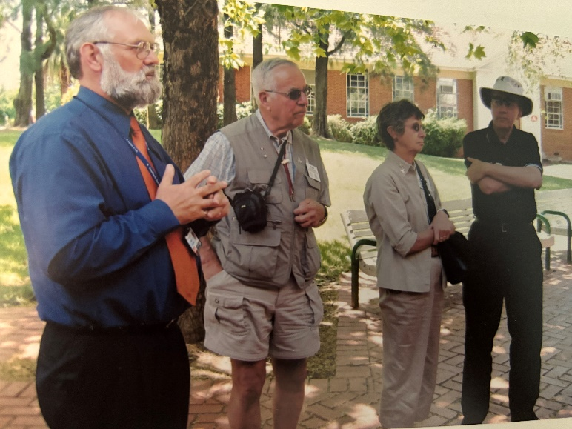

I met John & Nancy over 30 years ago, when I first joined the newly formed Rotary Club of Nelson Daybreak. Dr. John (usually referred to as “Mac”) was a good friend to our new club, though he was a member of the Friday club (Rotary Club of Nelson) and a fairly recent transplant from his former home in Fruitvale, where he had been a member of the Beaver Valley Rotary Club for many years. The North Shore at Longbeach became their home after Mac retired in 1991.

Mac was a wonderful friend and mentor to me. I visited his home on many occasions – usually in larger groups such as Rotary Friendship Exchanges, gatherings of the Second Wind musical group, or a New Year’s Eve celebration, and these would all involve singing, with Mac at the piano, and Nancy making us all feel at home in their home.

We traveled together to District-wide Rotary meetings, on excursions to deliver used hospital equipment to Colville WA (where it was then loaded onto a freight train bound for Mexico) and on a “bucket-list” Rotary Friendship Exchange to New Zealand and Australia in 2005.

Along the way I learned many lessons, including Rotary values, the importance of family and friends, & sharing life’s adventures. However, I never learned to play the harmonica.

Mac left this earth in September of 2020, at the age of 91. Because of the pandemic restrictions at that time, his memorial service was on-line and subdued.

Nancy continued to participate in community, though she struggled with her hearing. She sang with the Second Wind musical group (started by Mac) until just last month. She passed away on May 11, 2024, at the age of 94.

They were well-lived and well-loved. Their memories will continue.

Lorne Westnedge, Rotary District Governor - 2024-2025

Are You Interested in Being Involved at the District Level?
DG Doreen Kelsey is passionate about The Rotary Foundation (TRF) and will Chair the D5080 Foundation Committee after July 1. She is currently seeking volunteers for the following positions:
District Fundraising Sub-Committee Chair and Members – this committee partners with the Chairs of the Annual Fund, Polio Plus Fund, and Endowment Fund/Major Gifts Sub-Committees in the pursuit of fund development.
District Scholarship Sub-Committee Chair and Members
District Vocational Training Team Sub-Committee Chair and Members -
The scholarship and vocational training teams listed above are funded by Rotary Foundation Global Grants.
Contact Doreen Kelsey if you are interested.

Committees for Rotary year 2024-25 Confirmed to Date at February 9, 2024
President: Sheila Hart
President-Elect for 2025-26: Allison Alder
Past President: Andy Leathwood
Secretary: Sandra England
Treasurer: Ian Comishin
Programs: Chair Sandra England
Club Administration Committee: Chair Dave Simpson
Membership Committee: Chair Allison Alder
PR Committee including Facebook: Sheila Hart, Pat Dooley
Youth Services including Trafalgar School Interact: Chair Marilyn Miller, Ezra Foy, Dave Douglas
Youth Protection Officer: Marilyn Miller
Foundation Committee: Chair Peter Chipman
Community Services Committee:
International Services Committee: Chair John Stegman
WaCanId Reps – Dave Simpson and Alan Inkster

Conference Committee for 2025 District Conference. Note: More will be added in the next weeks and months
Co-Chairs: Andy Leathwood and Ainslie Mackie.
Treasurer: Jeanette McCarvell
Program Chair: Allison Alder
Home Hospitality and Home Stay: Sheila Hart and June Nuyens
Co-Masters of Ceremony: Pat Dooley and John Dooley

Future District 5080 Conferences
May 2-4, 2025, in Nelson at the Prestige Lakeside Resort

Future RI Conventions
2024 Singapore – May 25-29
2025- Calgary – June 21-25 Lorne’s DG Year (Calgary conventions are always late in June as earlier dates might be impacted by Stanley Cup play-offs)
2026 – Taipei, Taiwan -June 13-17
2027 – Hawaii – June 5-9

Special Notes for 2024
May 25-29 – Rotary International Convention, Singapore
Friday September 6 & Saturday September 7 – Road Kings Queen City Cruise
Monday September 9 – Cops for Kids Dinner
Monday September 9 – Saturday September 14 – WaCanId Ride
Sept 11-15 – Rotary Institute in Spokane. This involves 30 Districts.
Sunday September 15-Wednesday September 18 – Rotary Friendship Exchange visit of Australian Team from Adelaide
Sept. 19-22 – Waterton-Glacier Peace Park Session at Glacier Park Lodge, East Glacier, Montana
Saturday September 21 – District Council, Rossland.
Saturday October 5 – Fall Assembly in Spokane; Sunday October 6 – Fall Assembly in Creston
Week of November 5 – World Interact Week

2025 – this is going to be a very busy year
February 20-22, 2025 – PNWPETS
Saturday March 1, 2025 – International Dinner at Selkirk College
Monday March 17-March 28 – Spring Break 2025
Saturday April 20, 2025 – Easter Egg Hunt
Friday May 2 – Sunday May 4 – District Conference in Nelson at the Prestige Lakeside Resort
June 21-25 – Rotary International Convention in Calgary

