**The Daybreak for the week of Tuesday June 18, 2024**

**We will meet at the Hume. Please come before 7am to order breakfast.**

**Role Schedule:**

**Greeter:** Peggy Devries

**Inspirational Message:** Patricia Dooley

**Toast:** Sandra England

**Engagement Leader**: Al Inkster

**Our Program will be: Kathi Knapik and the GIE students report on their project in Oaxaca**

**Adopt A Highway**

A successful work party, under the direction of Alan Inkster, cleared our designated area in an hour and a half on Saturday June 1. Members find that with a regular clean-up that there is much less debris than when we started assisting with Adopt A Highway.

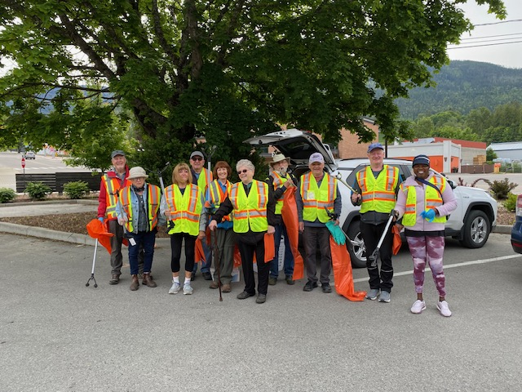

*L to R: Eric Marks, Frances Gehr, Pat Dooley, John Bargh, Marilyn Miller, Sheila Hart, John Stegman, Alan Inkster, Andy Leathwood, Puleng Pratt*

**Meals on Wheels Drivers for June**

.

**Planning is underway for D5080 Conference in Nelson in 2025**.

The District 2025 Conference will be held at the Prestige Inn, Nelson on May 2,3 2025. The next planning meeting has been re- scheduled to **Wednesday June 11 at 3 pm** in Ian Comishin’s Board Room.

**Planning is Underway to host a Rotary Friendship Exchange Team from Australia**

Dave Simpson, RFE Vice Chair is searching for volunteers to host on Sunday September 15 when the team needs to be transported from Creston and home stayed, Monday September 16 for a day trip to Kaslo, Tuesday September 17 when the team will attend our club meeting, meet the Mayor, visit Nelson & enjoy a BBQ at Simpsons. On Wednesday September 18, one couple needs transportation to Cranbrook and the others need to be transported to the airport in Spokane. Please volunteer.

Please remember that Outbound Team Members are appointed based on the “credit” they have for involvement with Rotary and Rotary Friendship Exchange related events. Think about hosting. The RFE Committee is considering a number of future exchanges.

**Interactors On a Mission to Raise Funds for Shelterbox**

Members of the LVR Interact Club and Trafalgar Interact Club joined forces at the Saturday Market on May 1, to raise funds to purchase a Shelterbox. Additional fund-raising activities will be required. ShelterBox is currently responding to the flooding situation in Malawi, providing emergency shelter and other essential items for up to 1.9 million people left with nowhere to live in Gaza, supporting those who have fled to Chad as a result of escalating conflict in Sudan.

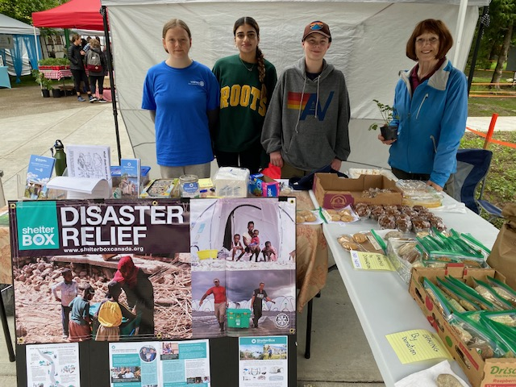

*LtoR Alya Kiphi & Noor Kaur of LVR Interact, Jake Smith, VP of Trafalgar Interact, Marilyn Miller Interact Club Advisor for Rotary Club of Nelson Daybreak*

**Columbia Basin Alliance for Literacy (CBAL) Sponsors Nelson StoryShare at Art Gibbon Rosemont Park**

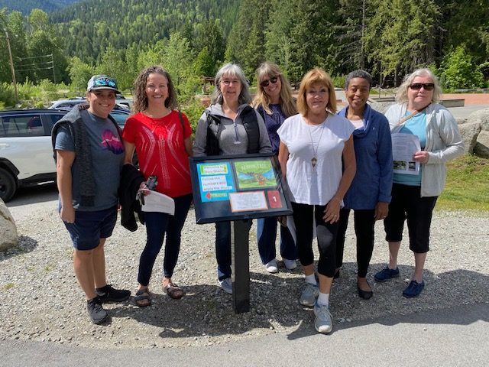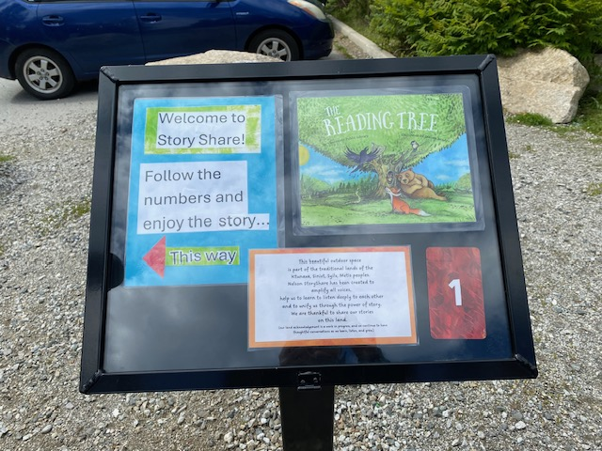

*L to R: Paulina Mason, event visitor, Joan Exley, Bryar Radonich-Camp, Pat Dooley, Kay Coburn, Meg Milner*

Nelson’s **StoryShare** is creating a permanent StoryWalk in Art Gibbon Rosemont Park. It will extend beyond children’s books to include broad context such as indigenous story, youth photography, biographies of elders written by children, Nelson history etc. Content will be curated by the StoryShare Committee. Eighteen display boards have been made and are being installed by the City of Nelson. A friendly group of volunteers and CBAL staff enjoyed a “soft” opening of the project on June 1. The Grand Opening will be held on Friday September 13 from 10:30-12. For more information contact Joan Exley of CBAL at [jexley@cbal.org](mailto:jexley@cbal.org) Both Nelson Rotary Clubs donated to this project along with 13 other organizations and individual donors. This has been a work in progress since at least 2021 when the City of Nelson gave its consent to provide assistance.

**More Trafalgar Interact Club Activity –**

Bake sale at Trafalgar School raised money for cancer research. They are now on a roll!

**Jamie Moye, Nelson Climbing Centre**

Jamie Moye spoke to the club about plans to build a Cube 2 Climbing Centre in Nelson. Based on 16,389 individual visits in the last year to the Cube 1 Climbing Center at Selkirk College, it is felt that Nelson can support a stand-alone center. In 2024 climbing will be included as an Olympic sport. This will be the first Olympic standard climbing centre in BC. Columbia Basin Trust has committed $60,000 to this project and fundraising for half a million dollars has commenced. The City of Nelson has approved use of their land near Selkirk College for the center. The intention is to use Mass Timber wood products. Stay tuned for more updates….

**Committees for Rotary year 2024-25 Confirmed to Date at February 9, 2024**

**President:** Sheila Hart

**President-Elect for 2025-26:** Allison Alder

**Past President:**  Andy Leathwood

**Secretary:** Sandra England

**Treasurer:** Ian Comishin

**Programs:** Chair Sandra England

**Club Administration Committee:** Chair Dave Simpson

**Membership Committee:** Chair Allison Alder

**PR Committee including Facebook**: Sheila Hart, Pat Dooley

**Youth Services including Trafalgar School Interact:** ChairMarilyn Miller, Ezra Foy, Dave Douglas

**Youth Protection Officer:**  Marilyn Miller

**Foundation Committee**: Chair Peter Chipman

**Community Services Committee:**

**International Services Committee:** Chair John Stegman

**WaCanId Reps** – Dave Simpson and Alan Inkster

**Conference Committee for 2025 District Conference. Note: More will be added in the next weeks and months**

**Co-Chairs:** Andy Leathwood and Ainslie Mackie.

**Treasurer**: Jeanette McCarvell

**Program Chair:** Allison Alder

**Home Hospitality and Home Stay:** Sheila Hart and June Nuyens

**Co-Masters of Ceremony:**  Pat Dooley and John Dooley

**Future District 5080 Conferences**

**May 2-4, 2025, in Nelson at the Prestige Lakeside Resort**

**Future RI Conventions  
2025- Calgary – June 21-25 Lorne’s DG Year (Calgary conventions are always late in June as earlier dates might be impacted by Stanley Cup play-offs)**

**2026 – Taipei, Taiwan -June 13-17**

**2027 – Hawaii – June 5-9**

**Special Notes for 2024**

Friday September 6 & Saturday September 7 – Road Kings Queen City Cruise

Monday September 9 – Cops for Kids Dinner

Monday September 9 – Saturday September 14 – WaCanId Ride

Sept 11-15 – Rotary Institute in Spokane. This involves 30 Districts.

Sunday September 15-Wednesday September 18 – Rotary Friendship Exchange visit of Australian Team from Adelaide

Sept. 19-22 – Waterton-Glacier Peace Park Session at Glacier Park Lodge, East Glacier, Montana

Saturday September 21 – District Council, Rossland.

Saturday October 5 – Fall Assembly in Spokane; Sunday October 6 – Fall Assembly in Creston

Week of November 5 – World Interact Week

**2025 – this is going to be a very busy year**

February 20-22, 2025 – PNWPETS

Saturday March 1, 2025 – International Dinner at Selkirk College

Monday March 17-March 28 – Spring Break 2025

Saturday April 20, 2025 – Easter Egg Hunt

Friday May 2 – Sunday May 4 – District Conference in Nelson at the Prestige Lakeside Resort

June 21-25 – Rotary International Convention in Calgary