The Daybreak for the week of Tuesday August 6, 2024

We will meet on zoom at 7 am.

Our Speaker on August 6 will be Maria Kliavkoff, President of the Waterton Glacier Peace Park Association who will do a presentation about the Waterton-Glacier International Peace Park

**Information About Forthcoming Meeting Schedules**

Please refer to the Meeting Schedule Information Sheet circulated with the last Daybreak.

**Rotary Friendship Exchange Team from Australia**

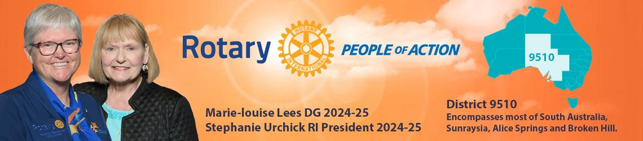

Dave Simpson, RFE Vice-Chair, circulated the proposed schedule of activities for the Team from D9510 in Australia. Of note, is the change in the club’s meeting date to Monday September 16 at the Hume. This will be a buffet breakfast. The Aussies will do a presentation about their District. Come and enjoy. Please confirm your attendance with Dave by **September 1**.

In addition, Dave and Wendy Simpson are opening their beautiful lakefront property for a Potluck Dinner on Tuesday September 17 starting at 4 pm. All club members and their spouses are invited to attend. Please let Dave know by **September 1** if you will attend. Note: This event is earlier than usual, but the team must leave Nelson very early the next day.

**We Are Good to Go at Road Kings Queen City Cruise**

**Road Kings is sponsoring a 50/50 draw and Sheila has a book of tickets to sell to members. If you would like additional tickets, they can be made available. Tickets are selling for $10 each. Marcello hopes that all tickets can be sold prior to Road Kings Queen City Cruise.**

**Zone 26/27 Institute in Spokane – September 11-14, 2024**

Fees are now $925. Register at [Zones 26 & 27 Rotary Institute | (zoneinstitute.org)](https://www.zoneinstitute.org/)

**Membership Recruitment**

Thank you to Allison Alder who has created a membership recruitment post- card for members to use to introduce prospective members to the club. A supply of these will be available at our meetings.

**D5080 Conference in Nelson in 2025**.

The District 2025 Conference will be held at the Prestige Inn, Nelson on May 2&3 2025. The next planning meeting has been scheduled for **Tuesday August 27** at 3 pm at the Verecan Board Room, 514 Nelson Avenue.

**Plan to attend the Rotary International Convention in Calgary**



Registration is now open for RICON Calgary. It is anticipated that over 23,000 Rotarians will attend this event, so don’t delay in getting organized to attend. Hotels etc. can be booked through RI Housing. The official program will not be released until closer to the event. Visit the website to learn more and register.

**July 30, 2024, Social at Rosemont Park**

Nine club members attended the morning social at Art Gibbon Rosemont Park and enjoyed the Skateboard presentation by Ian Comishin and his introduction to Disc Golf. Ian built the first Disc Golf course in Kimberly many years ago.

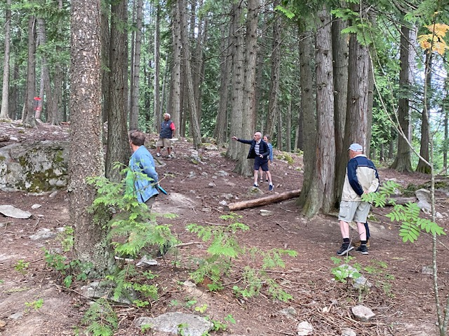

*Marilyn Miller, DG Lorne Westnedge, Dave Douglas, Ian Comishin, Dave Simpson, John Bargh, Peggy Devries, Sandra England and photographer Sheila Hart enjoyed the social in the cool of the morning.*

Sandra England led the group to an area that could be used as a memorial garden recognizing Art Gibbon using Native plants. The group discussed proposing a three-stage plan with the first phase close to the handsome fish shaped sign with the name of the park and the Rotary logo. Ian’s firm, Twente Additive Manufacturing Inc. was instrumental in creating this cherished masterpiece.

There were also concerns expressed about gravel abutting the asphalt walkways that poses a safety hazard. The ongoing issue of graffiti is of great concern. The “grassed areas” are of very poor quality and indeed are built on crumbled asphalt. The slide access needs to be reviewed and a more attractive and safer design sought. These concerns will be brought to the Board’s attention and hopefully addressed at a meeting with the City Works Department. Members were enchanted by a group of youngsters who arrived with scooters for an NDCC Day Camp session.

**Special Request for Microscopes**

Marc Honorat of Haiti Arise has requested assistance in finding microscopes. As you know equipment in health care facilities and educational facilities is routinely replaced as new products come on the market. If you know someone who might know about equipment being replaced and have access to recycling it through Haiti Arise, it would be greatly appreciated. Please contact Sheila Hart.

*A bit of club history – one of the first International Service projects that our club did was to transport dozens of beds to Colville for shipment to Mexico. The project was called Pipeline to Mexico. The beds were being replaced at Kootenay Lake Hospital so we took advantage of retrieving them before they were taken to the dump.*

**Committees for Rotary year 2024-25 Confirmed to Date at July 1, 2024**

**President:** Sheila Hart

**President-Elect for 2025-26:** Allison Alder

**Past President:**  Andy Leathwood

**Secretary:** Sandra England

**Treasurer:** Ian Comishin

**Programs:** Chair Sandra England

**Club Administration Committee:** Chair Dave Simpson

**Membership Committee:** Chair Allison Alder

**PR Committee including Facebook**: Sheila Hart, Pat Dooley

**Youth Services including Trafalgar School Interact:** ChairMarilyn Miller, Ezra Foy, Dave Douglas

**Youth Protection Officer:**  Marilyn Miller

**Foundation Committee**: Chair Peter Chipman

**Community Services Committee:**

**International Services Committee:** Chair John Stegman

**WaCanId Reps** – Dave Simpson and Alan Inkster

**Conference Committee for 2025 District Conference. Note: More will be added in the next weeks and months**

**Co-Chairs:** Andy Leathwood and Ainslie Mackie.

**Treasurer**: Jeanette McCarvell

**Program Chair:** Allison Alder

**Home Hospitality and Home Stay:** Sheila Hart and June Nuyens

**Co-Masters of Ceremony:**  Pat Dooley and John Dooley

**Registration:** Kees van der Pol

**Merchandise:**  Dave Simpson

**Outdoor Activities**: Ian Comishin

**Logo:** Jen Cowan

**Peace Pole**: Tom Schneider

**Memorial Service:** PDG Doreen Kelsey and Maria Kliavkoff

**Facilities Space:**  John Ferguson

**Chief of Staff:** Peggy Devries

**Future District 5080 Conferences**

**May 2-4, 2025, in Nelson at the Prestige Lakeside Resort**

**Future RI Conventions  
2025- Calgary – June 21-25 Lorne’s DG Year (Calgary conventions are always late in June as earlier dates might be impacted by Stanley Cup play-offs)**

**2026 – Taipei, Taiwan -June 13-17**

**2027 – Hawaii – June 5-9**

**Special Notes for 2024**

Friday September 6 & Saturday September 7 – Road Kings Queen City Cruise

Monday September 9 – Cops for Kids Dinner

Monday September 9 – Saturday September 14 – WaCanId Ride

Sept 11-15 – Rotary Institute in Spokane. This involves 30 Districts.

Sunday September 15-Wednesday September 18 – Rotary Friendship Exchange visit of Australian Team from Adelaide

Sept. 19-22 – Waterton-Glacier Peace Park Session at Glacier Park Lodge, East Glacier, Montana

Saturday October 5 – District Council, Rossland.

Saturday October 19 – Fall Assembly in Spokane; Sunday October 20 – Fall Assembly in Creston

Week of November 5 – World Interact Week

**2025 – this is going to be a very busy year**

February 20-22, 2025 – PNWPETS for President-Elect Allison Alder

Saturday March 1, 2025 – International Dinner at Selkirk College

Monday March 17-March 28 – Spring Break 2025

Saturday April 20, 2025 – Easter Egg Hunt

Friday May 2 – Sunday May 4 – District Conference in Nelson at the Prestige Lakeside Resort

June 21-25 – Rotary International Convention in Calgary