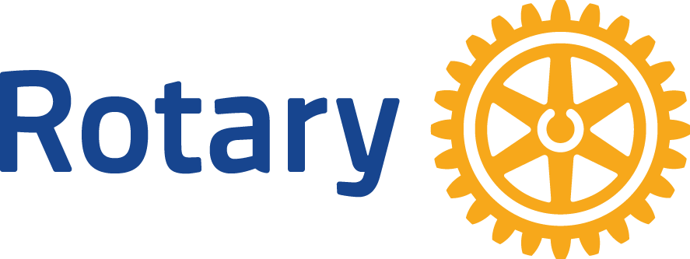

Klamath basin sunrise rotary

Greetings!

The Klamath Basin Sunrise Rotary Club is holding our **21thAnnual** Brats, Brews, & Blues Festival on **August 13th, 2022!** Sunrise Rotary is part of Rotary International, a service organization whose stated human rights purpose is to bring together business and professional leaders in order to provide humanitarian services, encourage high ethical standards in all vocations, and to advance goodwill and peace around the world.

Locally, we were chartered in 1997 and our mission is to serve the Klamath Community in order to improve the lives of our “neighbors”. Our commitment to youth is because we believe if a child’s life is improved now, they will be better citizens in our community in the future.

Our signature event features an impressive silent auction and we would like to request your partnership to raise funds for Camp Evergreen, a bereavement camp for youth who have lost a loved one. Camp Evergreen is hosted each year by Klamath Hospice (**http://www.klamathhospice.org**) and is funded solely by donations. There is no cost to children or their families to attend the camp. We also support several other local programs including the Oregon Tech Dental Hygiene grade school outreach program.



Our hope is to obtain a donated item or service from you by July 23th, 2022 in order to raise as much funding as possible for local youth to attend Camp Evergreen.

With our event being late in the summer, could you make any gift certificates good for 12 months?

We appreciate your dedication and compassion toward Klamath Basin youth.

Please submit donations using the enclosed SASE or contact us via our web page **http://www.klamathsunriserotary.org**

Thank you for your support!

Klamath Basin Sunrise Rotary