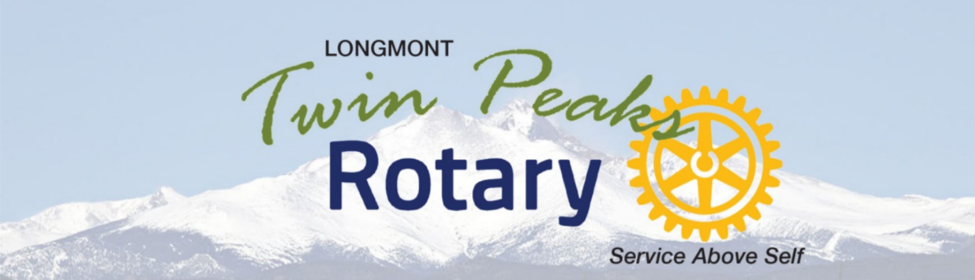

CLUB AWARDS 2024

LeMoyne Monson Award
Given to a Club member who exemplifies “service above self” to Twin Peaks Rotary beyond the normal Rotarian.

2024 Jeanne Dworak

Larry Nelson Award
Given to a Club member who exemplifies both Rotary Club service and Community service.

2024 Chris Treharne

New Member Award
Given to a new member of the Club by the President- but nominations are welcome.

2024 Emily Bauer

4 Way Test Award
Given to anyone, inside or outside the Club, who exemplifies the strands of the Four Way Test.
Is it the truth? Is it fair to all concerned? Will it build goodwill and better friendships? Will it be beneficial to all?

2024 Larry Gearing

