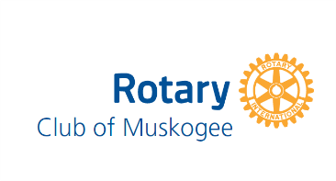
Muskogee Rotary Board Minutes
July 25,2024 12:31 PM OMHOF

In Attendance -Rich Schaus, Kim Jaquez, Wayne Buck, Melissa Nissley, Martin Updike, Daniel Miller, Nycky Miller, Ed Choate, Tom Turner
Not in Attendance: Kim Williams
Agenda Item | Discussion and decisions | Action Items
Item #2 - Approval of Meeting Minutes | Daniel Miller made a motion to approve minutes from April 2024 Meeting Kim Jaquez seconded. Motion passed unanimously
Item # 3 - Approval of financial Report | Wayne Buck made a motion to approve financials. Daniel Miller seconded. Motion passed unanimously.
Item # 4- Committee Reports | Sep 23 Golf Tournament  Oct 17:District Governor Visit  Oct 17-20 RYLA  Dictionary Oct/Nov  Oct 24 Name that Tune  April 26 Party in the Park | Discussed Community Blood Drive
Old Business | - Benevolence Fund | Kim Williams is working on it
New Business | - Daniel Miller made a motion to remove Allan Copeland/Melissa Williams from our Rotary Roles. Kim Jaquez seconded. Motion approve unanimously  - Location of 2025 Rotary Meetings. Considered several options. Ed Choate made a motion to table discussion to future meeting after research. Kim Jaquez seconded. Motion passed unanimously .  - Discussed budget: Melissa will adjust based on conversation and resubmit next month. Ed Choate made a motion to table and Tom Turner seconded. Motion passed unanimously  - Discussed Historian chairperson. Considered Dave Davis. If he says no Daniel Miller will take the role.  - Discussed social media chairperson. Melissa will check with Nina King if she says no Nycky Miller will take on the role. | Melissa will rework budget and resubmit next year.
No further business addressed.  Meeting was adjourned at 1:12 pm |  | Next Meeting: August 15,2024 1pm OMHOF

