District Governor, Roger Utnehmer (Oot-name-er)



# District 6220 District Governor Club Visit Information

|  |  |  |  |  |  |
| --- | --- | --- | --- | --- | --- |
| **CLUB** | **DATE** | **CLUB** | **DATE** | **CLUB** | **DATE** |
| *Merrill Club Visit* | *6/18/2024* | *GPC (Stevens Point) Club Visit* | *8/16/2024* | *New London Club Visit* | *9/30/2024* |
| *Antigo Club Visit* | *6/25/2024* | *Waupaca Club Visit* | *8/21/2024* | *Ishpeming Club Visit* | *10/1/2024* |
| *Appleton Club Visit* | *7/9/2024* | *Kewaunee Club Visit* | *8/22/2024* | *Munising Club Visit* | *10/1/2024* |
| *Minocqua/Lakeland Area Breakfast Club Visit* | *7/10/2024* | *Marinette-Menomonee Club Visit* | *8/27/2024* | *Ironwood, MI-Hurley Club Visit* | *10/2/2024* |
| *Appleton Breakfast Club Visit* | *7/11/2024* | *Lakeland (Minocqua) Club Visit* | *9/5/2024* | *Wakefield-Bessemer Club Visit* | *10/3/2024* |
| *Clintonville Club Visit* | *7/15/2024* | *Iron Mountain-Kingsford Club Visit* | *9/10/2024* | *Rhinelander Club Visit* | *10/7/2024* |
| *Eagle River Club Visit* | *7/25/2024* | *Calumet-Laurium-Keweenaw Club Visit* | *9/11/2024* | *Packerland Sunrise Club Visit* | *10/9/2024* |
| *Manistique Club Visit* | *7/30/2024* | *Houghton/Hancock Club Visit* | *9/11/2024* | *Door County North (Baileys Harbor) Club Visit* | *11/6/2024* |
| *Marquette (Breakfast) Club Visit* | *7/31/2024* | *Green Bay Club Visit* | *9/16/2024* | *Park Falls Satellite Club Visit* | *TBD* |
| *Marquette Club Visit* | *7/31/2024* | *Sturgeon Bay Breakfast Club Visit* | *9/17/2024* | *Wausau After Hours Club Visit* | *1/8/2025* |
| *Marquette West Club Visit* | *7/31/2024* | *Green Bay West Club Visit* | *9/18/2024* | *Wausau Early Birds Club Visit* | *1/8/2025* |
| *DePere Club Visit* | *8/5/2024* | *Shawano Club Visit* | *9/23/2024* | *Sturgeon Bay Club Visit* | *1/9/2025* |
| *Escanaba Club Visit* | *8/6/2024* | *Stevens Point Club Visit* | *9/25/2024* |  |  |

# **Why I’m a Rotarian**

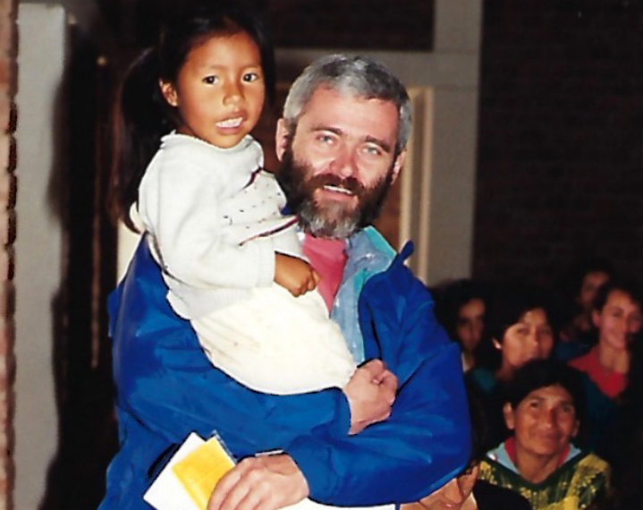

# **Rotary International 7 Area of Focus Every Rotarian Every Year**

<https://my-cms.rotary.org/en/document/rotarys-areas-focus> <https://my-cms.rotary.org/en/document/every-rotarian-every-year-brochure>

# **Paul Harris Society Paul Harris Fellow**

<https://rotary.qualtrics.com/jfe/form/SV_eCYMZ3u8qeCZALb> <https://my-cms.rotary.org/en/document/paul-harris-fellow-recognition-transfer-request-form>

# **Endowment Commitment Form RYLA**

<https://my-cms.rotary.org/en/document/every-rotarian-every-year-brochure> [https://www.dacdb.com/Rotary/Accounts/6220/Downloa ds/0/RYLA PROMO for potential participants.pdf](https://www.dacdb.com/Rotary/Accounts/6220/Downloa%20%20%20ds/0/RYLA%20PROMO%20for%20potential%20participants.pdf)

<https://www.youtube.com/watch?v=S9z9PrAZ_Nw>

# **Cultural Appreciation Initiative: Land Acknowledgement Statement**

*Today we are meeting on lands formerly occupied by Indigenous peoples, many of whom were forced to leave generations ago.*

*Rotary International recognizes the historical and ongoing impact the colonization on Indigenous communities.*

*We pay respect for our First Nation elders, past, present and future.*

*We express our respect and gratitude to all First Nation people for preserving and protecting the lands on which Rotarians meet*