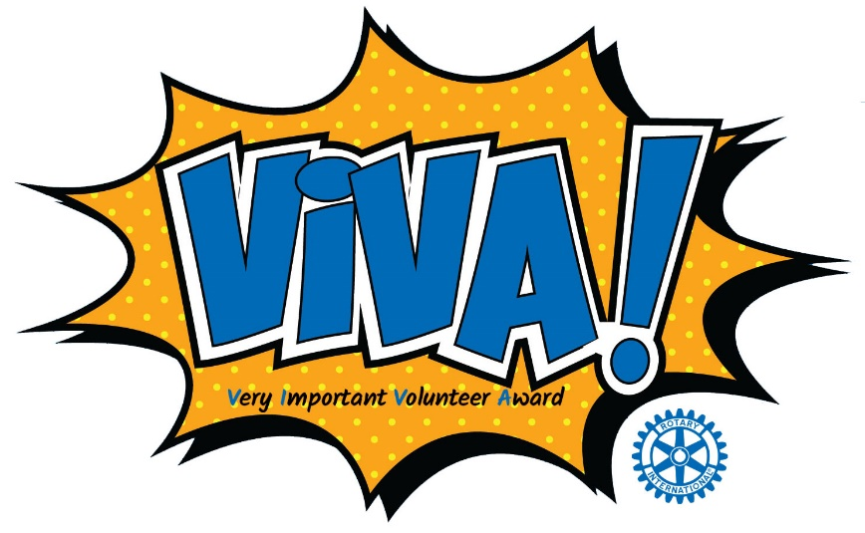

**Tuesday, April 15, 2025,**

**Doors open at 11:30 a.m.   
Horizon Convention Center Muncie, Indiana**

# Your Chance to Nominate a Very Important Volunteer

The V!VA (***V***ery ***I***mportant ***V***olunteer ***A***ward) Awards were developed as a gift to the community in 1993 by the Muncie Noon Rotary Club and are now held in conjunction with the Muncie Sunrise Rotary Club to recognize Delaware County’s proud volunteer heritage.

Up to four individuals and one organization will be recognized with V!VA Awards for their volunteer efforts to the community within the past 12 months. In addition, The Edmund F. Ball Lifetime Achievement Award will be given for outstanding long-term, lifetime volunteer commitment. Each V!VA Award Recipient will receive a plaque.

# Eligibility

1. Nominees must live or work in Delaware County; or the impact of his/her volunteer service must be felt in Delaware County. The same parameters apply to organizational nominees.
2. Nominees must provide the volunteer service without expectation of financial remuneration, although reimbursement of expenses will not disqualify a nominee. Nomination of student volunteers is encouraged.
3. Except for the Lifetime Achievement Award, all individual and organizational nominees must have rendered volunteer services within the last 12 months (no carryover from years previous). Any lifetime achievement award nominations not selected as winners will be carried over for 3 years.
4. Nomination forms for the V!VA Award must be typed.

# To Nominate a Volunteer

1. This should include names of organizations and/or individuals that benefitted from the nominee’s volunteering and the capacity of the volunteer’s efforts. Using specific examples of volunteer service, demonstrate the nominee’s commitment to volunteer activities within the last year or lifetime, depending on category selected.
2. Why is the nominee worthy of this special recognition beyond other equally qualified volunteers?
3. What type of impact did the nominee have on individuals and/or organizations within the last year?
4. How would those individuals and/or organizations have been impacted had the nominee not provided dedicated leadership?

(You may attach up to 5 additional pages of appropriate materials)

# *Nominations must be received by March 1, 2025.

# Submissions can be emailed (preferred), mailed, or delivered to:

V!VA AWARDS

Joann McKinney

C/O Rotary Club of Muncie

PO Box 1033

Muncie, IN 47308  
Email: [jmckinney0712@gmail.com](mailto:jmckinney0712@gmail.com) or [sswin49383@aol.com](mailto:sswin49383@aol.com)

**Nomination Form**

**Information About the Nominator**

Your Name: Your Address: Relationship to nominee: Personal Telephone:

Work Telephone: Email Address:

# Information About the Nominee

Nominee’s name: Nominee’s mailing address: Nominee’s employer Nominee’s category (Please check only one): _______Lifetime Achievement Award

______ Individual V!VA Award

Organizational V!VA Award

*Nominators will be notified by March 15, 2025, if their nominee was selected or not.

# Selection Process

* A Selection Committee consisting of Rotarians and former V!VA Award winners will review all nominations, and select up to four individual and one organizational V!VA Award Winners as well as one Lifetime Achievement Award Winner.
* 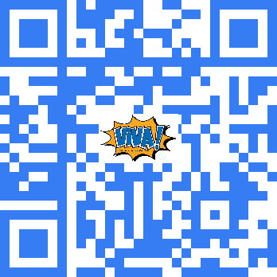All V!VA Award winners will be announced on Tuesday, April 15th, 2025, at the V!VA Award Luncheon held at the Horizon Convention Center.

# To Attend the Ceremony – Register at:

[**https://2025-Viva-Awards.eventbrite.com**](https://2025-Viva-Awards.eventbrite.com/?fbclid=IwZXh0bgNhZW0CMTAAAR1gIo3GT-HiCfW2iU7DhhgkkjT8vzN8TslJbaTty-NntrDOPRPf3L9ri-0_aem_TNV1GsprYJlajcV-m-ulyQ) or SCAN HERE 🡪

*Materials become property of Muncie Rotary and cannot be returned to you.*