**SAVE the DATE**

**Friends of the Foundation Event**

**Paul Harris Society Social**

**Friday, February 25th**

**5:30 – 7:30 pm EST**

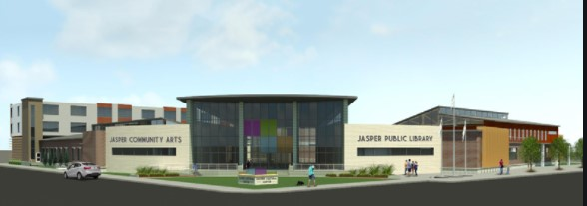

**Location: Jasper Art Center**

**Jasper, Indiana**

**More Details to follow!!**