**DACDB SHOWS START DATE GREATER THAN 30 DAYS AND CAN’T BE ADDED TO RI**

If your Member Compare shows this:



Click on the member’s name, change their start date to within 20 days of today’s date and then refresh your browser. It should look like the next screen capture. IF not, run Member Compare again and they will be included in your roster list:



Send the email below to [data@rotary.org](mailto:data@rotary.org) to correct their start date. RI will only act on emails from the club president, secretary or executive secretary:

SUBJECT: (New Member Name/RI#)- Please correct start date

My name is (NAME), RI # (your member number) and I am the secretary/president for the Rotary Club of (NAME)/Club # (your club #) in District #XXXX (6560-IN or 6710-KY). We recently added (NEW MEMBER NAME)/RI# (their new member #), on START DATE (20 days from today). However, their actual start date should have been (CORRECT START DATE). Please contact me with any questions and let me know when this is corrected. Thanks for your assistance.

Yours in Rotary Service,

NAME

Secretary/President

Club Name/#:

Cell:

Email:

REMEMBER: Changes can only be made on members with birthdays. So, if your Member Compare looks like this:



You will have to click on the members name and input their full birthdate first. THEN, follow the instructions above.

**DACDB SHOWS MEMBER HAS DIFFERENT MEMBER #’S**

If your Member Compare shows this:

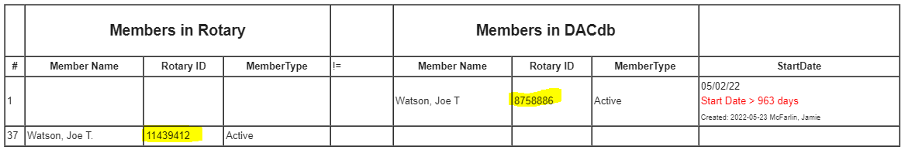

Send the email below to [data@rotary.org](mailto:data@rotary.org) to aggregate their record and . RI will only act on emails from the club president, secretary or executive secretary:

SUBJECT: Insert New Member Name-multiple RI Member #’s

My name is (NAME), RI # (your member number) and I am the secretary/president for the Rotary Club of (NAME)/Club # (your club #) in District #XXXX (6560-IN or 6710-KY). (MEMBER NAME/RI# (their member # in DACDB), has been a member of our club since START DATE. However, the Rotary International records are showing (MEMBER NAME/RI# (their member # in RI). Please consolidate their record and let us know which # should be used. Contact me with any questions. Thanks for your assistance.

Yours in Rotary Service,

NAME

Secretary/President

Club Name/#:

Cell:

Email:

**MEMBER TYPE IS DIFFERENT**

If your Member Compare shows this:



Please refer to the “Active, Honorary & R-85” document.