

**Tuesday, Oct. 25, 2022, 10:15 A.M. – 3:30 P.M EST**

**free zoom details on 2nd page; email** [**TeenaHal@aol.com to be on reminder list ;**](mailto:TeenaHal@aol.com%20to%20be%20on%20reminder%20list%20;) **see bios below**

**United Nations Association of the USA Kentucky Division UN Day & UN Human Rights Day Program on SDG #5 & SDG#6**

**Anti-Human Trafficking & Sexual Exploitation Conference (SDG #5)**

**Clean Water & Sanitation: Cleaner Water for Better Health (SDG #6)**

**Bronze Sponsors Co-Sponsors**

**UNA-USA Kentucky Division Floyds Fork Environmental Assn. UNA-USA Bluegrass/Lex. Chapter**

**Rotary Club of Louisville Frankfort Rotary Club UNA-USA Frankfort Chapter**

**Rotary District 6710 UNA-USA Louisville Chapter Rotary District 6740**





**10:00 A.M.** Welcome, UNA-USA Kentucky Division **President Richard Beliles, Esq.**

**10:05 A.M.** Introductions, Sponsors, Proclamations – **Teena Halbig**

**10:10 A.M.** Invocation, **Aaisha Hamid**

**10:15 A.M.** **Bill Miller**, journalist, [www.globalconnectionstelevision.com](http://www.globalconnectionstelevision.com), UN and UNA-USA BOD & Information

**10:20 A.M.**  **Honorary Guests: (more TBA)**

**Nancy Stearman, Rotary District Governor 6710**

**Seema Sachdeva, Rotary District Governor 6740**

**Larry Sloan, Rotary Club of Louisville** **BOD, Chair Lifeline Committee**

**11:00 A.M.** **- NOON** “**Inter-familial Human Trafficking Dialogue” Dr. Azurdee M. Garland; Aaisha Hamid interview**

**12:20 P.M. – 1:20 P.M.** **“Forever Chemicals/PFAS”** **World Health Organization representative** (TBA)

**1:20 P.M. – 2:20 P.M** **“Angel of Alabama” documentary movie &** **Elijah Yetter-Bowman, Founder Ethereal Films**

**1:20 P.M – 1:30 P.M.** Break with videos of **Murdered & Missing Indigenous Peoples, etc.** **Kierahn J. Johnson**

**1:30 P.M. - 2:30 P.M.** **PROJECTS: Water for GOMA!**; **Books for Public Libraries in KY**; **Human Trafficking**; **Play Ball Puerto Rico**; **Forever Chemicals/PFAS Chemicals**

 **2:30 P.M. – 3:00 P.M** Closing: Thanks to Sponsors, Presenters and Zoom Attendees

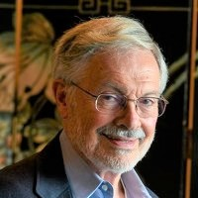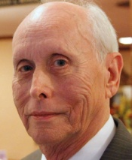 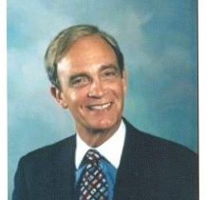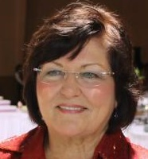

Richard Beliles Bill Miller Teena Halbig Larry Sloan Aaisha Hamid Azurdee Garland Elijah

Yetter-Bowman

**FREE ZOOM INFORMATION**

**United Nations Association of the USA Kentucky Division** is inviting you to a scheduled Zoom meeting.  
Topic: **UN Day & UN Human Rights Day** **Program** Zoom (Info: [TeenaHal@aol.com](mailto:TeenaHal@aol.com), 502 267-6883)

Time: **Oct 25, 2022 10:00 AM Eastern Time** (US and Canada)

Join Zoom Meeting

https://us02web.zoom.us/j/87897326144?pwd=bmdzcUs4cXF3anVUTloxMXVjazduQT09

**Meeting ID: 878 9732 6144 and Passcode: 076904 phone:** +1 312 626 6799 US (Chicago and Kentucky)

Meeting ID: 878 9732 6144

Passcode: 076904

One tap mobile

+13092053325,,87897326144#,,,,*076904# US

+13126266799,,87897326144#,,,,*076904# US (Chicago)

Dial by your location

+1 309 205 3325 US

+1 312 626 6799 US (Chicago) – use for Kentucky

+1 646 876 9923 US (New York)

+1 646 931 3860 US

+1 301 715 8592 US (Washington DC)

+1 253 215 8782 US (Tacoma)

+1 346 248 7799 US (Houston)

+1 386 347 5053 US

+1 408 638 0968 US (San Jose)

+1 564 217 2000 US

+1 669 444 9171 US

+1 669 900 6833 US (San Jose)

+1 719 359 4580 US

**Meeting ID: 878 9732 6144**

**Passcode: 076904**

Find your local number: https://us02web.zoom.us/u/kdPYy7WBDv

   We welcome you to know more about the United Nations Association of the USA Kentucky Division (UNA-USA Kentucky Division).

Students get a FREE Membership up to 26 yrs.; new member $25)    
www.unausa.org/chapter/kentucky/, facebook.com/UNAUSAKentucky Division/, @UNAUSAKY, @unausakydivision

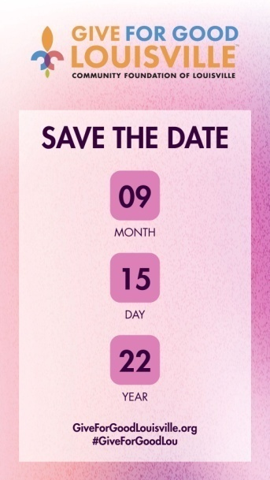

*Let’s show everyone that Kentuckiana is full of generosity!*

*On Sept. 15, 2022 (Thursday), help us celebrate Give for Good Louisville and continue our works on* ***Human Trafficking and Sexual Exploitation*** *and* ***Forever Chemicals/PFAS*** *(pronounce P-FAS, per- and polyfluoroalkyl substances) which are linked to serious illnesses and cancers which can cause women and men to lose their livelihoods and ability to support their families.*

*Please support UNA-USA Kentucky Division on September 15 by donating $10 or more at* <https://www.giveforgoodlouisville.org/organizations/united-nations-association-of-the-usa-kentucky-division>

*Donors who give to our organization from* ***7:10 - 7:12 PM ET*** *may be randomly selected to receive a $20,000, $10,000, or $5,000 boost to their donation.*

**Free Zoom is courtesy of Sponsors* & Co-Sponsors**

**Special Thanks to Gold Sponsor: Rotary Club of Louisville**

 

**\*UNA-USA Kentucky Division\*** **\* Rotary Club of Louisville\***

UNA-USA Bluegrass/Lex. Chapter Rotary Club of Frankfort

UNA-USA Frankfort Chapter Rotary District 6710

UNA-USA Louisville Chapter Rotary District 6740



Thank you!

Questions: [TeenaHal@aol.com](mailto:TeenaHal@aol.com)

502 267-6883

[www.unausa.org/join](http://www.unausa.org/join)

students up to 26 free

first time membership: $25

renewals: $50 senior: $25

***Floyds***

***Fork***

***Environmental***

***Association***



**Rotary Club of Frankfort**

**Rotary District 6740**



**Rotary District 6710**

