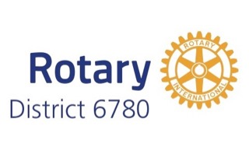 | District Grant Progress Report Form  2021-2022

District Grant Number:

Rotary Club:

Project Title:

Project Description

- Briefly describe the project (location of project, what is being done, when will it be done, and who will be the beneficiaries)

Rotarian Participation

- How many Rotarians have participated in the project to date?

- What have the Rotarians done to date? (give two examples)

Project Status

- What parts of the project have been completed to date?

- What parts of the project remains to be completed?

- Is the project on schedule to be completed and the final report submitted no later than May 31, 2022?
Yes No

If no, describe the steps being taken to ensure this will be accomplished?

Financial Impacts

- Funding to date

Source | Amount
- Amount of District Grant funds requested in original application
- Club matching funds
- Partner club(s) funds– specify club(s):
- Other Funds* (specify):
- Other Funds* (specify):
* ”Other funds” are not included in the calculation of the district grant funding match not apply to the funding match

- Expenditures to date (be specific, add supplementary page if necessary)
Note: No receipts are to be submitted until the final report

Item | Amount
- Sub-total from supplementary page if used
Total

- Amount of District Grant funds expected to be requested (not to exceed the amount approved by the district or 50% of club expenses, whichever is less):

Certification

I confirm that to the best of my knowledge the expenditures for this project for which District Grant funds will be received at the conclusion of the project were/will be spent only for eligible items in accordance with Rotary Foundation Trustee-approved guidelines, and that all of the information contained herein is true and accurate.

Certifying Signature: |  | Date:

Name:

Club Position:

Rotary club of:

Attachment:
- Supplementary expenditure sheet if needed

Submit Progress Report To: David Carroll at dcarroll1960@aol.com and
Pat White at http://pkmsw@aol.com

