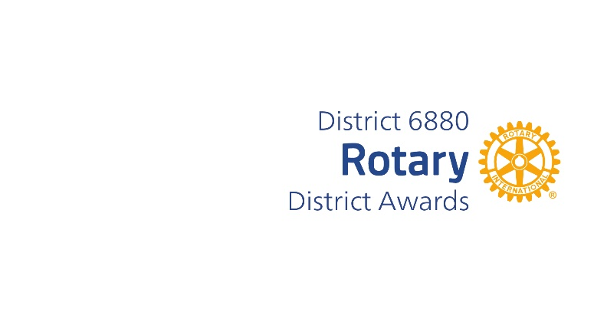
J. BARTON GREER CITIZENSHIP‐FOUR WAY TEST AWARD
This Award was established by Past District Governor Robert A. Greer in honor of his grandfather who was the epitome of an example of living the Four Way Test.
J. Barton Greer was a Paul Harris Fellow and President of the Mobile Rotary club in 1933‐34. Robert’s brother J. Barton Greer, III (Rotarian & Paul Harris Fellow) was inspired by his grandfather and wrote the book titled, “The Four Way Test” which illustrates its principals.
The winner of this Award each year should be a Rotarian in the District who lives by the Four Way Test, is a model citizen and conducts themselves in all aspects of their lives with only the absolute best practices and uncompromised ethics.
Although every Rotarian is encouraged to live by the Four Way Test, there are those whose actions go above and beyond and exemplify the Four Way Test.
This person may have also done something special using the Four Way Test as their guide.
You may complete and submit this form online on or before March 1st, 2025, to District Award Committee atrotarysteve6880@outlook.com
OR
You may download this form and post US mail to The District Award Committee, 38 Paddock Dr. Fairhope, AL 36532, to be received before March 1, 2025.

Any questions should be directed to DGN Bob Cochran
at his email address, at rotarysteve6880@outlook.com
Mobile Phone: 913-485-0807

J. BARTON GREER CITIZENSHIP‐FOUR WAY TEST AWARD NOMINATION FORM

DATE:
ROTARY CLUB OF:
CLUB PRESIDENT’S NAME:
ADDRESS:
PHONE NUMBER:
EMAIL ADDRESS
ROTARIAN SUBMITTING NAME FOR CONSIDERATION:
NAME OF NOMINEE:
ADDRESS
ROTARIAN SINCE:
BASIS FOR NOMINATION: (add page if needed)

_________________________________________
Club President’s Signature

