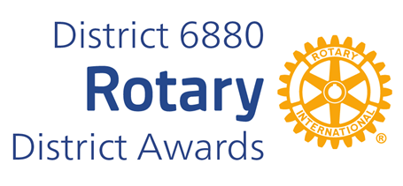**SOCIAL MEDIA AWARD**

**The Social Media Award was established in 2013 by District Governor Jim Golson (2012-13) to recognize Clubs meeting the challenge of communicating in new ways.**

**The Award is given to a small, a medium, and a large size club with the most active and diverse page using social media (Facebook, Linkedin and/or Twitter).**

**Selection is determined by evaluating the social media based on the following criteria:**

**SELECTION CRITERIA**

**1. Information about the Club (service projects, member news and recognitions, budgets, etc. 30%**

**2. Information about past, current and upcoming programs and speakers of the club. 20%**

**3. Information about Rotary International and The Rotary Foundation. 20%**

**4. Information about activities of the district. 10%**

**5. Appearance – attractiveness, formatted so that it is easy to read and easily understood. 10%**

**6. Other – community news, anecdotes, inspiration, humor, etc. 10% Total 100%**

**You may complete and submit this form online on or before March 1st, 2025 to District Award Committee at** [**rotarysteve6880@outlook.com**](mailto:rotarysteve6880@outlook.com) **OR**

**You may download this form and post US mail to The District Award Committee, 38 Paddock Dr. Fairhope, AL 36532 , to be received before March 1, 2025.**

**Any questions should be directed to DGN** Steve Weaver

**at his email address, at rotarysteve6880@outlook.com**

**Mobile Phone: 913-485-0807**

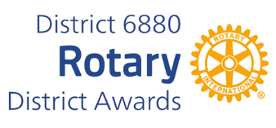**SOCIAL MEDIA AWARD NOMINATION FORM**

**DATE:**

**ROTARY CLUB OF:**

**CLUB PRESIDENT'S NAME:**

**ADDRESS:**

**TELEPHONE NUMBER:**

**E-MAIL ADDRESS:**

**Social Media Site Address(es):**

**INDICATE CLUB SIZE:**

**Under 40 members. 41 to 99 members. Over 100 members.**

**_____________________________________________________**

**CLUB PRESIDENT'S SIGNATURE**