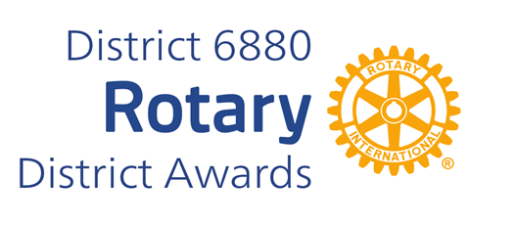

**STEVE JAMES YOUTH SERVICE AWARD**

**Steve James Youth Service Award was established in 2015 in honor of Steve James who had an unfailing commitment to Rotary and especially young people.**

**Steve served as Secretary and President of the Jackson Club. He also sponsored his beloved interact club.**

**On the District level he was cochair of the Rotary Youth Leadership Academy (RYLA) and facilitated the Leadership Academy in 2013.**

**Steve received the Rotary International Vocational Award. Steve was honored as Jackson Citizen of the Year in 2015. Steve passed in 2016.**

**The Steve James Award for Distinguished Youth Service recognizes the individual who has contributed to the overall betterment of youth in their community and around the District by exemplary service and a cheerful heart.**

**You may complete and submit this form online on or before March 1st, 2025 to District Award Committee at** [**rotarysteve6880@outlook.com**](mailto:rotarysteve6880@outlook.com)

**OR**

**You may download this form and post US mail to The District Award Committee, 38 Paddock Dr., Fairhope, AL 36532  
, to be received before March 1, 2025.**

**Any questions should be directed to DGN** Steve Weaver

**at his email address, at rotarysteve6880@outlook.com**

**Mobile Phone: 334-663-1764**

**STEVE JAMES YOUTH SERVICE AWARD**

**NOMINATION FORM**

**DATE:**

**ROTARY CLUB OF:**

**CLUB PRESIDENT'S NAME:**

**ADDRESS:**

**TELEPHONE NUMBER:**

**E-MAIL ADDRESS:**

**BASIS FOR NOMINATION: ( add page if needed)**

**___________________________________________**

**CLUB PRESIDENT'S SIGNATURE**