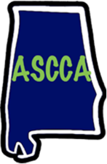
Camp ASCCA Photo and Video Release
Easter Seals Camp ASCCA
P. O. Box 21
Jacksons Gap, AL
(256) 825-9226

Permission to Use Photograph, Video and Audio
I grant to Easter Seals Camp ASCCA, its representatives and employees the right to take photographs, video and audio recordings of me and my property in connection with my visit. I authorize Easter Seals Camp ASCCA, its assigns and transferees to copyright, use and publish the same in print and/or electronically.
I agree that Easter Seals Camp ASCCA may use such photographs, video and audio of me with or without my name and for any lawful purpose, including for example such purposes as publicity, illustration, advertising, and Web content.
I have read and understand the above:
Signature Date
Printed name
Group/Organization/School Name
Date(s) of Visit
Signature, parent or guardian
(if under age 18)

