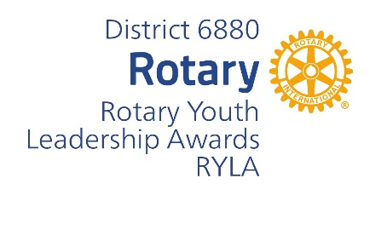
Rotary Youth Leadership Award

CONFERENCE CODE OF CONDUCT
I UNDERSTAND THAT: I have a commitment to attend the RYLA conference and will notify the RYLA Conference Committee immediately should a conflict arise.
- I may not arrive late or leave the conference earlier than the program schedule.
- I will be assigned to a student team and an adult team facilitator who will be my primary contact for information, issues, problems, and emergencies.
- I am responsible for attending all meetings and activities with my team.
- I must sleep in the room to which I am assigned and respect the lights out at the scheduled time. I will be quiet thereafter.
- There are separate sleeping areas for males and females. Males ARE NOT allowed in the female sleeping areas at any time and vice versa.
- Cell phones will only be used during scheduled recreational times. Items used during unauthorized times will be confiscated and returned at the end of the conference.
- Recreational activities are limited to those periods of the day on the schedule.
- If any person is injured or becomes ill, I will not move him/ her. I will contact a camp staff member or a Rotarian.
- I will report any damage or breakage immediately to my team facilitator, or any Rotarian. All participants are responsible for taking care of the camp facilities.
- Use of tobacco products (this includes E-cigarettes, vape pens, etc.) is prohibited by all students.
- Any medications, whether prescribed or “over the counter”, must be identified on the container. Unidentified medications found will be confiscated.
- Alcohol, weapons, and illegal drugs are prohibited. Any of these items found in the possession of any participant will be confiscated. The participant will be immediately dismissed from the conference and reported to the proper law enforcement authority.
- Foul or abusive language, including anything discriminatory or harassing in nature, will not be tolerated nor will physical violence or threats of physical violence.
- Any sexual or lewd conduct will be considered unacceptable behavior.
- I MAY NOT leave the camp area for any reason without the permission of a staff member.
- Confidentiality is important. Anything I have shared or heard within my group should remain in the group. However, I understand that counselors are mandated by law to report any suicidal or abuse issues to the proper authorities.
- I am to conduct myself in a manner which will reflect positivity on my school and Rotary International.

I have the Code of Conduct and do hereby agree and commit to honor it. Should my conduct be considered unacceptable at any time, per the discretion of conference officials, or should I violate any of the rules listed above, I understand that I will be dismissed from the conference and will be sent home at my parent’s or guardian’s expense.

______________________________________ Click or tap here to enter text.
Conference Participant Signature Date
_______________________________________ Click or tap here to enter text.
Parent / Guardian Signature Date
Send Applications To: Bob Kelley – RYLA Chair rylachair6880@gmail.com 334-327-0712 4330 AL HWY 22W, Selma, AL 36701
Camp ASCCA website: https://www.campascca.org RYLA Link on District Website: https://www.district6880.org/ryla/

