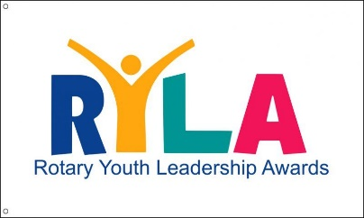

Camp ASCCA

**February 27 – March 2, 2025**

# ____________________________________________________________________

**MEDICAL**

**TO BE COMPLETED BY THE YOUTH APPLICANT AND PARENT/ GUARDIAN.**

**PLEASE PRINT. THIS INFORMATION IS CONFIDENTIAL AND IS ONLY FOR YOUR SAFETY AND EMERGENCIES. THIS DOCUMENT WILL BE DESTROYED AFTER RYLA IS COMPLETED**.

NAME: Click or tap here to enter text.

PARENT/ GUARDIAN NAMES: Click or tap here to enter text.

Click or tap here to enter text.

STUDENT CELL:Click or tap here to enter text. PARENT CELL: Click or tap here to enter text.

DATE OF BIRTH: _Click or tap here to enter text._ HOME PHONE: Click or tap here to enter text.

ADDRESSClick or tap here to enter text.

FAMILY DOCTORClick or tap here to enter text. PHONE: Click or tap here to enter text.

ADDRESS: Click or tap here to enter text.

HEALTH INSURANCE POLICY AND GROUP NUMBERS: Click or tap here to enter text.

Click or tap here to enter text.

**MEDICAL HISTORY:**

1. Do you have any allergies (bees, drugs, foods, etc.)? Explain: Click or tap here to enter text.

2, Are you taking any medications? Click or tap here to enter text.

3, List: Do you have any chronic illnesses (diabetes, epilepsy, asthma, etc.)? Explain:

Click or tap here to enter text.

**MEDICAL HISTORY CONTUNUED:**

1. Do you have any physical disabilities or conditions that might prevent you from participating in any physical activities? Explain:

Click or tap here to enter text.

Click or tap here to enter text.

1. Special Dietary needs? Explain:

Click or tap here to enter text.

Click or tap here to enter text.

1. Are you currently under the care of a physician? Explain:

Click or tap here to enter text.

1. Do you have any other medical conditions that the camp director should be aware of? Explain:

Click or tap here to enter text.

_____________________________________________________________________

**I acknowledge that the above is true and correct and that I understand that there are no nurses on site, but there are trained Camp Personnel, RYLA Leaders, and RYLA Chaperones with Basic and Advanced First Aid training.**

x Student Signature Click or tap here to enter text.

x Parent/ Guardian Signature Click or tap here to enter text.

**For more information contact:**

Send Applications To: **Bob Kelley – RYLA Chair** [rylachair6880@gmail.com](mailto:rylachair6880@gmail.com) **334-327-0712**

**Or Mail To: 4330 AL HWY 22W, Selma, AL 36701**

Camp ASCCA website: <https://www.campascca.org> RYLA Link on District Website: <https://www.district6880.org/ryla/>