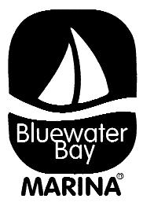Niceville/Valparaiso Christmas Boat Parade Rules and Information

* If you need a slip, please let us know prior to the event.
* Skippers Meeting – 4 PM at Emerald Coast Marine Pool Deck
* Staging – 5 PM outside of ECM docks
* Channel 71 will be monitored during the evening
* For safe travels & deep water – Follow the Lead Boat
* Speed – lead boat will maintain 4 Knots
* Attempt to maintain parade order. If any problems, contact the lead boat on channel 71.
* Route: 3.5 NM (Counterclockwise around Boggy Bayou)
* No throwing of candy etc. from boat
* If running off inverter, check to make sure batteries are charging
* Awards as soon as boats back (Approx. 7:00)
* Drinks on the pool deck after the parade
* Please leave lights on during the evening of the parade!
* Judges will be at Wharf 850, Lions Park and Lincoln Park.
* Awards will be given for Best Christmas Theme, Most innovative, Best Griswold, best overall.
* Any Questions, please contact Brian at 850-218-6381