
Greater Nassau Rotary Conducts Tool Drive for Habitat for Humanity
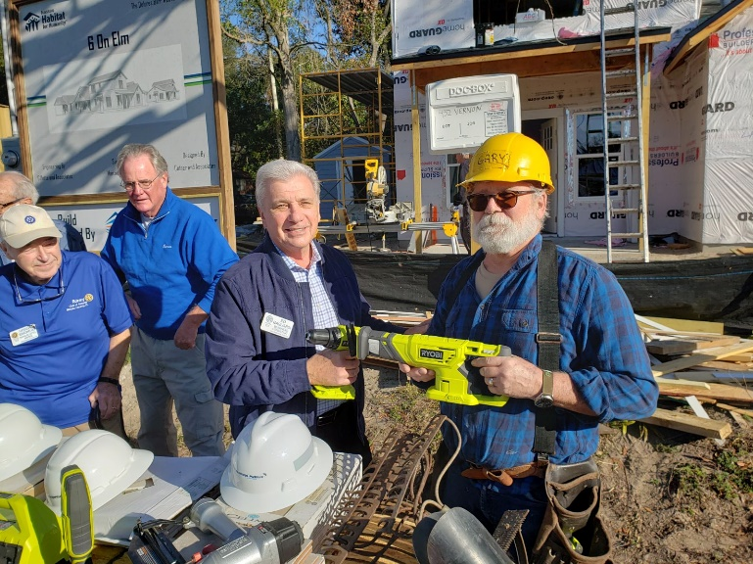
Habitat for Humanity of Nassau is dedicated to providing affordable workforce housing right here in our community. The Rotary Club of Greater Nassau supports Habitat’s “Four in ‘24” commitment to building housing for four families in Nassau County in 2024 by collecting and providing new and gently used tools for Habitat’s build sites. Our tool drive is open and we will be accepting tools and donations until February 11.
Help us have an impact here in our community in the following ways:
Clean out your garage! Many of us have duplicates or unused construction and lawn and garden tools taking up valuable space in our homes. Gather those tools and use the contact information below to schedule pickup of your generous donation before Feb. 11!
Make a cash contribution! Our club will use cash contributions to buy battery packs and new cordless tools for use at the build sites. Send a check, made out to the Rotary Club of Greater Nassau (Re Tool Drive) and mail to the contact information below before Feb. 11.
Your generosity transforms lives and creates a foundation for families in Nassau County to thrive. Every dollar and tool you donate brings us one step closer to building homes and hope for families in need. Donate today and be a cornerstone in the construction of brighter futures.

[INSERT NAME, CONTACT INFORMATION]

