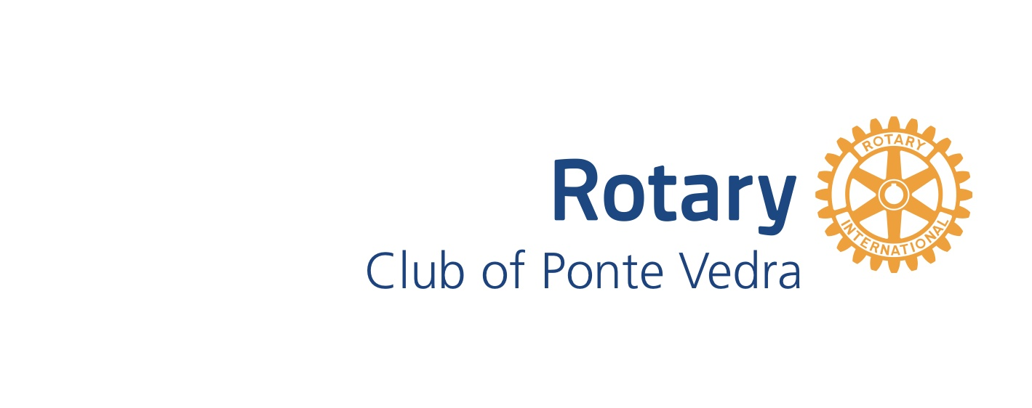
History of Club Service Projects
Since its inception in 2018, the Rotary Club of Ponte Vedra has given over $100,000 in donations and volunteered thousands of hours to our community through planning meetings, committee meetings, and hands-on service.
2024
- Hosted an international Rotary Youth Exchange (RYE) student, Marjorie Francechetti, from Brazil for the 2023-2024 school year
- Raised $20,000 to finance a “Save Our Students” campaign that helps local schools meet the needs of students who are homeless or resource-challenged
- Donated close to $2000 to the St. Johns County Parks & Recreation Foundation to finance the installment of a water bottle refill station at Nocatee Fields
- Conducted a trash pickup along the cart path running from Anejo restaurant to Davis Park in Nocatee
- Granted $500 for Nease High School students to provide clean undergarments to homeless people in our area
2023
- Took the position as lead international Rotary club on a $200,000+ global grant that will provide clean drinking water facilities for thousands of people in the poorest regions of Cambodia
- Bought five exercise stations (total value around $5000) and gifted them to the Nocatee community along its Greenway Path
- Packed over 100 backpacks for Blessings in a Backpack at holiday time
- Conducted multiple trash pickup events at Nocatee’s Splash Park
2022
- Raised $38,000 total in 2021 & 2022 for Learn to Read St. Johns ($24,000) & The Ponte Vedra Rotary Foundation ($16,000) through Rubber Duck Race event

- Raised $20,500 total in 2020, 2021 & 2022 for autism research through Autism Speaks Walks

- Donated a total of $17,500 in 2021 & 2022 for 218 bio-sand water filters in the Siem Reap region of Cambodia as part of the Rotary-sponsored “Water for Cambodia” project

- Collected $2000 worth of food items for the St. Johns Food Pantry (which serves 4000 families/week in St. Johns County)

- Conducted clean-up day service projects in 2021 & 2022 in Nocatee

- Raised $1900 in 2020 & 2022 for 150 food-scarce children at local schools with holiday spring break goodie bags events in cooperation with Blessings in a Backpack

- Packed 250,000 total meals in 2018 & 2022 for families in third-world countries through Rise Against Hunger (in cooperation with other area Rotary clubs, the Interact Club of Fletcher High School, and local community groups in Fernandina Beach)

- Honored a member of the St. Johns County Sheriff’s Department and a member of the St. Johns Fire Rescue with a “Rotary Heroes” Award and Reception

- Hosted a clothing drive to benefit the YMCA’s New American Welcome Center in Jacksonville

- Initiated and participated in a District-wide “Rotary Strong” fundraising team (that raised $2500) for Florida Special Olympics in a Polar Plunge event
- Donated hundreds of dollars of school supplies through Investing in Kids (INK) to families who are unable to afford them in St. Johns County
2021
- Collected 1200 food items, approximately 1000 pounds of food, in November for the St. Johns Food Pantry and the YMCA New American Welcome Center through the YMCA Nocatee Food Drive

- Donated $500 to the YMCA New American Welcome Center through a grant from The Ponte Vedra Rotary Foundation

- Donated $160 of diapers and baby supplies to several nonprofits in the Jacksonville area through the Sarah Collins Limbaugh Memorial Diaper Drive

- Donated more than $8000 in 2018-2021 to The Rotary Foundation and Rotary’s Global Eradication PolioPlus program

- Raised $2300 during a COVID surge (in the summer and fall) to buy 525 pizza dinners for frontline healthcare workers and first responders at five local hospitals and five fire rescue stations as part of the “Feed the Frontlines” effort
2020
- Donated hundreds of items to 9 nonprofits and Starling at Nocatee Assisted Living Facility residents while participating in 11 at-home, family-friendly, COVID-impacted service projects

- Donated $1700 in cash and $3500 in food items to the St. Johns Food Pantry

- Donated and distributed 350 masks in September to teachers and staff at Palm Valley Academy, Valley Ridge Academy, and Nease High School (as part of a $5000 Rotary District grant– of which our club donated $500 -- with four other area Rotary clubs)

- Sponsored $1225 in gifts and gift cards for two families at Christmas time (via Publix)
2019
- Donated $1200 toward purchasing a $7500 all-terrain vehicle for adults and children with disabilities for Camp Rotary in Bradenton, FL. (in partnership with The Rotary Club of Palatka Sunrise and the Rotary Club of Bartram Trail, along with a matching grant from Rotary District 6970)

- Donated $1200 toward the $50,000 resurfacing of a public pickleball in Palatka (in conjunction with other Rotary clubs, Rotary District 6970, Palatka High School, and private donors)

- Donated 25 backpacks ($875) to children moving into foster care through Fostering Connections

- Donated 100 sets of toothbrushes, toothpaste, and dental floss to children in rural Zimbabwe (in partnership with East Carolina University Nutrition Program)

- Donated art supplies to 100 children in Title I schools with summer camps for Daytona Beach children (in partnership with Interact clubs in the area)

- Packed 4,644 meals for Save My Starving Children Foundation, an international food project

- Donated $250 to the Cecil Field National POW-MIA Memorial Park, a National Memorial for those who are still Missing in Action from ALL branches of the U.S. Armed Forces

- Sponsored an inbound exchange student from India to attend Nease High School in the 2018-2019 school year as part of The Rotary Youth Exchange Program
2018
- Raised $1200 for Alex’s Lemonade Stand for Children’s Cancer Research

- Donated $500 to Make-a-Wish Foundation

- Sent letters to honor an 89-year-old Korean War Veteran who was taking an Honor Flight to the Korean War Memorial

- Donated personal items to 40 girls who attend Pace Center for Girls (in partnership with a Rotary club for young professionals: Beaches Rotaract Club)

- Made and served dinner for the camp staff of Camp I Am Special, a camp for children with
disabilities (in partnership with Catholic Charities)

- Donated hundreds of school supplies for INK, Investing in Kids, St. Johns County Public School

