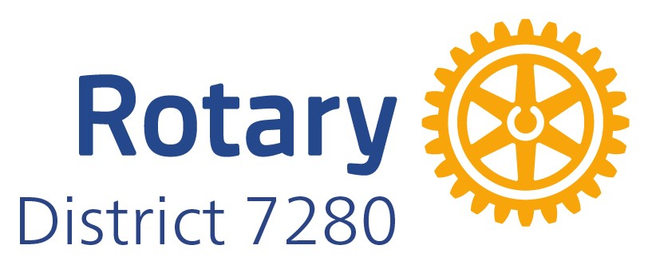

Membership Summit

November 9, 2024

For clubs to be successful, the members need to be engaged, new ideas for programs and projects need to be developed with the buy in of the members, fundraisers need to be supported, and an environment of fellowship, networking and fun needs to be present.

In addition, clubs need to continually think about how to grow. This cannot be done by the club leadership alone but needs to involve every member of the club.

Each year most of our clubs lose members for various reasons. Some leaving the area, health, or death. Others leave because of family commitments, the cost of belonging to the existing club, or because the club experience did not meet their expectations. For these individuals we need to find another way to keep them engaged and give them a club experience that fits their lifestyle or needs.

People don’t leave Rotary; they leave Rotary Clubs.

Membership growth must be extremely intentional and include a CULTURE OF INVITING, you must know your Why’s, that attrition is real, and it only works when we care about “what’s in it for them” for potential, new & existing members.
Today we are going to work through several exercises to help you and your club to do:
- Evaluation of the current club environment.
- Does your club REALLY want to grow?
- Identifying New Members. “The Culture of Inviting”.
- Attracting New Members.
- Onboarding New Members
- Member Care
- Developing a “Five Step Membership Grow”. This will be your action plan!

Membership growth needs to involve intentional strategies. Clubs need to take a multi-year approach to goal setting by asking current and future club leaders to work together to set goals and determine the correct path and strategies to meet those goals. This approach promotes continuity of leadership, alignment of purpose, and unified messaging over multiple years.

Keep this, share with your board and members and add to it, and refer to it regularly throughout the year.

Table of Contents

ATTRACT: “What’s In It for Them?” Relationships, Service, Growth, Learning…………….. 1

Tried and Not Always True Strategies ……………………………………………………………...... 2 & 3

Intentional Membership Strategies …………………………………………………………………… 4 & 5

Recipe for a Successful (Discover) Rotary Membership Event ……………………………… 6, 7, 8

Accessing the Membership Success Center ………………………………………………………… 9

Membership Action Plan (MAPSYS) …………………………………………………………………….10

Club Types ……………………………………………………………………………………………………. 11

Brainstorming – START WITH WHY ………………………………………………………………… 12 & 13

Does your club REALLY WANT TO GROW …………………………………………………………… 14

IDENTIFY New Members …..…………….……………………………………………………………… . 15

ATTRACT New Members ………....………………………………………………………………………. 16

ONBOARD New Members …..………..…………………………………………………………………. 17

MEMBER CARE, ENGAGEMENT & RETENTION ……………..……...…………………………….. 18

Create Five Step Membership Growth Plan (your action plan) ………………………….... 19, 20, 21
WHY YOUR CLUB ……………………….…………………………………………………. 22

WHO DO YOU KNOW (Club Exercise)……………………………………………… 23, 24, 25, 26

Suggested 3- 6 Month New Member Onboarding Steps ………………………………. 27, 28

Attrition or Attraction Issues ……………………………………………………………….. 29, 30

Take a Note of a Great Idea ………………………………………………………………… 31

USEFUL LINKS

- Zones 33, 34 Resources: https://www.rizones33-34.org/club-membership-committee/
- Zones 33, 34: some great videos: https://www.rizones33-34.org/membership-action-plan/
- Courageous Club Turnaround. Guilford Rotary Club - From decline to growth: https://www.youtube.com/watch?v=fj101zYJjh8
- Changing Your Club Culture https://www.rizones33-34.org/?s=intentional
- Great 2-minute video on why new Rotary clubs: https://www.youtube.com/watch?v=ge9acxXrk4A&t=11s
- Making your club IRRESISTIBLE!
https://www.rizones33-34.org/wp-content/uploads/2022/12/How-to-make-your-club-irresistible.pdf
Today’s Summit materials are available by going to:
https://dacdb.com/Rotary/Accounts/7280/Downloads/0/D7280%202024%20Membership%20Summit.docx
 WHAT’S IN IT FOR THEM?

We’ve all heard Rotary leaders talk about membership growth, but nobody joins to help with that. They join for “what’s in it for them” - one or more of The Four Powerful Benefits of Rotary: Relationships, Service, Growth and Learning.
When you talk to non-Rotarians, keep these four top-of-mind, tell them what you are proud of and passionate about in Rotary, and invite them to a Rotary meeting or event.
Relationships
1. Quality - Rotary offers friendships.
2. Fun - Most clubs have what I call fun doing service projects, club leadership, social activities, and fundraising. Work hard; Play hard!
3. Connections - We are connectors!
Service
1. People can find their passion in Rotary, or they can bring theirs.
2. They can serve locally or internationally, in most any way imaginable.
3. They get Rotary’s incredible reputation and logistical & financial support.
Growth
1. Past RI President Jennifer Jones has said “we are leaders by mindset as much as position”, making Rotary perfect for people of all ages.
2. People can improve leadership, organizational and speaking skills.
3. Rotary is a great place for mentors, and to be mentored, making a diverse age range ideal.
4. For some, Rotary can offer more leadership, service & growth opportunities than a job or business.
Learning
We sometimes don’t appreciate the value of exposure to a wide variety of community leaders and organizations, and obviously Rotarians, some of whom are outside their club. Rotary opens many doors!
-------------------------------------------------------------------------------------------------------------------------------
Thoughts to Consider:
- Personalize your invitation by sharing what you’re most proud of and passionate about - in your club, your Rotary service, or Rotary itself.
- Become part of your club’s ‘CULTURE OF INVITING’, and invite someone to your next meeting or event by remembering the answer to “what’s in it for them?” – Relationships, Service, Growth and Learning, and what you’re proud of and passionate about.
- Treat Rotary as a gift to give. That will make it much easier to invite people.
- Every one of us benefited from the gift of a simple invitation to a Rotary meeting or event, and it changed our life! Please do the same for someone else. And someone else….
-------------------------------------------------------------------------------------------------------------------------------

1


Tried and Not Always True Strategies
(From Zone 33 Membership Team)

The Rotary Zone 33 Rotary Coordinator Team has been successfully training clubs on attracting, onboarding and retaining members, recommending the Intentional Strategies shown in Steps 1 – 5 on page 4, proven by clubs to work. Surprisingly, a set of legendary strategies that don't work continue to appeal to clubs. To save your club a lot of time and frustration, here's a list of strategies that may not produce the best results:
- Club socials, "meet and greets" with prospective members invited as guests
- Invite prospective members to regular club meetings
- Incentives -- Offer members an incentive, such as "free dues for a quarter", gift cards or gift certificates, Foundation Recognition Points, etc. for proposing a new member
- Free or reduced dues for new members
- Podium announcements, newsletters, bulletins, emails, etc. asking members in mass to propose new members
- Direct mail, print advertising, billboards, post cards or emails inviting prospects to events or meetings

WHY these strategies don't work to attract members

    - 1. Club socials, "meet and greets" with prospective members invited as guests -- Clubs love this idea. Who wouldn't? Have a party and use membership as an excuse. Trouble is, a good social is a lousy venue for having a serious, informative conversation about what Rotary is and does. Members mostly talk with each other, guests feel a bit awkward and go home with, at best, a feeling that Rotary "may be OK".
No call to action = no action.
    - 2. Invite prospective members to regular club meetings - Almost as ineffective as socials. In the average club meeting, 2 or 3 minutes focused on what Rotary is or does would be the exception. Prospects meet some nice people, perhaps hear a good program, have a great meal, and leave without knowing any more about Rotary than when they came in. They go home wondering, "What's that all about?" Conversion rates of 1 in 10 (1 new member for every 10 prospects at meetings) for this strategy are about the best you can expect, even with great member follow-up.
    - 3. Incentives --- Offering members an incentive, such as "free dues for a quarter", gift cards or gift certificates, Foundation Recognition Points, etc. for proposing a new member -- For a full understanding of this one, read Predictably Irrational: The Hidden Forces That Shape Our Decisions. A weird thing happens when you attach money to something. Suddenly, instead of thinking, "That's even a better reason to do something I ought to do anyway" the member starts thinking, "There are probably easier ways for me to make $150."

2
The problem is you can't make it big enough to make the money matter in its own right. If you could offer, say, $2,000 it might work. If your budget will support that, give it a try.
This strategy also makes the prospect feel like they are being “sold” on Rotary. We do not want to recruit – we would rather attract those who have a genuine interest. If you recruit a new member to Rotary, the recruiting doesn’t end there, because you then need to recruit them to pay dues, recruit to meetings, recruit to club functions, etc. This new recruited member just became a lot of work.

- 4. Free or reduced dues for new members -- In general, community service isn't free and community service including a meal several times per month surely isn't free. Rotary isn't for everyone, and particularly not for someone for whom the cost is a hardship. We don't do anyone any favors by asking them to give up something else to be part of Rotary. If the "sticker price" of Rotary is too much, reducing that by half or to zero for a while is just postponing the inevitable. When the full dues rate kicks in, it will still be too much and you just upped your attrition, or reduced your retention.
Note: The jury is out on the intentional strategy of bringing in Young Professionals
who age out of subsidized dues by, say, age 35. It seems to work for country
clubs and may work for Rotary, as well.

    - 5. Podium announcements, newsletters, emails, etc. asking members in mass to propose new members -- In even a group of 20 people, let alone 200, a general "ask" is anonymous - everyone at the table assumes the speaker is talking to the person on his left or right -- that someone else will take care of it. A real one-on-one conversation in person or by phone (a personal "ask") where you ask for and receive a commitment, is a whole different deal.

    - 6. Direct mail, print advertising, billboards, post cards or emails inviting prospects to events or meetings -- Clubs love this because it's easy. Doesn't work at all. If our own members won't pay attention to an anonymous "ask", why would prospects respond to an anonymous ask? The way to get prospects to a membership event (not a regular club meeting) is for a member who knows them to invite them personally, get their firm (not "Maybe" or "I'll try") commitment to come and offer to pick them up.
If you really want to try this strategy, it would be a lot more entertaining to take the same money spent on these ideas, but instead convert it all to $1 bills and throw them down Main Street and watch the mayhem. Your results for attracting new members will be about the same.

3
Intentional Membership Strategies
10:3:1 Rule
- 10 targets (conversations)
- 3 Prospects
- 1 Member

Prospect Identification

(Lead Generation)
- Use the "Who do You Know?" handout at a Club Assembly. Actually allow time for people to fill it out (making it clear we're not leaving 'till everyone has some names written down) and then ask them to invite 10 of those people to a Rotary Information Hour (remember the 10:3:1 rule).
_____________________________________________________________________________
_____________________________________________________________________________
- Classification/Profession Gap Analysis -- Secure a list of local businesses and professions from the Chamber of Commerce and/or list sources like InfoUSA or ZoomInfo (available at your local Library).
Identify businesses and professions that ought to have someone in Rotary. Present the list at a Club Assembly and ask which members know someone at each and who will invite them to an upcoming Rotary Information Hour (#4 below). _______________________________________________________________________________________________________________________________________________________
- Club President personally asks each member to bring a prospect to a Rotary Information Hour (#4 below) or a service project -- an eyeball-to-eyeball conversation over breakfast, lunch, coffee, adult beverage or a 2way telephone conversation. Takes the anonymity out of the ask. "Can I count on you doing this not only for the club but also for me?" ___________________________________________________________________________
_____________________________________________________________________________

Attracting Members
- A regularly-scheduled "Rotary Information Hour" once a quarter or once a month. The "intentional" part of this is that it's a standing event, on the club calendar, and members are reminded by email or phone to bring their prospective members. Not just to a meeting whenever you think of it, but to a regularly scheduled date, time and place. See: Recipe for a Successful Membership Event
# 1 PROVEN ROI Strategy
# 1 PROVEN ROI Strategy
__________________________________________________________________________
__________________________________________________________________________________

- E-Marketing – Social Media & Drip Marketing -- Create a central prospect list, including email addresses, and use the "Potential Member" feature in DACdb to send your club's E-Bulletin once or twice a month to your entire prospect list. Regularly reminding prospects of your club's brand makes you "Top of Mind" when the time is right for the prospect to join a community service organization. Be sure and include "Response" information so they know how to raise their hands when they're ready. See: Don't Squander Your Leads
Social Media is another good way to stay in front of prospects and also generate some lead flow. Post photos from service projects and share them with your friends and followers.
_____________________________________________________________________________________
- Innovative Clubs and Member Types - Create a product for today's market, such as (1) A Corporate Membership category, allowing multiple people from a company to become Rotarians, with one being the "Corporate Active" member and the others "Corporate Associates". (2) Or create a “YP-35” membership category that follows the “Rule of 85” dues, meals and attendance structures. (3) Create Satellite club(s) for groups of members that have a different need or focus from the standard club. (4) Get creative. Put actions in place that are relevant for your club. RIZones33-34.org/zone-33-innovative-club-advocates
_____________________________________________________________________________________
_____________________________________________________________________________________
Onboarding New Members
7. Create a New Member Orientation program and process to engage members immediately in your club. Early engagement is the key success factor in retention. To follow up your New Member Orientation, use the New Member Scavenger Hunt for a fun way to get members engaged in learning more about Rotary and about your club. Consider a Red Badge/Blue Badge program.
_____________________________________________________________________________
_____________________________________________________________________________

Retaining Members
- Upgrade the Club Experience -- Clubs have proven that the club experience (including great programs) is what attracts and keeps members. Programs need to be informative, educational or inspirational (or a combination thereof). Limit or avoid programs by other non-profits (members see those as fundraising requests) unless there is a value proposition for your club. Do a Member Satisfaction Survey.
_____________________________________________________________________________
_____________________________________________________________________________
- Mentorship -- Create a mentorship plan to assign an experienced member to work with a new member. Mentors help new members get acquainted and engaged with existing members.
_____________________________________________________________________________
_____________________________________________________________________________

- Meaningful Service Projects -- The bottom line of engaging and retaining members is for the club to do meaningful, Rotary-branded service projects of its own (not writing checks to other non-profits). Hands-on, shoulder-to-shoulder service work is where members get to know and bond with each other.
_____________________________________________________________________________
_____________________________________________________________________________
HOPE is NOT a Strategy
5


Recipe for a Successful (Discover) Rotary Membership Event
(From District Zone 33 Membership Team)

A successful Rotary Membership Event (Rotary Information Hour, Discover Rotary, etc.) starts with the right framework. This is a "business seminar", rather than a Rotary meeting, social hour, networking event, etc. Think about how you'd organize a new product introduction event for your company's prospects or customers.

Besides advance planning (enough lead time for members to get prospects lined up), a successful membership event has several essential ingredients, most of which occur before the event:

Pre-Planning
- Enter the event on the DACdb club calendar. Better yet, set it up as Online Registration, where members can register themselves and their guests. This simplifies logistics
- Make members accountable to bring prospects. This is not the same as "ask members to bring prospects". Accountability means that EACH member has committed to someone (or several someone’s) to show up with at least one prospect in tow.
- Execute one or more intentional strategies to help members think of prospects
  - Invitation Card at each member's place at the next meeting, with instructions to invite someone and report contact info to the Membership Committee
  - "Who Do You Know" exercise at a Club Assembly. Every member knows someone to invite!
  - A targeted list of business or community leaders, with someone responsible for contacting each (assigned at Club Assembly). Do a “Gap Analysis” of your club’s classifications against those available in your community. Our clubs do need to represent our communities!
- Members report their confirmed prospects in advance of the event - at least a week, to the Membership Committee. That lets you know which members have come through with a committed prospect and which haven't -- time for you to contact those and remind them they need to bring a prospect. Prospect information at a minimum:
  - Name
  - Email
  - Mobile Phone #
Important: All Prospects are entered in DACdb as "Potential Members" and included in Email distributions of the club's E-Bulletin or E-Newsletter, both before and after the event. Enter the member who invited them in the "Sponsor" field.
- Membership Committee emails prospects with a reminder and all event info - time, place, dress code (probably business casual), etc. 2-3 days before the event (personalize with DACdb PMail). One more message the day of the event. Member that invited the Prospect should also call them.
- Membership Committee texts each prospect a short reminder the morning of the event
Event Day
The event itself should be practiced in advance and well executed. Essentials:

6
- Sign-in sheet at the door – Name, Email, Mobile Phone and Sponsor (who invited them). Make certain that someone is responsible for not only getting guests to sign in, but also to add walk-ins and contact data you collect to their Potential Member profiles in DACdb after the event.
- Refreshments – Perhaps served as prospects and members arrive.
- Agenda – VERY simple agendas work best
  - Introductions – Emphasize “30 seconds” each: (intent is 10 minutes, max. for all introductions)
    - Name
    - Vocation (or past, if retired)
    - For prospects, “What sparked your interest in Rotary?”
    - For members, “What attracted you to Rotary, and what’s kept you coming back?”

Host or MC goes first, setting an example within the 30-second time budget. Practice this before-hand!

  - Rotary Overview – 20 minutes or less, with GOOD visuals, perhaps 2 or 3 presenters:
    - Origin of Rotary, Object of Rotary, 4-way Test
    - Club overview – History, size, meeting day/time
    - Avenues of Service & Service Projects (Local and International)
    - The Rotary Foundation – highlights only – This is what funds “Doing Good in the World”
    - Membership is by Invitation. Include overview of financial commitment
    - “What happens if I join?” – Onboarding/orientation process. Expectations of being a member
    - Hand out proposal forms (use the info form from DACDB) – “Please return to your sponsor (the member who invited you)”

  - Take Home Collateral – Hand out a Rotary Brochure or Club Brochure for each prospect, along with a business card (President, Secretary, Membership Chair, etc.)

  - Wrap-up, invitation to stay for refreshments, networking, etc. (20 minutes left to stay inside 1 hour)

Note: NO Invocation, NO pledge, NO song, NO “Rotary Meeting” preliminaries, NO Rotary business – this is a “business seminar” format. Stay focused on the purpose of this meeting. Think of what YOU would want to hear and learn at one of these sessions if you had attended one. Simple is best! Details can come after they have become a member.
The Fortune is in the Follow-Up
Sponsors are primarily responsible for phone follow-up, same day or next day, inviting them to join and asking, “what’s your decision-making timetable?”, and reporting same to Membership Committee. Additionally:
- Follow-Up Email, thanking prospects for attending – same day or next day (create a template for all to use)
- Phone call from President or Membership chair within 2 days, asking if any questions and inviting them to join. (create a standard script before making these calls)
- Sponsor continues to follow up until we get a “Yes”, “No” or “Not Now”.
  - Yes – proceed with Membership Proposal process
  - Not Now – Keep as Potential Member and in “drip marketing”, sending your E-Newsletter or E-Bulletin by Pmail once or twice a month.
  - No – Terminate from DACdb to drop them out of your prospect list

7
Repeat
This is a playbook you can run two, three or four times a year. One club has a membership event every month, just before a regular meeting. Members will have prospects who can't make a given date. If you go ahead and schedule the next one out a few months, many times they can get a commitment for the alternate date.

REMEMBER:

We are in competition for everyone’s time, talent and treasure. Therefore, we must put forth a “value- proposition" that meets the needs of our prospects and meets the needs of our communities. For Rotary club to continue to grow and succeed, we must continually understand our communities, adapt to their needs, and attract new members that will assist us in achieving these goals. This requires ongoing assessments of our clubs and our communities. By doing so, your club should continue to grow. If you are not growing, you are dying. There is no such thing as “stable” when it comes to membership.

8

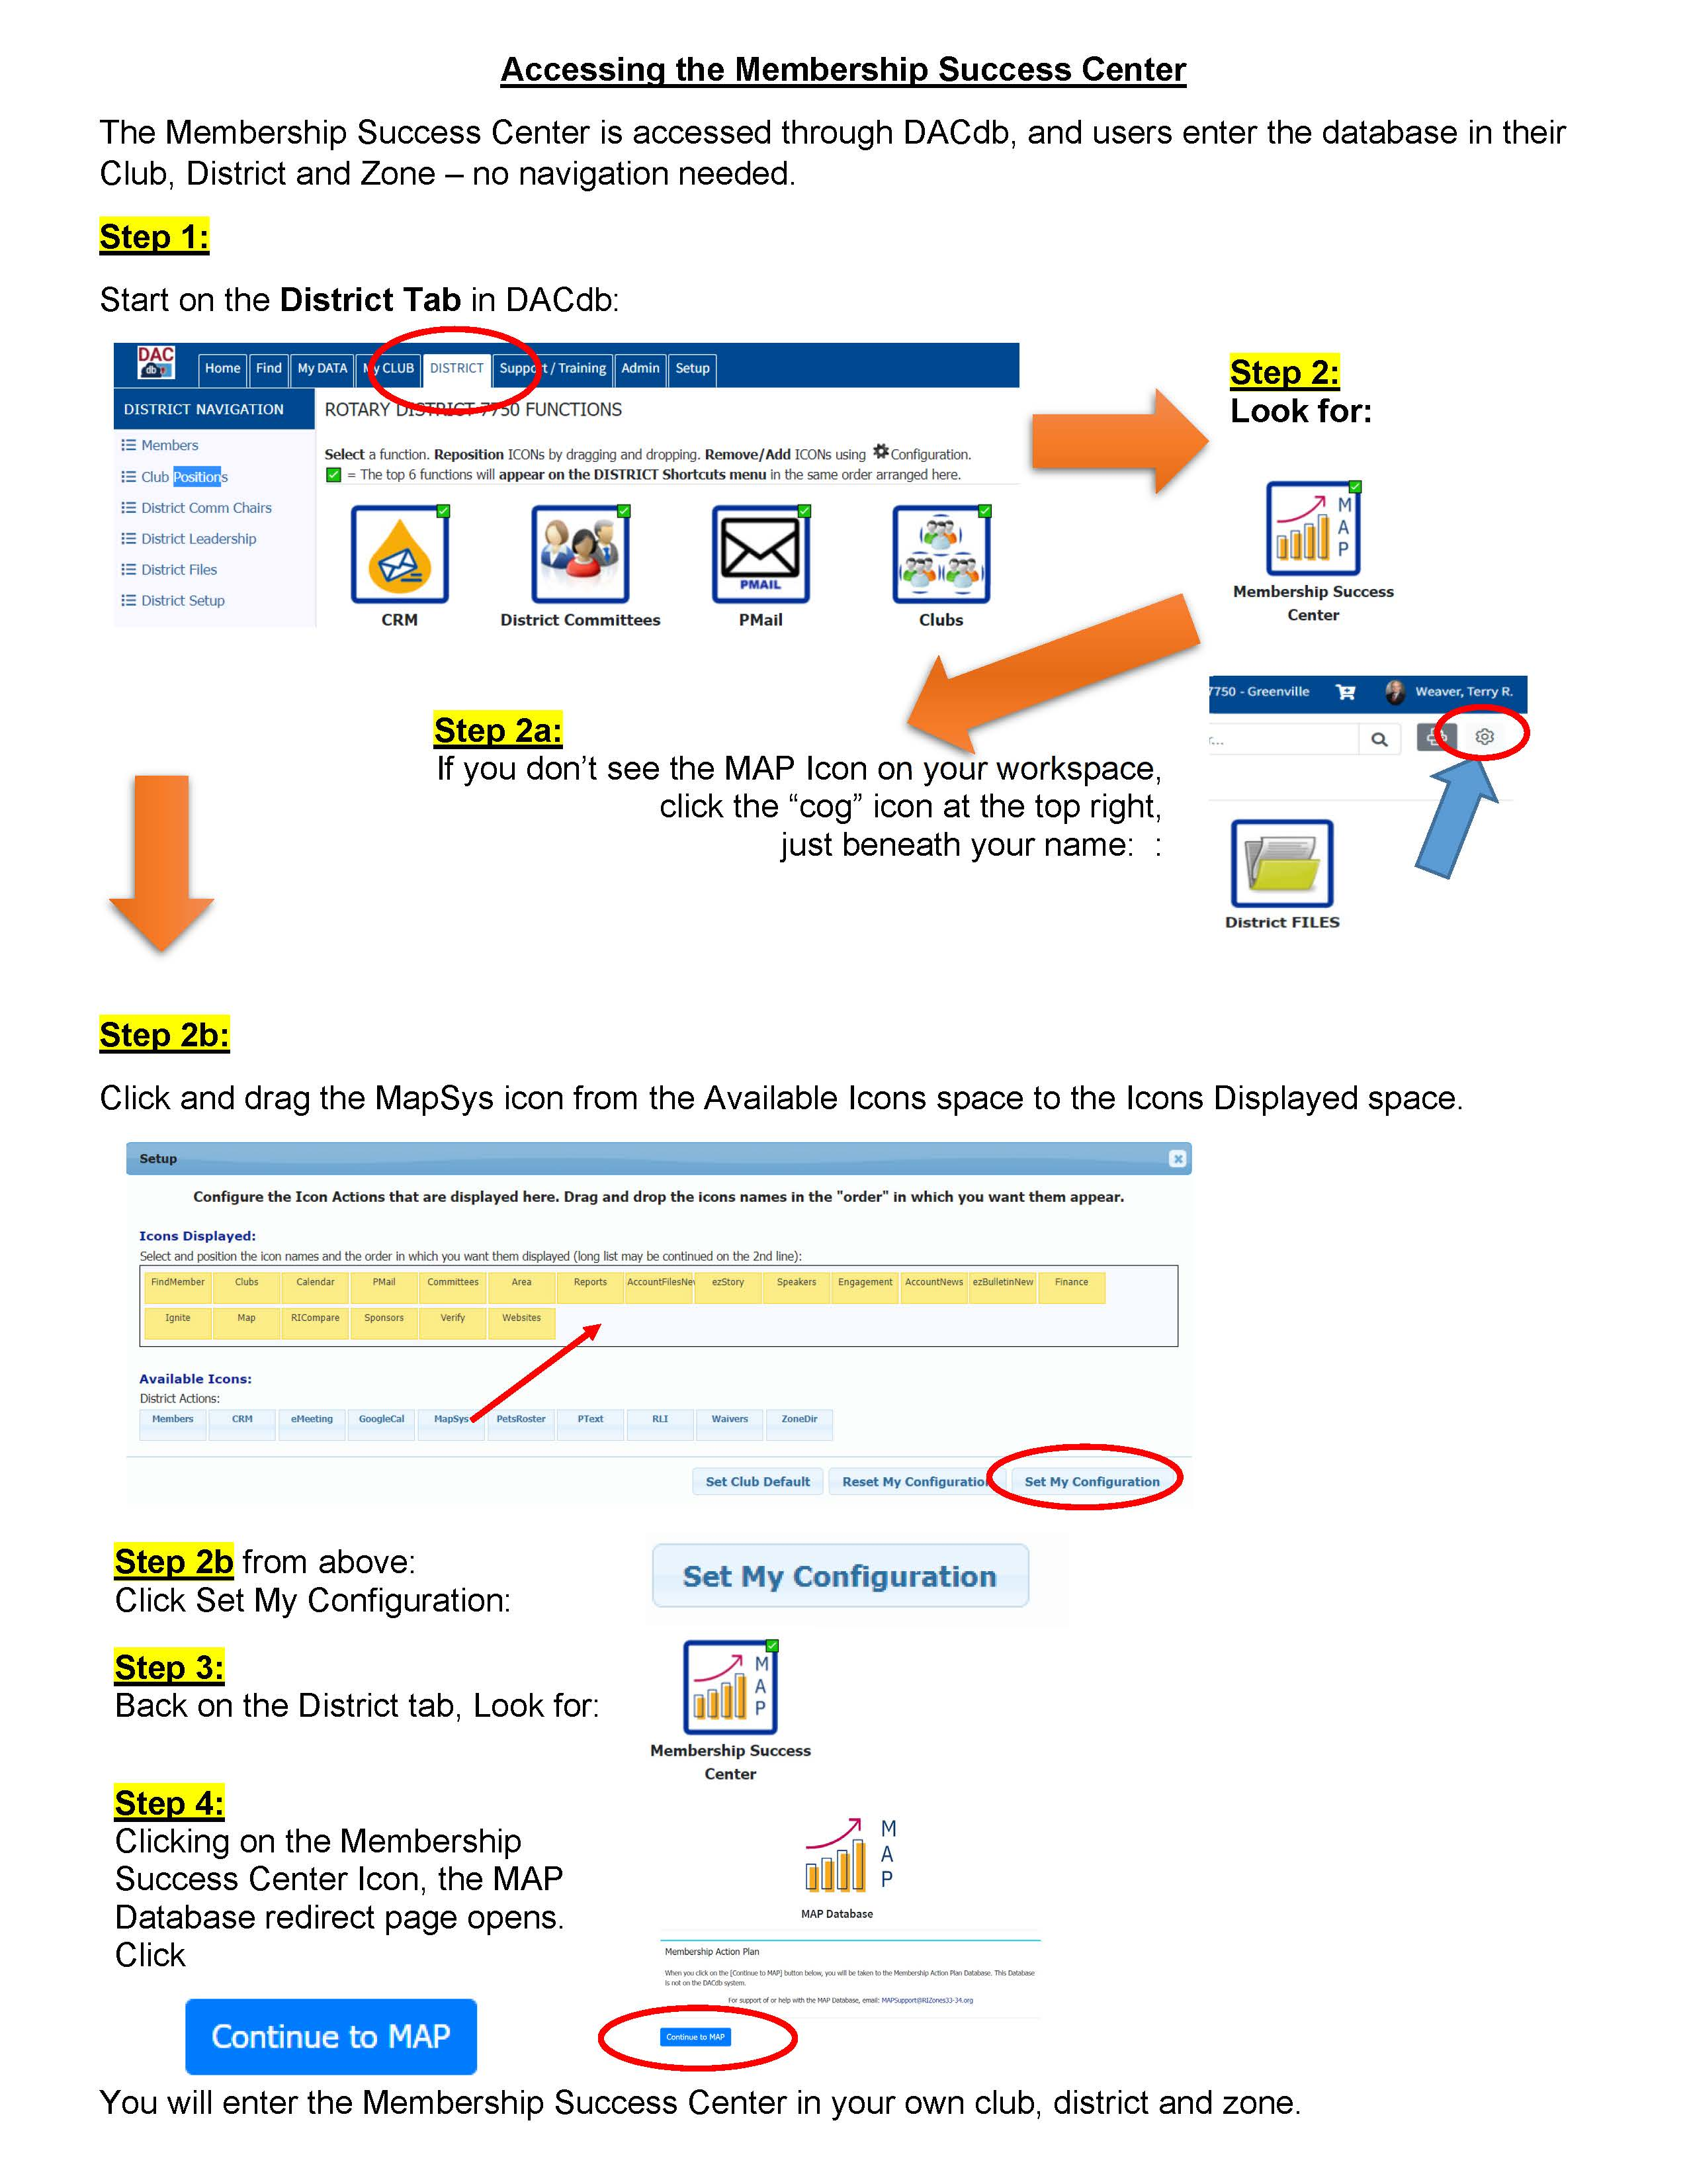
9
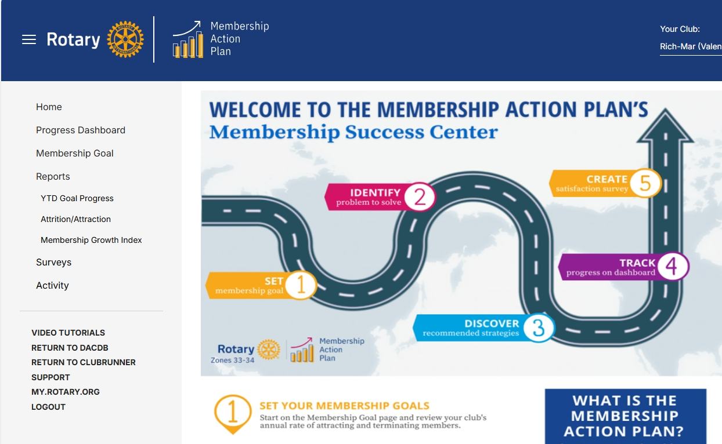
10
CLUB TYPES
CLUB TYPE | DESCRIPTION | APPEALS TO
Rotary Club | Club Experience can include a meal, hosting a speaker, and practicing traditions that members value. Often have higher dues because of venue and meal costs. | People who want to socialize over a meal while learning more about a new topic or an opportunity to serve the community.
Satellite Club | A section of a Rotary Club that has its own meetings and projects fun individually or in collaboration with its sponsor club. May decide to charter as an independent Rotary Club in the future. | Those who want a club experience, a format or time other than what’s offered by other clubs in the area but appreciate the support and partnership of another club.
Companion Club | A type of Satellite Club with no intent to separate from the Host Club. | Similar to a Satellite Club.
Cause Based | Club whose members are passionate about a particular cause or interest and focus their service efforts in that area. | People who want to network and connect with others while addressing a particular cause or interest to provide solutions or assistance.
IMPACT | The club’s primary mission is community service, perhaps seen as a “service only” club without a commitment to traditional meetings, speakers, meals, etc. | An IMPACT club’s service-only focus without meeting requirements offers Rotary membership as an opportunity to those who cannot attend meetings for various reasons.
E-CLUB | A club that meets primarily online. | People who travel frequently, people from different parts of the district, state, country or world who want to be part of a club that offers networking/socializing and opportunities to serve in their local area through a project that is being completed across the different geographical areas or a main project of the club.
11
Rotary Club of _______________________________________
Name _____________________________________ Date ___________
Part 1: Membership Growth Plan Brainstorming (pp. 12-18)
There are no wrong answers – it’s brainstorming!
Let’s Get Growing!!!
Step 1: Start with Why, Who & Wow!

First and foremost, who is LEADING the membership efforts?
Identify your Membership Chair and ACTIVE Committee members. They will lead Steps 1-3. You’ll list the Committee’s step-by-step specifics in Step 3 on page 16.
----------------------------------------------------------------------------------------------------------------------------------
Next: THE CLUB IDENTITY EXERCISE to clarify your WHY & WHO:
(Write in the circles on the next page.)
How do we see our club? How do others see us?
How can we improve our club experience, to make our club irresistible?
How can we use this to grow stronger, so we can create greater value for our members?

1. Outer circle: what are our club’s GIVEN characteristics (stats)? e.g., lunch, traditional, large, small, diverse, satellite, young, etc.

2. Middle circle: what are our CHOSEN characteristics? e.g., work with children, sweat equity work, check writers, work with city officials, international focus, signature projects & fundraisers, etc.

3. Inner circle: what are your club CORE VALUES? e.g., connectedness, fun, quality time, service to others, quality time, community involvement…

For consideration: Invite people so they have a place to improve the quality of their life.
- Are our actions aligned with our values?

- Do our GIVEN and CHOSEN characteristics align with who we want to be as a club?

- Which items contribute to being irresistible?

- Which items take away from being an irresistible club?

Who's responsible/accountable?
12
3. CORE
VALUES
1. GIVEN
CHARACTERISTICS
2. CHOSEN
CHARACTERISTICS
CLUB IDENTITY EXERCISE

See previous page for instructions
Step 1 additional sub-steps:
- Does your club REALLY want to grow? Many members like their club because of the stability, but a steadily growing club may look significantly different in 3 or 4 years. Even slow, consistent net growth requires deliberate, ongoing discussions and buy-in.

- What discussions need to happen to set the stage to really grow?

- What are your reasons for wanting to grow? What are your reasons for wanting to remain “as is”?

- What would happen if you added a net 5 new members? Is it a positive change? Can you do that?
- On a scale of 1-10, what is your:
- Confidence level that your club can have net positive growth this Rotary year?
- Commitment level you are willing to invest to make growth happen?
- What needs to change & is holding you back from growing? e.g. venue size, no plan, no buy-in.

Who's responsible/accountable?

- What are your REAL club growth goals? Why? Are they different than current goals?
More and bigger service projects? Bigger fund raisers? More fun? More high-quality friendships? More community impact? EXAMPLE: One small club’s goal is ‘dramatically more service quickly’. They’re starting two companion clubs as the only way to do that. Membership could double in a year, because they identified their REAL goal (it wasn’t membership growth), and got strong member buy-in.
14
- What are your club’s most compelling REAL goals that require more members to achieve them? Who feels most strongly about these? IMPORTANT: Membership growth may be the by-product
and not the primary REAL goal. Put your energy toward your REAL goals.
- When will you discuss this with the board and club?

Who's responsible/accountable?
Step 2. Identifying New Members
A club must create a CULTURE OF INVITING, to consistently add new members who would enjoy and benefit the club. This CULTURE OF INVITING is the most common "missing link".

- Take 5 minutes now to complete “Why Your Club” on page 22.
Now: Work on identifying who we want, and helping members find them.
- How can we help members identify specific potential members AND to invite them?
- How can we use ‘What’s in it for Them?’ from page 1 to invite more members?
- How can we create a ‘CULTURE OF INVITING’? Who will Model the Way & set the example?
- Who will be the first person to invite multiple guests, to initiate this CULTURE OF INVITING?
- What events can we invite guests to besides meetings? See pages 6-8 for Discover Rotary.
- How can we be more intentional about all sorts of diversity and inclusion?
- Where is the energy in your community? Where does the action take place? Schools? A central community place? The Chamber? Other professional organizations? The live music on weekends at the local shopping center? Main St? Go to the heartbeat of the community and invite those people to a social, to a service project, or to a meeting with a speaker that would interest them.

SOME INTENTIONAL STRATEGIES TO IDENTIFY NEW MEMBERS
Use the “Why your Club” and “Who Do You Know’ on pages 22 - 26 at a Club Assembly. Allow about 15 minutes for members to fill it out. Members will keep it. Ask them to regularly add to this sheet, and just as regularly invite people on it to a meeting or club event.
Fill in the Gaps: Classification/Profession Gap Analysis – Identify local business leaders and professions that ought to have someone in Rotary. Ask which members know someone at each and who will invite them to an upcoming meeting or event, or meet with them one on one.
Consider first inviting to a Discover Rotary event, fund raiser, social or service project.
Create a strong CULTURE OF INVITING, with the Club President and board members Modeling the Way by inviting prospective members on a regular basis, to either a club meeting, project or event. Clubs with this culture tend to grow. The ones without this culture? You can guess the answer.
Who's responsible/accountable?
15
Step 3: Attracting New Members
Effectively presenting Rotary to qualified potential members. Many clubs experience a 50%+ success rate with potential members attending a Rotary Information Hour (Discover Rotary).
- Attracting Members -- How will we present our club? How will we tell our Rotary story?
- Should we consider new membership types, such as Family, Service and Corporate?
- What else should we do to attract new members? Something we’ve never done?
- How can we use ‘What’s in it for Them?’ from page 1 to invite more members?

- List the specific steps our Membership Chair/Team follows from guest to pinning:

SOME INTENTIONAL ‘ATTRACTING’ STRATEGIES:
#1 PROVEN STRATEGY: Periodic "Discover Rotary events", where the guest is the primary focus.
Keep membership applications at your meetings, and email a pdf of it to every member.
Use more and bigger service projects and invite guests, especially younger ones.
Membership Team gets guest contact info at the meeting to reach out to invites them back. You can also add them as a Potential Member on DACdb so they receive the club newsletter.
Innovative Clubs – consider a ‘companion’, ‘satellite’ or ‘impact’ club to grow, by attracting new people who just want to do service, meet at a different time, or have a different group to interact with. It’s limited only by your creativity. Please contact PDG Ken Fleeson for help.
Innovative Member Types. See page 11 for description of Club Models
Who's responsible/accountable?
16
Step 4. Onboarding New Members
Long-term retention starts with an effective Rotary onboarding and training program. Engaging members in the club's activities during their first year of membership is essential to keeping them.
Members play and stay where they feel valued! How can we make them feel they BELONG?

How will we ensure that new members understand Rotary, our Club, its expectations and
opportunities for service, and feel they BELONG here? Intentional strategies we will use:

SOME INTENTIONAL ONBOARDING STRATEGIES:
ONE APPROACH:
- Create an Onboarding Chair position to work with newly pinned members in their first year.
- Create an Onboarding Checklist (sample on pages 27 & 28).
- Front with lots of great engagement ideas, including beyond
the club. For example, Rotary Leadership Institute, District events, and more.
- Back – 4 quadrants for Four Powerful Benefits – Relationships, Service, Growth and
Learning. Ask them to fill in what they want out of Rotary in each area.
- Onboarding Chair first year Formalized Caring with each: 15 minutes/mo., helping them on front & and back items. Use it to expand their Rotary world, including introductions outside the club.
Schedule periodic New Member Orientation events with recent new members. Never go more than 6 months without a new member attending one. Include board or other key members.
Work to get new members engaged immediately in a project, and helping the Sgt. at Arms so they get to know members faster. Early engagement is THE key success factor in retention.
New member service project – new members organize it and recruit club members to help.
Who's responsible/accountable?

17
Step 5: Member Care, Engagement, & Retention

We join and stay where we feel like we belong. A “good fit” feels right. A good fit feeds what makes us come alive. A strong three-legged stool of Head-Heart-Feet, aka Thoughts-Emotions-Action, will help achieve the results for member care, engagement, and retention.
- Head (Thoughts): What mindset do you employ? What do you think about member care, engagement, and retention? What is your plan?

- Heart (Emotions): How do you create a sense of belonging and connection? What is the energy you feel in your club and among members? How do you transfer a feeling of positivity? When you get granular of what impacts the heart, you will get and keep members. The heart is the glue for connection and stamina during challenges.

- Feet: What ACTIONS & behaviors do you take to demonstrate & support what you think & feel? What behaviors and actions do you take to show others you care? To help people feel as if they belong? To emphasize connection and camaraderie? Do you only reach out in a crisis? Do you make time for conversation at meetings? Do you implement a table question for discussion? Do you highlight members? Do you allow for health/happiness? How can that work for large clubs?

SOME INTENTIONAL, CARING & ENGAGEMENT STRATEGIES:
Member Care Team: contact members who’ve missed ___ meetings, have health or family issues, etc. (Because we are busy, caring acts sometimes have to be formalized and intentional.)
Elevate the Club Experience (see Step 1) -- Clubs have proven a great club experience is key to attracting & keeping members. Meetings should be well-organized, & programs should be informative, educational, or inspirational. Diversify programs & limit non-profit presentations unless you support them or there’s a value proposition for your club. Do a Member Satisfaction Survey. See the Membership Success Center for sample surveys. (See p.9 on how to access it.)
Mentorship -- Create a mentorship plan to assign an experienced member to work with a new member. Their help could be in addition to the work of the Onboarding Chair.
Meaningful Service Projects – Why most join Rotary. Your own Rotary-branded service projects work best. Hands-on, shoulder-to-shoulder service work is where members get to know one another & bond. Use more service projects to grow. Work hard! Play hard!
Who's responsible/accountable?

18
Rotary Club of _______________________
Part 2: Five Step Membership Growth Plan
(pp. 19-21)
Name _______________________________________ Date ___________

Please add your information from the handout:
7/1/21 Membership: _____ members 3 Yr. Avg. Attraction #: ______ rate (%): _______
7/1/24 Membership: _____ members 3 Yr. Avg. Attrition #: _______ rate (%): _______
Membership Goal: Grow by ___ members (net), requiring ___ new members (growth + 3 yr. attrition #)

NOTE: Data from handout are also in the MEMBERSHIP SUCCESS CENTER. See page 9 to access it through DACdb. Use it to quickly see if you have a front door (Low Attraction) or back door (High Attrition) problem, neither, or both.

Our Membership Challenges – From the above data, what challenges are facing our club?
- Low Attraction? | - High Attrition? | - Maintaining good growth momentum?
(See pages 28 and 29 for specific Strategies for Attrition and Attraction issues.)

Step 1: Start With Why: An Irresistible Club = Retaining Members & Attracting New Members
How will we improve our club experience, so members want to join & remain in Rotary? How will we make our service projects more meaningful? Are we really ready to grow, and know our big goals?
Intentional strategies we will use:

Who's responsible/accountable?
19
Step 2: Identifying New Members -- What is our plan for prompting members to think of candidates AND for inspiring members to contact them? Intentional strategies we will use:

Who's responsible/accountable?

Step 3: Attracting Members -- How will we present our club to prospects? How will we tell the Rotary story & share the Four Powerful Benefits of Rotary? Intentional strategies we will use:

Who's responsible/accountable?

20
Step 4: Onboarding New Members -- How will we ensure that new members understand Rotary, our
Club, its expectations and opportunities for service? Intentional strategies we will use:

Step 5: Member Care, Engagement & Retention - How do we formalize caring to make members cared for and engaged so they want to stay in? Intentional strategies we will use:

Who's responsible/accountable?

21
Name: __________________________ Club: _____________________ Date: ________
15-minute Club Assembly exercise: 8 minutes: Why Your Club. 7 minutes: Who Do You Know?
Encourage members to keep this with them, to add to & invite guests to meetings & events.
Six Questions: Why Your Club?
Questions Your Answers
What reputation do you want for your club? “We’re known as the ______ club”.

What types of people do you want to join your club? Be specific. Some ideas below.

Membership benefits in your club should be obvious. What are they?

Why should someone be excited about joining your club from Day 1?

Why should they be excited about joining Rotary from Day 1?

How can you create and show energy that draws people in?

Your 15-30 sec ‘elevator speech’: To encourage someone to attend a meeting.

Who Do You Know Who? Name, what they do, contact info.
= Is someone who likes to get things done.
= Is different than you in some way.
= Is a leader by mindset, in the community or in their profession.
= Has a Service Above Self mentality.
= Has classy values.
= Is someone you want to spend time with.
= Is fun and hardworking.
= Likes to recruit & grow an organization.
= Is a future Rotary “partner in crime”, and a good fit in your club.
= Is a Rotarian before being in Rotary.
= Is attracted to high quality relationships & growth opportunities.
= Is in a profession you’d like in the club.
= Importantly, can benefit from Rotary!!

ADD SOME NAMES NOW, THEN MORE LATER.
Remember why people join – Relationships, Service, Growth & Learning. Invite them to a meeting or event.

22

This very useful worksheet, properly deployed, can be a great "lead generation" exercise for your club. Most clubs that fall short of their growth goals do so because of a lack of "lead flow", meaning they don't have enough people on their prospect lists.

The 10-3-1 Rule

People experienced at prospecting realize that not every prospect will come through, whether as a customer or as a new Rotary member. In major league baseball, a 30% hit ratio is considered GOOD, even if it's a 30% hit ratio of only singles.

Generally speaking, it will take about 10 leads (referrals or acquaintances) to get into 3 substantive conversations about Rotary, to get 1 member.

How to Use This Worksheet

Most Important: This is not "homework". Anyone who has let a member take this home, expecting to get it back has been disappointed. That does not work.

Second Most Important: This information is not for the Membership Committee. When this exercise is complete, don't ask members to pass the worksheets in. What that does is imply that it's the Membership Committee's job to contact prospects and attract new members. Keep that shoe appropriately on the member's foot. In a Rotary Club it's everyone's job to attract new members.

Quick Start Guide

- Announce a Club Assembly where members are asked to bring their contact information.
- Send reminders a few days before and the day of the meeting emphasizing contact information.
- Print the "Rotary Membership - Who Do You Know?" worksheet 2-sided and put one at each member's seat
- At the meeting, explain why it's essential to build membership
- Explain the exercise -- 15 minutes, heads-down, listing everyone we know on the back page
- List the “Top 5” potential Rotary prospects on the front page, with contact information
- Walk the room to be sure members are engaged -- break up "chit-chat" sessions
- Contact the Prospects – Members get in touch with a week to invite them to a Rotary event
- Option -- Have them list the Top 5 on a 3"x5" card so the membership committee can enter them as Prospects
- Option 2 - Have them take a photo of their page and email to the Membership chair so the membership committee can enter them as Prospects

See next page for detailed "How to use this worksheet"

23
Detailed "How-to"

- At least a week in advance, announce to your members that an upcoming meeting will be a Club Assembly, where they need to bring all their personal and business contact information. That may be on a smartphone, tablet, laptop, Rolodex, business cards in a rubber band, or handwritten on notebook paper. Email or phone all members, so you also reach those who weren't at the meeting.
- Remind your members to bring their contact information to the meeting. Use phone or email, a few days before the meeting and the morning of the meeting. Make sure there's enough communication that "dog ate my business cards" isn't a plausible excuse.
- Lay out the 2-sided "Rotary Membership - Who Do You Know?" Worksheet on each table - 1 per member.
- As you open the exercise, explain why this is important -- It's essential to build our membership, and we need members bringing prospects to membership events and as guests at meetings to ensure a steady flow of new member candidates. We need more prospects.
- Explain what we're going to do -- We're going to take 15 minutes, individually, to recall as many people as we can who we know - not necessarily prospects, just people we know, jotting those names on the “thought-starter page” (reverse side).
- Then, enter the Top 5 on the front page, along with contact information.
- Go into "Proctor" mode. Some members won't take you seriously. If you let that happen, the exercise will collapse. Walk the room. When you find a couple of members chit-chatting instead of doing the assignment, say, "Guys, I really need your help with this. You may have a better idea for how to identify prospects, but I'm asking you to humor me for the next few minutes and give this exercise a try."
- Ask each member to contact their prospects in the next week to invite them to either a pre-determined prospective member event, or to a future meeting focused on membership.
- OPTION: You might also have 3"x5" cards on the table where they can report their names and contact information to the membership committee. They take the full prospect list with them, and the membership committee enters them in DACdb as Potential Members
- OPTION 2: Ask them to take a picture of their prospect page with their phone, and email it to the Membership Chair, who will enter them in DACdb as Potential Members, along with their contact and Sponsor information.
IMPORTANT: Please don't take up these sheets after the meeting. That suggests to the members that it's somebody else's responsibility to approach and contact these prospects. Keep that shoe on the member's foot -- it's everyone's job to regularly bring prospective members to Rotary.
Follow up -- At the next meeting or by email, ask members how they're doing on their 3 prospects. If they're not making contacts, ask "What's getting in the way?" Then see what you can suggest to break down the excuses or roadblocks.
GOAL: If you can get each member to bring just one prospect to the table, you'll eclipse most any prior membership development effort in your club. Getting members to act on approaching and inviting members is not only your biggest challenge, but also your key success factor.
24


Rotary Membership - Who Do You Know?

Your Name Date

Your E-Mail Phone

Considering our Rotary Club's passion and purpose - Service above Self and networking opportunities, do you know professional colleagues, community leaders, friends or acquaintances who might qualify as potential Rotarians? Please list at least five individuals you believe should be in Rotary.

Name | Occupation | Email | Phone

25

Acquaintances to Consider:
Architect Home Health Service
Attorney Hospitality Owner/Manager
Banker Internet Technology Consultant
Business Consultant Manufacturer
Chiropractor Non-Profit Executive Director
Contractor Other Leader(s) in your Company
C-Suite Executives or Management Physician
CPA Public Relations Manager
Customer(s) Public Relations/Marketing Agency
Dentist Religious Leader
Distributor Reseller/Manufacturer’s Rep.
Engineer Retail Owner/Manager
Entrepreneur School Administrator
Estate Planner Software Developer
Financial Manager/Planner Supplier(s)
Friend/Neighbor Veterinarian
Funeral Service Other

26

ROTARY CLUB: _________________________________________
Rotary District 7280
Suggested 3-6 Month New Member Onboarding Steps
FRONT: Getting the most out of Rotary membership and moving you from a club member to a Rotarian. Discuss these with the Club Onboarding Chair.
BACK: Write what you want out of Rotary in the areas of the Four Benefits of Rotary: Relationships, Service, Growth and Learning. Regularly discuss what you want with the Onboarding Chair.
Please complete both sides, give a copy to the Club Onboarding Chair, and keep the original.
You should have 3-6 months of ongoing discussions about both sides with our Club Onboarding Chair.
Date Completed:
- Attend Orientation/New Member event (when scheduled). _____
- Serve as a Greeter and assist at the Sergeant-At-Arms table for three Club Meetings. _____
- Attend a District event (District Conference, Fall Workshop, District Assembly, etc.) _____
- Participate in one of our service projects. _____
- Help with one of our fund-raisers or social events. _____
- Actively serve on a club Committee. _____
- If possible, attend another Rotary club meeting. _____
- Become familiar with www.rotary.org & www.rotarydistrict7680.org. _____
- Learn how to login on www.My.Rotary.org. _____
NOTE: www.My.Rotary.org is Rotary’s internal website, and www.Rotary.org is the public website.
- Learn how to login on www.DACdb.com, the District and Club Database. _____
You can add to your information, find District Rotarians, register for events under Calendar, & more.
- Become familiar with our club website, and Friend us on Facebook. _____
Please help us get to know you better by participating at meetings and sitting at a different table every week. Reach out to a few members you think you might be able to help, and vice versa.

When you’ve completed the activities, congratulations! You’ve become an integral part of our club, learned about Rotary beyond our club, gotten to know your fellow members, feel you belong here, & had some fun.

Questions? Please contact
- Your Sponsor. Contact info: _____________________________________________________________
- Onboarding Chair. Contact info: _________________________________________________________
- Membership Chair. Contact info: ___________________________________________________________
- President. Contact info: __________________________________________________________________
- Your Name: ___________________________________________________________________________

27

Onboarding page 2: FOUR POWERFUL BENEFITS OF ROTARY
HOW CAN WE HELP YOU GET WHAT YOU WANT IN EACH AREA?
RELATIONSHIPS SERVICE
- Quality (people who recite live the Four Way Test) - Either find your service passion or bring it
- Serve locally or internationally
- Fun serving, growing & learning together - Use Rotary’s incredible reputation and support
- Connections

GROWTH – PERSONAL & PROFESSIONAL LEARNING - ABOUT
- Improve speaking, organizing & leadership skills - Community organizations, leaders, opportunities
- Be a mentor or be mentored - Your club and club members
- Leadership, service & growth opportunities - Our District, other clubs & Rotarians
- Rotary International & The Rotary Foundation

First time https://DACdb.com login: Username is your email address, & password is your RI member number,
which you can get from your club Secretary, Rotary communications, & your Rotarian magazine address label.
First time https://rotary.org login: Click on My Rotary at top. Click on Register for an Account. Click on Create Account. Fill in Account registration information & click Continue. Click Activate your Account in the email it will send. Finish Account Setup and click Create Account. Then click Continue or My Profile. NOTE: outward facing https://Rotary.org and inward facing https://My.Rotary.org have different menus and inform.

28

Attraction or Attrition Issues?

Strategies taken from the Membership Success Center

See page 9 for accessing the Membership Success Center

General Strategies
- Set a Club Membership Goal and develop a written Membership Growth Plan (pp 19 - 21)
• Communicate the Goal & Plan to the club regularly
• Highly visible, relevant, and impactful service projects and events (Invite “Not
Yet” Rotarians to these events)
• Consider these 10 proven Intentional Membership
Strategies: https://www.rizones33-34.org/?s=intentional
• Work on making your club irresistible

Insufficient Attraction
Attraction Rate is less than 5% greater than Attrition Rate.

- Start a satellite club with an alternate meeting time/place/frequency or create new member types that reduce cost (no meal) and time demands...
- Consistent messaging to club members about why the club’s consistent, moderate membership growth matters. Use all communication media – direct conversations, podium announcements, club newsletters, etc.
- Is your club attractive to prospects? Invite a friend or another Rotarian to attend a meeting as a “secret shopper”. Ask them for a candid, honest assessment of how your club looks to a stranger. Are we a friendly club, or a group of friends?
- Inspire members to identify prospects – customers, suppliers, co-workers, friends, neighbors, family members - and bring them to a Rotary Information Hour – a crisp, focused overview of your club and Rotary International
- Do a “Who do You Know?” exercise at a club assembly or before a meeting to prompt members’ recall of their contacts
- Do a “Gap Analysis” on types of businesses and professions missing from your club’s membership. Specifically ask members to seek our prospects in those vocations
- Club president personally asks (a real conversation) each member to bring a prospect forward
- Capture all prospect contact information in your member management database, then drip market and follow up regularly
- Become visible in the community -- Actively use social media & other means to promote projects, events & fellowship.

29

High Attrition
Attrition rate exceeds District average of about 14%

- Focus on Active, Intentional Member Engagement
    - New Member Mentorship – a “buddy system” to facilitate acquaintance and engagement (train the mentors)
    - Involve all members in committees/projects
    - Consider a “new member class project” – selected, designed, promoted, and led by all the new members joining in a one-year period. – a service activity with some bonding built in.
    - Start a new service project in an area not previously served. If needed, put a tired project to sleep
- Do a Member Expectations Survey or Entrance Survey when members join, asking what they’re looking for.
- Find out what your members want. Do a Member Satisfaction Survey - available in the Membership Action Plan module of DACdb
- Enhance the club experience – consider:
    - Programs– Eliminate non-profit funding asks. Make sure every program educates, inspires, or entertains your members.
    - Meeting place
    - Food
    - Alternate meeting time/frequency
    - Cost of membership and non-meal offering
- Develop an effective New Member program. https://www.rizones33-34.org/?s=onboarding

30

Take Notes of Great Ideas
District 7280 Membership Summit
Name_________ _ _______Club _ _______Date _ _ ___

31

