District 7360 Club MOU Document 2020-2021



Rotary Club of= Lewisburg (Sunrise) MOU Qualifications Document

# A) Terms of Oualification

* Clubs that receive certification are qualified for one (l) year.

 2 club members must attend yearly a Grant Management Seminar (GMS) held by District 7360.

* Clubs must submit a MOU to the District 7360 Grants Subcommittee by September 15th 2020  Clubs must have entered at least 13 goals in MyRotary by September 15, 2020
* Clubs must disclose any conflicts of interest and cooperate with any District or TRF audit.
* Club President must have attended PETS or equivalent training.

# B) Club Leadership Responsibilities

* The Rotary Foundation Chair of the Rotary Club of will be responsible for the management of the club's qualifications and ensure there are financial stewardship measures and proper grant management practices in place.
* Documents will be stored in hard copy by the club's TRF Chairperson. Also, an electronic file of all related documents will be kept by the TRF Chair and financial records by the Club Treasurer. The Club TRF Chair, Club Treasurer, Club President and the Club Grants Chair will have access to these records.  If any one of these individuals should leave the club for any reason, the club will appoint in a timely manner an individual to replace the person that left.

# C) Financial Management Plan

* A separate bank account will be opened if the Club is the Host Partner of a Global Grant.
* For "District Community Grants, " this will be reimbursable after submission of "Final Report," there is no need to open a separate bank account. Instead, use check/ bank cards to track fund distribution.
* The Club Treasurer will keep a standard set of accounts related to the Clubs District Community and/or Global Grants. The treasurer will maintain a record of all receipts in hard copy and electronic copy with access by Club Treasurer, Club TRF Chair, Club President and Club Grants Chair.
* The Club Treasurer and Assistant Treasurer or other assigned member of the club must sign all checks related to any disbursement of grant funds as received by the club for any District Community or Global Grants. A copy of all Bank Statements will be kept both hard copy and electronically.
* The Club Treasurer will maintain a ledger of all grant funds received for either District Community/lnternational Grants or Global Grants.
* The Club Community Grants Chair will be responsible for the inventory of items purchased, produced or distributed through grant activities and provide a copy of such to the Club TRF Chair.
* The Club is responsible for naming a new person to any of the roles of Club Treasurer, Club TRF Chair or Club Community Grants Chair with a copy of this document so they will be aware of duties as they relate to the TRF Grants/Monies.

# D) Document Retention

The Club TRF Chair will maintain a file of all documents related to MOU in both hard copy and electronic file.

District 7360 - Club MOU

• The Club TRF Chair will maintain the documents relating to Terms of Qualification, Leadership Responsibility, Financial Management and Document Retention both hard copy and electronically.

# E) Reporting on Use of Grant Funds

* The club must submit a report a Final Report within 60 days of the completion of a District Community/lnternational Grant with copies of all receipts, bank statements and a copy of the DI/CG report form to the District Community Grants Co-Chairs (DCGC), Pam Wagoner and Ken Martin
* Global Grant reports must be submitted each year (Interim) and a Final Report within 60 days of the completion of the Grant Project to TRF including all receipts, bank statements etc. This is done through member access on the RI website, with copy to Global Grants Co-Chair (GGC), Susana Falck and Carl

Askew.

# F) Method for Reporting and Resolving Misuse of Grant Funds

The club will report to the DRFC Swan Stull any potential misuse or irregularities in grant related activity.

Authorization and Agreement

This memorandum of understanding is an agreement between the club and the district and acknowledges that the club will undertake measures to ensure the proper implementation of grant activities and proper management of Foundation grant funds. By authorizing this document, the club agrees to comply with all of the conditions and requirements of the MOU.

On behalf of the Rotary Club 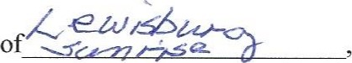 the undersigned agree to comply with all of the conditions and requirements of the MOU for Rotary year 2020/2021 and will notify Rotary International District 7360 of any changes or revisions to club policies and procedures related to these requirements.

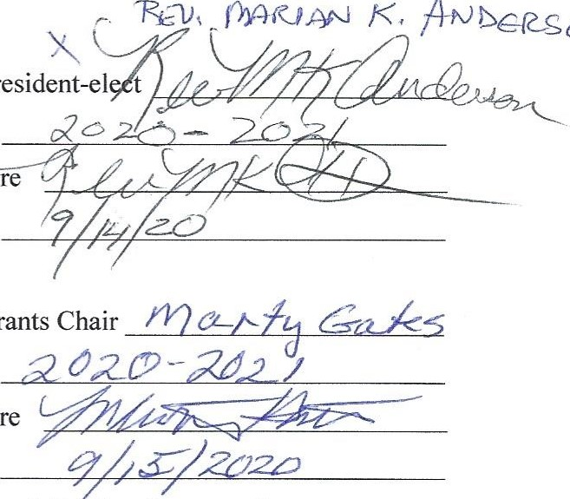

Am)bcesoo

Club

President-el

Club

Grants

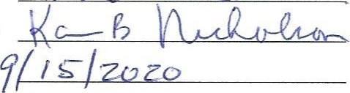Club President  Term

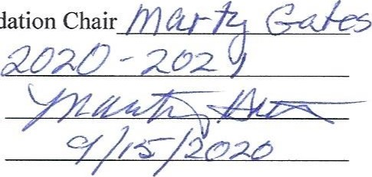

Club

Foundation

SignatureSignature

Send electronic copies of this form to the following four people:

District Rotary Foundation Co-Chair Swan Stull — swans@ptd.net,

District Rotary Foundation Co-Chair Kelly Wike — kelly.wike.bvkb@statefarm.com District Grant Co-Chair Ken Martin - [kpmartin@stamps.org](mailto:kpmartin@stamps.org),

District Grant Co-Chair Pam Wagoner — depotflorist@yahoo.com

Revised 2020/06/09

2

# District 7360 Community Grant Application 2020-21 Application Deadline: Sep. 15, 2020

Oualified Clubs may submit one (1 ) project per each Rotary year or two (2) if they gave over $6,000 to the Annual Fund during 2017-18

Rotary Club of:

Project Title: (Maximum 25% of AF Giving 3 yrs prior per club or $500 to $1500)

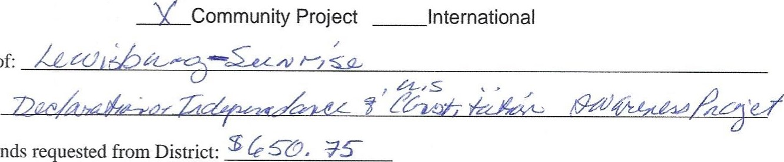

Amount

of

funds

Amount of funds committed by Rotary Club for Project: (Must be equal to

or greater than amount of funds requested from District)

Club has previously applied for District Grant? YES If Yes, what year? 19-20

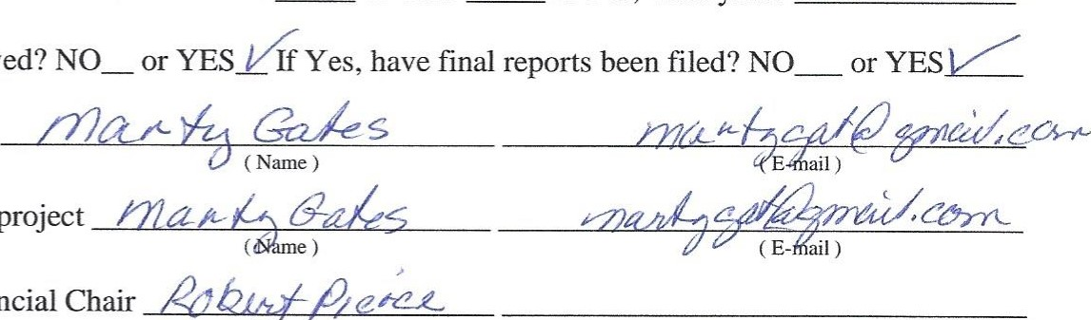Was that previous grant received? Yes Final Reports filed? YES

2020-2021 Club Grants Chair

2020-2021 Club Chair of this project

2020-2021 Club Projects Financial Chair

(Name) (E-mail)



No project may start until final approval is received from District 7360 and The Rotary Foundation

PLEASE ANSWER THE FOLLOWING QUESTIONS IN NARRATIVE FORM:

ADDENDUM: 7360 DCG 2020-21 RC of Lewisburg (Sunrise) Grant Application in narrative Form:

l. Briefly describe the proposed project. What will be done, when and where will the project take place, and who will benefit from the project?

The Lewisburg Rotary Club (Sunrise) promotes active citizenship and community service for its members. A crucial aspect of good citizenship is knowledge of the government and its structure. To this end, the Lewisburg Rotary Club (Sunrise) is requesting funding for booklets of the Declaration of Independence and the U.S. Constitution to be distributed to the students of Mifflinburg Middle School (grades 6-8) and the Lewisburg Middle School (grade 7). The club has also received approval for the Union County Boy Scouts to distribute booklets to troops ages 6-12 and the club has also been in contact with the Girl Scouts in Union County. The booklet will also be given to the Club Student of the Month and to participants in the 4 Way Speech Contest. These efforts will provide civic education throughout Union county. The estimated number of booklets is 750 and each will include a sticker of the 4Way Test and the Rotary symbol with the club name. We believe that knowledge of the U.S. founding and the Constitution supports education and good citizenship. The distribution will begin in October, if possible, and continue during the school year.

1. **How many club members will participate in the project and in what role? Is there a cooperating organization also involved and what will their role be?**

There are 44 members of the club and members actively participate in the club activities. At any given project between 15 and 25 members participate, and there will be different members depending on the activity. There will be additional members preparing the booklets with the 4 Way Test and Rotary stickers. We expect approximately 25 members will be active in this project.

1. **How will the project benefit the community and for how long? Approximately how many people will benefit from the project?**

The direct benefit will be to the 750 students who receive the booklets. The club expects that this will provide an opportunity for conversations in the homes, as well as in the classroom. The effort will strengthen the community in the present as well as in the future.

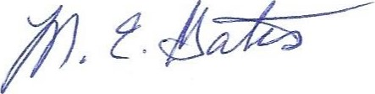

District 7360 Community Grant Application 2020-2021

1. Will the project be completed if less than requested funds are granted?__**YES** X If yes will the project be modified if this occurs? **NO** in what way?
2. How does this project reflect the mission of The Rotary Foundation?

A significant portion of the RI mission involves education and youth. This project supports youth education and community awareness.

APPLICATION REOUIREMENTS:

* All 2020-2021 Rotary Foundation Certified Clubs may submit one (1) Community Grant Proposal if they gave

$6,000 or less to Annual Fund in 2017-18 OR two Community Grant Proposals if Annual fund giving exceeded $6.000 OR one (1) collaborative project with one or more clubs. The project may be either in the district or internationally.

* Each year the Rotary Club must be certified. Please check to certify that the following steps for the 2020-2021 Certification have been completed:

Yes l. Club Memorandum of Understanding (2 pages) signed and received by the District.

Yes 2 Club Grants chair has completed the District Grant Management Seminar.

Yes. 3. Prior District Grant Final Report submitted to the District by stated deadline.

Yes . 4. Club has given $50 per capita minimum to the Rotary Foundation's Annual Programs Fund two of 3 prior years.

Yes. 5 Club President must have completed the PETS or equivalent training as approved by the District Governor.

* District requirements:
* Two (2) club members (one must be the Club Grants Chair) must attend online or in person the District Grant Management Seminar  The club will receive the grant money when the final report and all receipts have been submitted to the District Grants Committee Chair

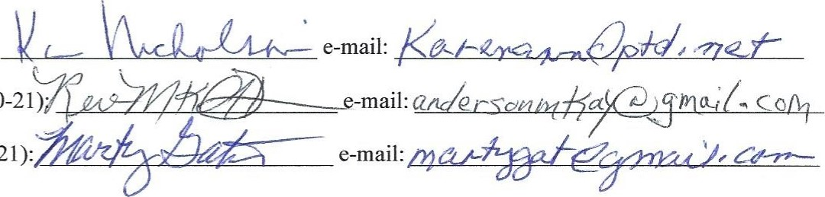

Grant

Application

Signatures:

Rotary

Club

President

(2020-21):

Rotary

Club

President-Elect

(2020-21)•

Rotary

Club

Grants

Chair:

(2020-21):

Submit by e-mail to kelly.wike.bvkb@statefarm.com, swans@ptd.ngt, kpmartin@stamps.org, depotflorist@yahoo.com

Or by regular mail to District Grants Committee Co-Chair:

Ken Martin, 105 Irish Hollow Rd. Bellefonte, PA, 16823 814-380-4008 Email: kpmartin@stamps.org

2