

**FOR IMMEDIATE RELEASE CONTACT:**

March 16, 2017 Tod Balsbaugh

tbalsbaugh@jacksonfeild.org

804-354-6929

**Rotary Club Coat Drive Helps Jackson-Feild**

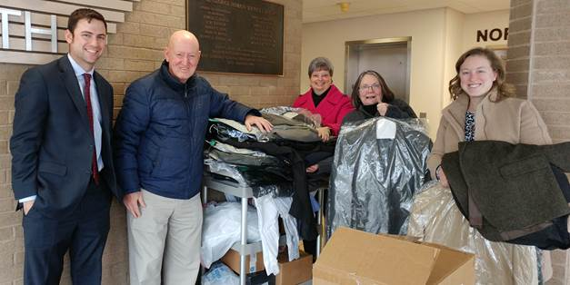

Nine local Rotary Clubs recently joined forces to help the boys at Jackson-Feild Behavioral Health Services (JFHBS) prepare for the 2017 prom.

Prom is one of the highlights of the year for the residents at Jackson-Feild, and for a number of years the Fairy Godmother Program at The Collegiate School in Richmond has provided prom dresses, shoes and accessories for its girls. Ever since JFBHS went co-ed in 2012, there has been a need for blazers/sport coats, dress shirts and ties. For the first time ever, the boys at JFBHS will have a similar opportunity to select attire for the prom to be held on May 19.

Members of the Prince George Rotary Club contacted other local clubs requesting these items. As a result, 79 blazers/sport coats, 29 dress shirts, one pair of loafers, 12 pairs of slacks and countless ties were collected and stored at Prince George Department of Social Services (DSS) by Shel Douglas. Recently, JFBHS’ Meredith Melo and Tod Balsbaugh went to Prince George DSS where Douglas and other Rotarians loaded a van that transported the items to JFBHS.

Prom Night is a special evening that the residents at JFBHS cherish for a lifetime, and JFBHS thanks the members of the Emporia, Petersburg - Breakfast, Petersburg, Fluvanna, Ashland, Colonial Heights, and Prince George Rotary Clubs for providing special attire for its boys.