THE TRINGLE

**The Rotary Club of The Historic Triangle**

**VOLUME 10 No 22 “Service Above Self” January 4, 2023**

**Weekly meetings, Wednesdays, 12:00 noon - Colonial Heritage Clubhouse,**

**6500 Arthur Hills Drive, Williamsburg, VA 23188**

**Visit:** [**HistoricTriangleRotary.org**](http://historictrianglerotary.org)



**Members:**

Mark Anderson *

Paul Arrowood * (Honorary)

John Baxter*

Scott Biondi *

Jason Blanchard *

Patti Boxeth *

Tom Bozek *

Andre Cherebin *

Tom Clark (Service Corps)

Julio Da Silva*

Elisabeth Daley*

Mac Deekens*

Nick Fairbanks*

Swanson Grizzard *

Mitchell Harry*

Jack Hostetter *

Mike Jallo *

Dave Kleppinger *

Fran Kleppinger*(Service Corps)

Jeff Marston *

Clay McEldowney *

Will McElfresh *

Efren Olivo *

Stephen Rice *

Andy Robinson *

Bob Tassone *

Mark Tisone *

Gale Treiber *

Nolan Yelich *(Honorary)

**The Rotary Four-Way Test of the things we think, say or do:**

1. Is it the Truth?

2. Is it Fair to all concerned?

3. Will it build Goodwill and Better Friendships?

4. Will it be Beneficial to all concerned?

**2022-2023 Club Officers**

President: Dave Kleppinger

Past President: Mitchell Harry

President Elect: Liz Daley

VP/Sgt.at Arms: Nick Fairbanks

Secretary: Andre Cherebin

Treasurer: Mitchell Harry

Newsletter Editor:Andre Cherebin

**Rotary Club Calendar: January-Vocational Service Month**

Jan.4- Guest Speaker – John Delano-NASA’S Artemis Program:America’s Return to the Moon

Jan.7-Pre PET’s Presidential Retreat

Jan.11- Guest Speaker-Samantha Redman-Alzheimers Association

Jan.17-Board Meeting

Jan.18.Club Assembly

Jan.25- Nicholas Luckketti-James River Institute for Archaeology

Jan.28- District 7600 Membership Summit

THE TRINGLE

**The Rotary Club of The Historic Triangle**

**VOLUME 9 No 32 “Service Above Self” April 13, 2022**

**Weekly meetings, Wednesdays, 12:00 noon - Colonial Heritage Clubhouse,**

**6500 Arthur Hills Drive, Williamsburg, VA 23188**

**Visit:** [HistoricTriangleRotary.org](http://historictrianglerotary.org)

**Rotary Club Calendar: April-Maternal & Child Health Month**

April 6-Guest Speaker- Mary Helen Hilton-EDMARC

April 13-. Guest Speaker-Kasia Grzelkowski-VersAbility Resources

April 19- Board Meeting

April 20-Club Assembly

April 21-Club Foundation Meeting

April 27-Guest Speaker-Colleen Bonadonna-Purple Pinkie Day

April 28-District Awards submission deadline

April 30- District Training Assembly

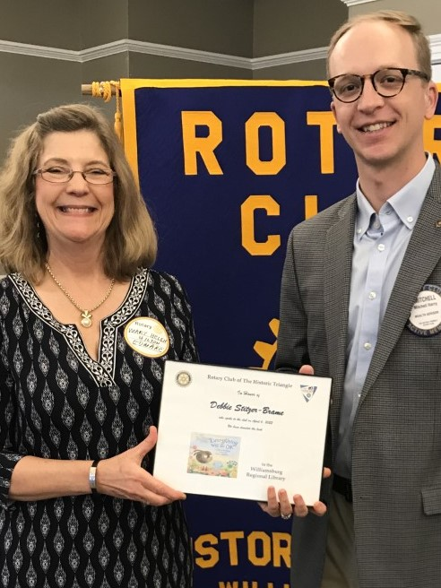

.

**Birthdays this Month:**Jan.1-EfrenOlivio; Jan.7-Bob Tassone; Jan.11-Dave Kleppinger

**Rotary Anniversaries:** Jan.9-Dave Kleppinger; Jan.15- Scott Biondi; Jan.29-Mark Anderson

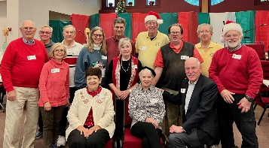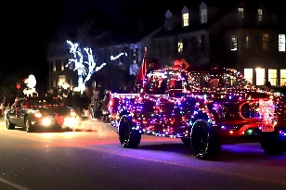 **Activities for the Holiday Season**

Bell Ringing Elfs CornerCommunity Parade

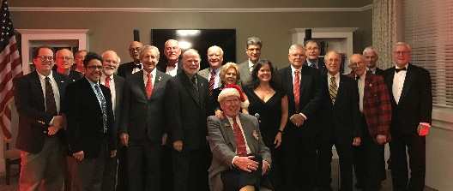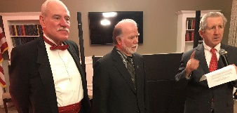

Party

Awards

**ORGANIZATIONS SUPPORTED BY THE ROTARY CLUB OF THE HISTORIC TRIANGLE**

*Elf’s Corner *The Salvation Army

*The Arc of Williamsburg *Dream Catchers

*Williamsburg Youth Baseball League *Angels of Mercy

*Friends of the Williamsburg Regional *FISH

Library

**Club Directors**

Foundation: Clay McEldowney

Membership: BobTassone

Public Image: Jeff Marston

Service Projects: Mike Jallo

Administration: Swanson Grizzard





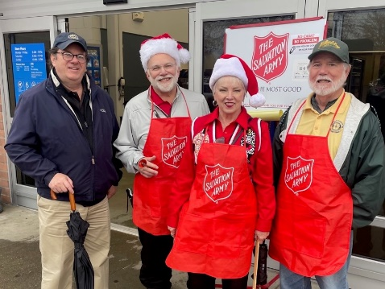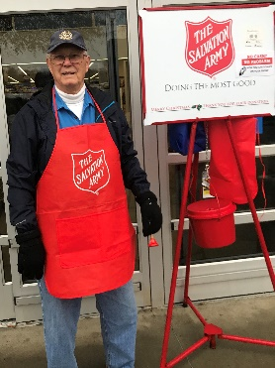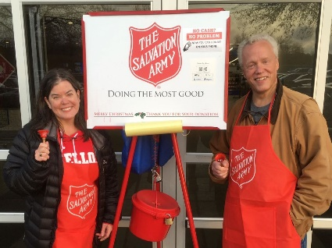

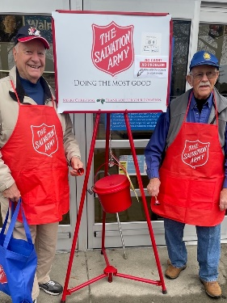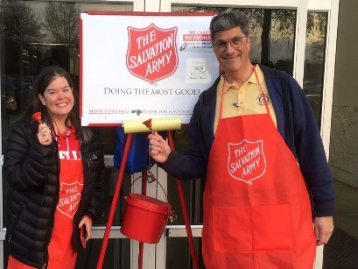

**Bell Ringing for the Salvation**

**Army at Walmart on December 3rd**



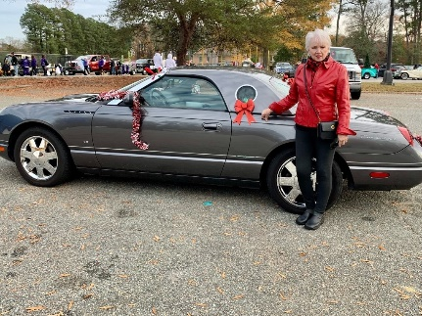

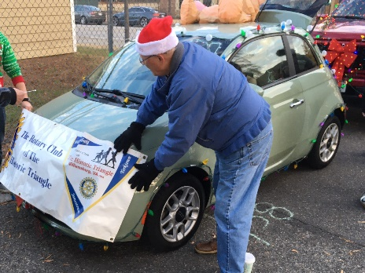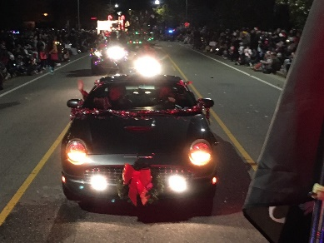

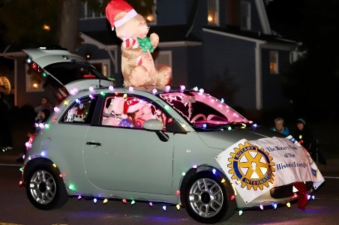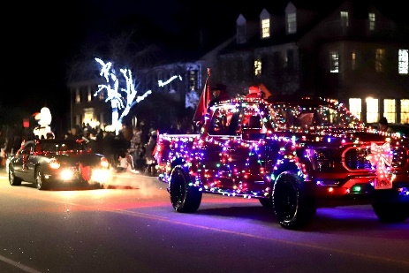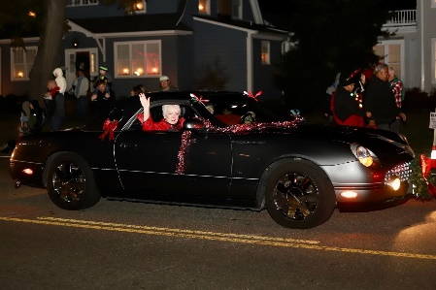

**Community Holiday Parade, Colonial Williamsburg, December 4th**

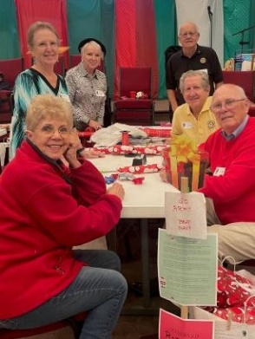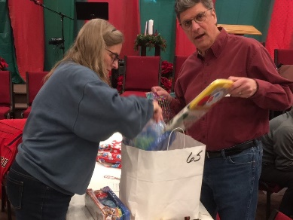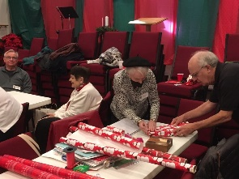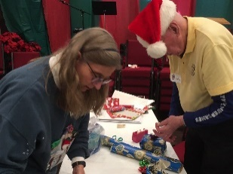

**Elfs Corner, December 10th**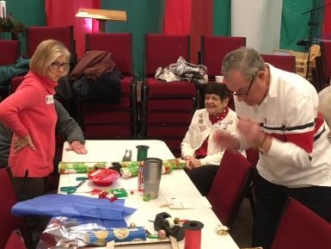

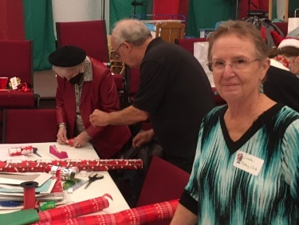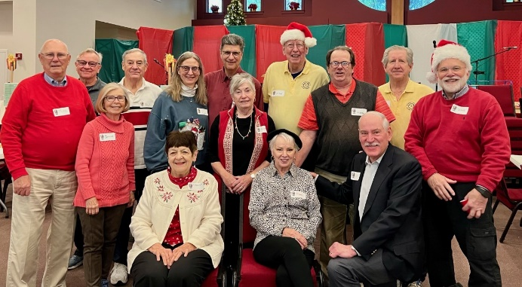



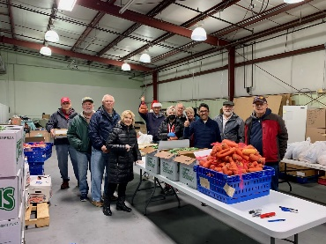

**Salvation Army Food Pantry**

**December 15.**



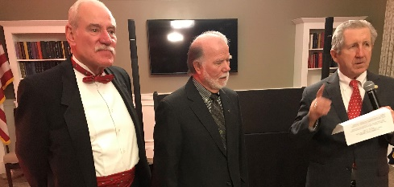 **Awards, Donation, Appreciation, December 14.**

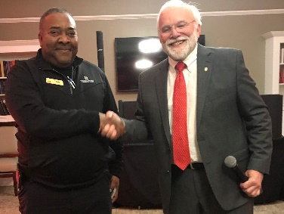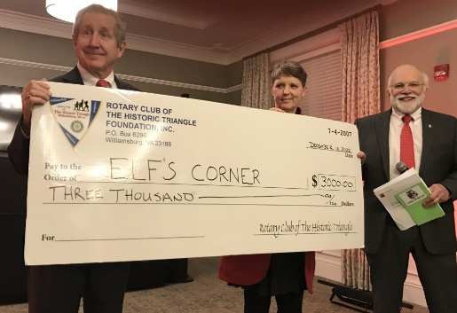



Paul Harris Fellow awards to Jeff and Swanson presented by Clay. Pres Dave and Clay present donation to Gretchen of Elfs Corner. Pres Dave presents our appreciation to Tony.



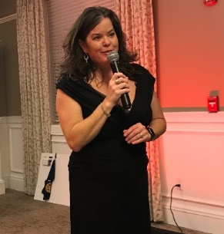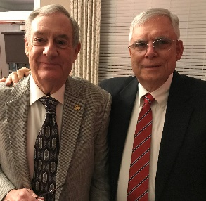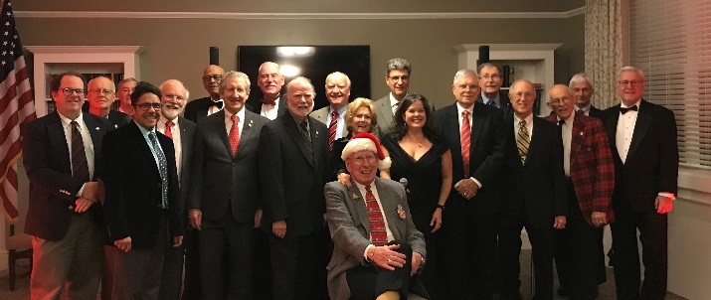 **THE PARTY- December 14**

Rotarians Mac won the 50/50 M/C and DJ Liz

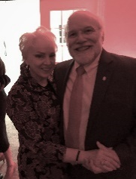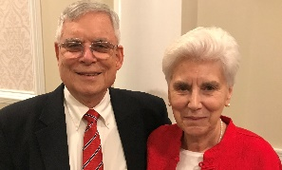

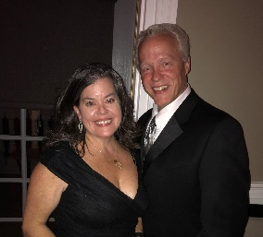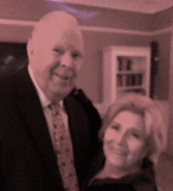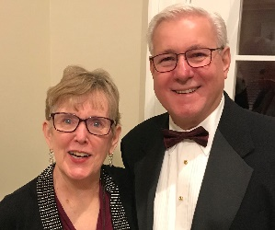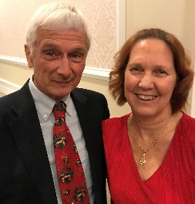

Biondis Grizzards Andersons Treibers Daleys

Clarks Bozeks Boxeths Deekens Kleppingers

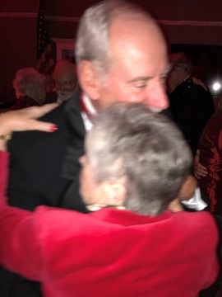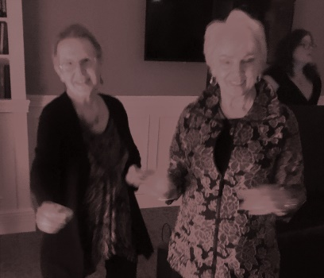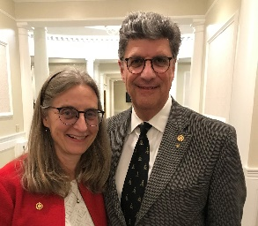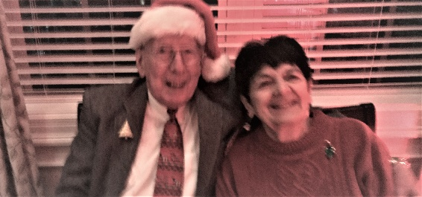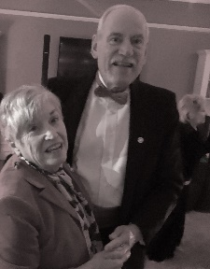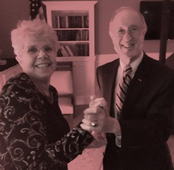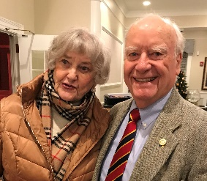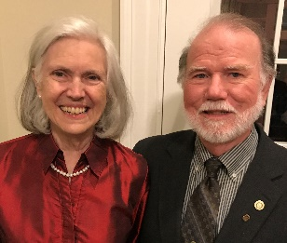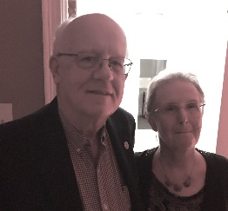

SOME DANCING AND A GOOD TIME WAS HAD BY ALL

Marstons Robinsons DaSilvas Tassones

