Rotary of Manassas Charity Cornhole Tournament



Event Date
Sunday, October 15, 2023


Event Time
1pm – 4pm (Adult Social Division) &
4pm – 7pm (Competitive Division);
12pm – 1pm (Kids Tournament)


Rotary Of Manassas Charity Cornhole Tournament
All Proceeds will benefit Semper K-9
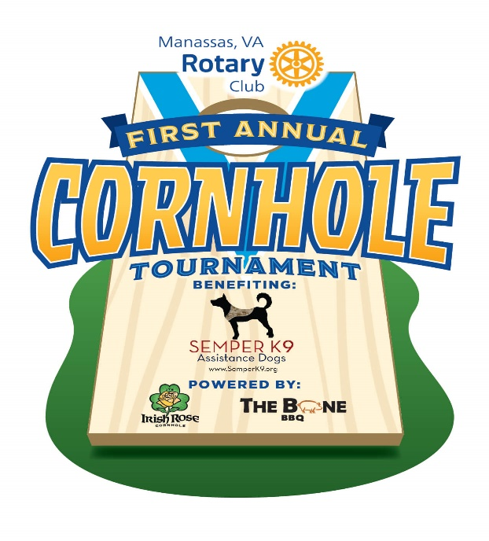Compete for the title of the 1stAnnual The Rotary Club of Manassas Cornhole Tournament or just come and enjoy the day with family and friends on Sunday, October 15th.
The Rotary Club of Manassas, Semper K-9 and Irish Rose Cornhole invites you to register in one of the divisions that suits your skill level. A newbie? No problem! Sign up for the ADULT SOCIAL division. Won your fair share of games? Sign up in the COMPETITIVE division.
WANT TO SPONSOR OUR GREAT EVENT? CLICK HERE!
$20/person includes tournament registration (min 4 games guaranteed), donation to Semper K-9, 1 FREE Drink Ticket, 1 FREE Prize Raffle Ticket and discounts on drinks and food from The Bone BBQ.
Families, friends, and supporters are encouraged to attend, for free of course!
ALL skill levels are welcome (even the not-so-skilled!) Pick from Adult Social or Competitive Divisions, see descriptions below to find out what would be best suited for your team. We also have added a tournament just for Kids.
Divisions:
1. Adult Social – This means you do not play in any groups or leagues, and do not play very regularly. This is a straight-up, for good times only, type division. Great prizes will still be awarded! You will be playing a min. of 4 games with 4 different partners. Super Fun!
2. Competitive Division– This means, you are comfortable with the game, maybe even have the Scoreholio app on your phone. If you play fairly regularly in a group or a league, this is the place for you! Cash Prizes for winning teams in this Division. You will be playing a min. of 4 games with a Switch to a Single/Double Elimination Blind Draw.
3. Kids Tournament: This is for kids ages 8 – 14 years of age. It is for all levels of players. We will be running a 3 game Switcholio, where each kid will get to play with 3 separate partners. We will have a ton of volunteers to assist the kids and ensure an amazing experience.
Times:
* Check-In begins at 12pm (Adult Social) & 3pm (Competitive)
* Bags Fly at 1pm and 4pm respectively.

TO REGISTER FOR ADULT SOCIAL DIVISION

TO REGISTER FOR COMPETITIVE DIVISION
(Link not working? Find "Rotary of Manassas Charity Cornhole Tournament")
Here is what to expect:
Backyard Division ~ 100 Player Capacity ~ Bags Provided
Min. top 15 places win prizes. (We will pay out 1 for every 6 registrations)
Advanced Division ~ 80 Person Capacity ~ BYOB
Min. top 8 in Switcholio and top 8 in Blind Draw, win cash! Over $1,500 in cash to be awarded. (We will pay out 1 for every 6 registrations)
TOURNAMENTS WILL BE HELD ON THE LAWN AT THE MANASSAS MUSEUM.
Historic District, 9101 Prince William St, Manassas, VA 20110
Pre-Registration is highly Recommended. Once divisions are full the waitlist will activate.
RULES
RAFFLES & Other Stuff.
We will be selling prize and 50/50 raffle tickets starting at 12pm (Raffle drawing will be directly after the Adult Social Division Tournament).
Awards to follow the last game of each division.
No OUTSIDE alcohol or food.
Must be 21+/over with a valid ID to drink.
This event is produced by The Rotary Club of Manassas and powered by Irish Rose Cornhole.
All Proceeds will benefit Semper K-9.
Visit us at: https://www.semperk9.org
WANT TO SPONSOR OUR GREAT EVENT? CLICK HERE!
By:Irish Rose Cornhole
- The Manassas Museum
- 9101 Prince William Street
- Manassas, VA
October 15, 2023 12pm-7pm
Share This Event
ADD TO CALENDER

