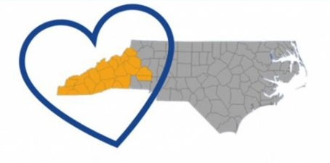

Rotary District 7670 Disaster Response Grants

This isn’t your normal Rotary Grant! The purpose of these grants is to make the process quick, easy, and impactful. The goal is to get money into the community quickly for immediate needs. Turnaround time is 4 days and the final report is simple.
The Facts
- Grants are available for up to $10,000 per club
- Clubs with matching funds will be given priority but is not a requirement
- Focus is on disaster response
- Clubs can work together but are not required
- Clubs in the District that are outside the “Disaster” area can apply for projects related to the relief efforts.
- Once APPROVED, the money can be spent.
- Money is provided up front and is NOT a reimbursement
- You can apply for more than one grant at a time
- Turnaround is fast
- Funds are coming from the Zone 33/34 foundation fundraising and District Fundraising
The Process
- Identify disaster relief needs in your community
- Determine the amount needed
- Complete application and send to paigecs123@gmail.com
- District will review (48 hrs.)
- Zone will review (48 hrs.)
- Checks will be sent to the club
- Club sends final report to the District (receipts, summary, and pictures)

If you have questions, please reach out to Paige Scott at paigecs123@gmail.com or 816-714-9998

