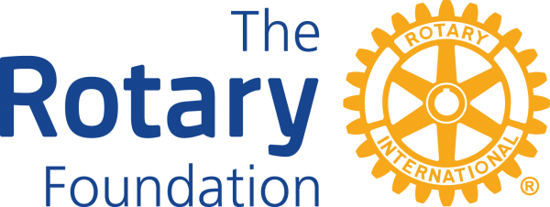

The Rotary Foundation transforms your gifts into service projects that change lives both close to home and around the world.
With your help, we can make lives better in your community and around the world.

Our mission
The Rotary Foundation helps Rotary members to advance world understanding, goodwill, and peace by improving health, providing quality education, improving the environment, and alleviating poverty.

Your Club donation can:
- protected a child from polio.
- provide clean water to help fight waterborne illness.
- launch an antibullying campaign and create a safe environment for children.

Please make your club contribution to The Rotary Foundation EVERY Quarter!



