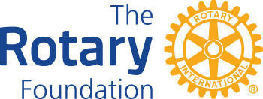 | District 7980 Youth RYLA Scholarship Applications  For the Fall 2024 RYLA Program
Rules & Instructions

- Support high school youth attending the District RYLA program. A scholarship in the amount of $175.00 per student used to subsidize the Rotary Club support. Limited to two RYLA scholarships per Club per year. Scholarship Applications for Fall 2024 RYLA MUST be received by November 8, 2024.
- Clubs must be qualified. Signed District MOU for the current Rotary year, Annual Fund goal posted on DACdb and all reporting requirements for past District Managed Grants must be current. DMG training of the Primary Contact is not required for this scholarship application.
- Completed application is submitted directly to John Merkel, District Grants Chair, via email: GrantsChair7980@gmail.com.
- Reporting shall consist District Grants Chair confirming with RYLA administration that (A) the application fee was fully paid and (B) the student participated in the program.The Club need not file any documentation of the above unless requested.
- Upon approval of this application, a District check will be issue on a first-come first-served basis, pending the availability of funds.

Rotary Club: | Club President:
My Club is qualified: Yes No

Student #1 Name: Conference Date: School:
Student #2 Name: Conference Date: School:

By signing below, our club accepts responsibility for paying the student’s application fee for each student sponsored as stated above.

Club President Name: | Signature: __________________ | Date: ________

Where do we send the check?

