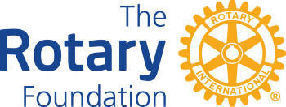 | District 7980 Youth RYLA Scholarship Applications  For the Fall 2024 RYLA Program
Rules & Instructions

- To support high school youth attending the District RYLA program, a scholarship in the amount of $175.00 per student is available to subsidize the Rotary Club support. Limited to two RYLA scholarships per Club per year.
- Scholarship Applications for Fall 2024 RYLA MUST be received by November 21, 2024.
- Your Club must be DMG Qualified. Detailed instructions available on the District website here. DMG training of the Primary Contact is not required for this scholarship application.
- Submit completed application directly to John Merkel, District Grants Chair, via email: GrantsChair7980@gmail.com.
- Reporting shall consist District Grants Chair confirming with RYLA administration that (A) the application fee was fully paid and (B) the student participated in the program.The Club need not file any documentation of the above unless requested.
- Upon approval of this application, a District check will be issueed on a first-come first-served basis, as long as funds remain available.

Rotary Club: | Club President:
My Club is DMG Qualified: Yes No

Student #1 Name: Conference Date: School:
Student #2 Name: Conference Date: School:

By signing below, I affirm that:

Our Club is DMG Qualified.

Our Club accepts full responsibility for paying the student’s application fee for each student sponsored.

The sponsored students are not children or grandchildren of Rotary Club members.

Club President Name: | Signature: __________________ | Date: ________

Where do we send the check?

