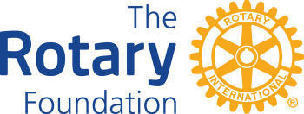 | District 7980 Youth RYLA Scholarship Applications  For grants being funded after July 1, 2022
Rules & Instructions

- Support high school youth attending the District RYLA program. A scholarship in the amount of $137.50 per student used to subsidize the Rotary Club support. Limited to two RYLA scholarships per Club per year. Scholarship Applications MUST be received by March 30, 2023.
- Clubs must be qualified. Signed District MOU for the current Rotary year, Annual Fund goal posted on DACdb and all reporting requirements for past District Managed Grants must be current. DMG training of the Primary Contact is not required for this scholarship application.
- Completed application is submitted directly to Rick Benson, District Grants Chair, via email: dgrick7980@gmail.com.
- Reporting shall consist of a confirmation of the student’s participation. A copy of the certificate of completion within 10 days following the end of the program is acceptable.
- Upon receipt of this application, a District check will be issue pending the availability of funds.

Rotary Club: | Club President:
My Club is qualified: Yes No

Student #1 Name: Conference Date: School:
Student #2 Name: Conference Date: School:

By signing below, our club accepts responsibility for submitting the completion certificate for each student sponsored as stated above.

Club President Name: | Signature: __________________ | Date: ________

Where do we send the check?

