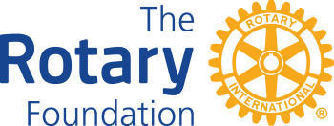 | District 7980 World Affair Seminar Scholarship Application  For grants being funded after July 1, 2023
Rules & Instructions

- Supporting high school youth attending the World Affairs Seminar (WAS) in Waukesha, WI, this scholarship in the amount of $945.00 is used to subsidize the Rotary Club support. Limited to one scholarship per Club per year. Scholarship Applications MUST be received by June 1, 2024.
- Club must be qualified. Signed District MOU for the current Rotary year, Annual Fund goal posted on DACdb and all reporting requirements for past District Managed Grants must be current. DMG training of the Primary Contact is not required for this scholarship application.
- Completed application is submitted directly to John Merkel, District Grants Chair, via email: GrantsChair7980@gmail.com.
- Reporting shall consist of a confirmation of the student’s participation. A copy of the certificate of completion within 10 days following the end of the program is acceptable.
- Upon receipt of this application, a District check will be issue pending the availability of funds.

Rotary Club: | Club President:
My Club is qualified: Yes No

Student Name: WAS Date: June 22-28, 2024 School:

By signing below, our club accepts responsibility for submitting the completion certificate for each student sponsored as stated above.

Club President Name: | Signature: __________________ | Date: ________

Where do we send the check?

