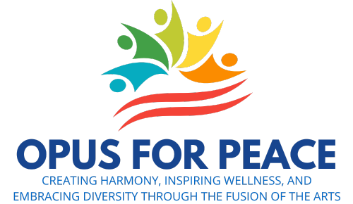

**Rotary International District 7980**

**Peacebuilding | OPUS for Peace Impact Grant**

**Application Form**

Original May 18, 2025

Click [HERE](https://dacdb.com/Rotary/Accounts/7980/Downloads/0/Peace%20Grant%20Instructions.pdf) for instructions.

Opus for Peace Grant # OFP-

Club:

Project Topic Area – check all that apply:

|  |  |
| --- | --- |
| Violence Prevention | Community Building |
| Cultural Exchange | Peace and Healing |
| Conflict Mediation | Cultural Arts Programming |
| Conflict Resolution | Community Peace Pole |
| Education | Public Image Campaign |

Project Title:

Project Location:

How many non-Rotarians benefited from this project?

If there is a significant difference from the number claimed in the application, please explain:

Describe how these non-Rotarians were helped:

How many Rotarians participated and what activities did they perform?

If there is a significant difference from the number claimed in the application, please explain:

How was the project recognized and publicized?

Financial Summary:

|  |  |  |
| --- | --- | --- |
| Item Description | Approved Budget Amount | Actual Expense |
|  | $ | $ |
|  |  |  |
|  |  |  |
| Total | 1. $ | 1. $ |

|  |  |
| --- | --- |
| Unused funds returned to D7980, if (A) is greater than (B) | $ |
| Additional funds provided by Club, if (B) is greater than (A) | $ |

Receipts for all expenses are attached.

Date Submitted:

Club President:       (name)

Please have your Club President approve this application by sending an email to [GrantsChair7980@gmail.com](mailto:GrantsChair7980@gmail.com) , containing the wording: “I have read our Club’s Peacebuilding | OPUS for Peace Impact Grant Final Report and agree that all the information contained is accurate and that the project was executed in conformance to all District 7980 and Rotary Foundation terms and conditions.”

Primary Contact:       (name)

In submitting this application form, I, the Primary Contact, agree that all the information contained is accurate and that the project was executed in conformance to all District 7980 and Rotary Foundation terms and conditions.

      (phone)

      (email)

Send this Final Report, along with any supporting documents, to John Merkel, District Grants Sub-Committee Chair: [GrantsChair7980@gmail.com](mailto:GrantsChair7980@gmail.com)

District 7980 Use Only:

Approved on       (date) by

__________________________ (signature)

John Merkel, District Grants Subcommittee Chair